Shield-INT

Integrated Detection, Jamming & Spoofing Shield
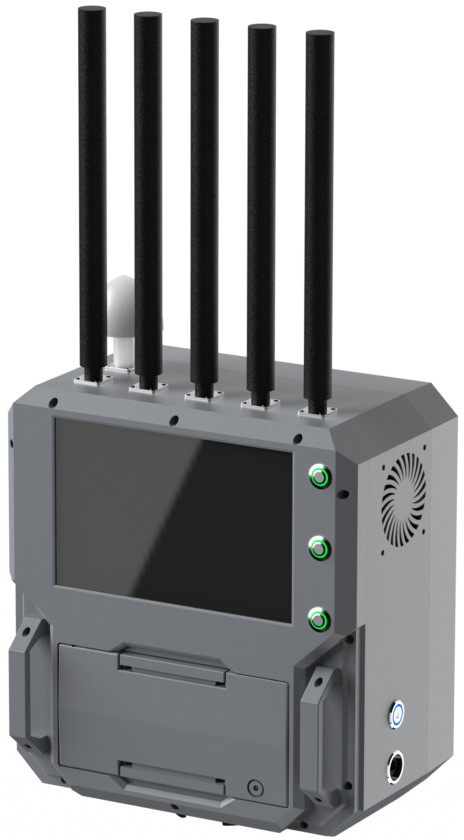 | 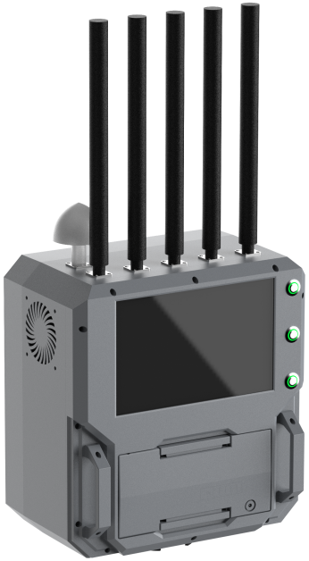 | 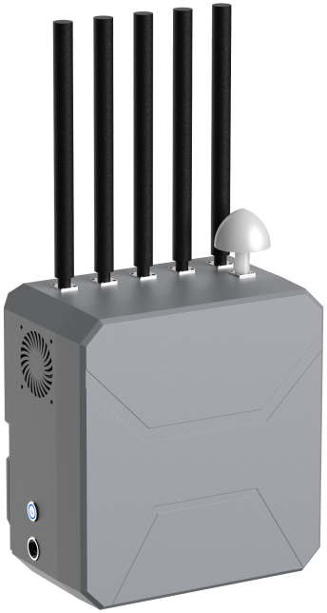

Product Introduction
The integrated detection, spoofing and jamming shield device is designed for portable functionality, equipped with a directional antenna, capable of directional UAV countermeasures within a 3 km range. The device is lightweight, easy to operate, and convenient for front-line personnel to conduct use training. With an added detection module, it achieves "detect-and-jam" integrated functionality, which can meet the low-altitude UAV countermeasure requirements for important conferences, cultural and sports events, border patrols, and multiple other scenarios.

Product Specifications
 | Parameter Name | Parameter Value
Complete machine | Overall Dimensions
 | Overall Weight
 | Deployment Mode | Portable
 | Power Supply | Built-in 20 Ah battery, external battery
 | Operating Duration | Detection mode ≥ 8 h; Jamming mode ≥ 1 h
 | Power Consumption | 300 W
 | Operating Temperature | -20 ℃ ~ +50 ℃
Detection | Detection Frequency Bands | 2.4 GHz, 5.8 GHz
 | Detection Radius | 0 ~ 3 km (varies with deployment environment and target UAV)
 | Direction-Finding Accuracy | ≤ 10° (RMS)
Spoofing | Spoofing Frequency Bands | GPS-L1, GLONASS-L1
 | Spoofing Effect | Forced landing (default)
 | Spoofing Module | 1.5 G (50 W)
Jamming | Jamming Frequency | 900 M, 2.4 G, 5.2 G, 5.8 G
 | Jamming Power | 50 W (900 M), 65 W (2.4 G), 50 W (5.2 G), 65 W (5.8 G)
 | Jamming Range | 3 km (in open line-of-sight environment)
 | Jamming Activation | < 3 s
 | Jamming Angle | Horizontal: 65°, Vertical: 30° (directional)
 | Protection Functions | Temperature control protection, reflection protection

