VPA1173620 Data Sheet
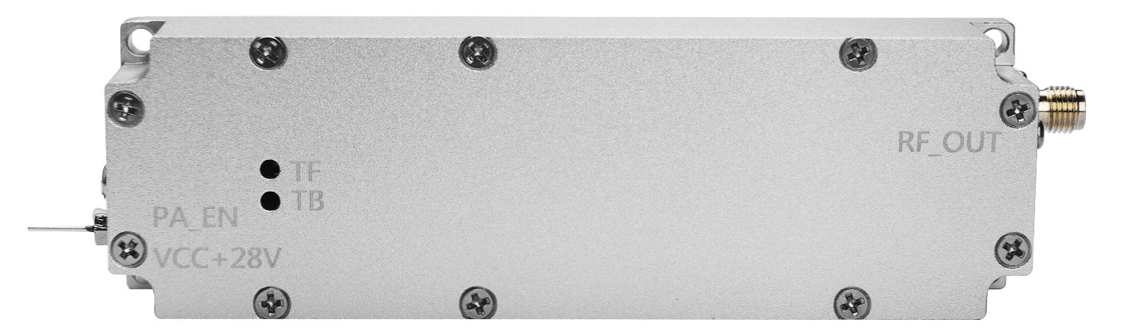
Figure 1 Appearance of VPA1173620

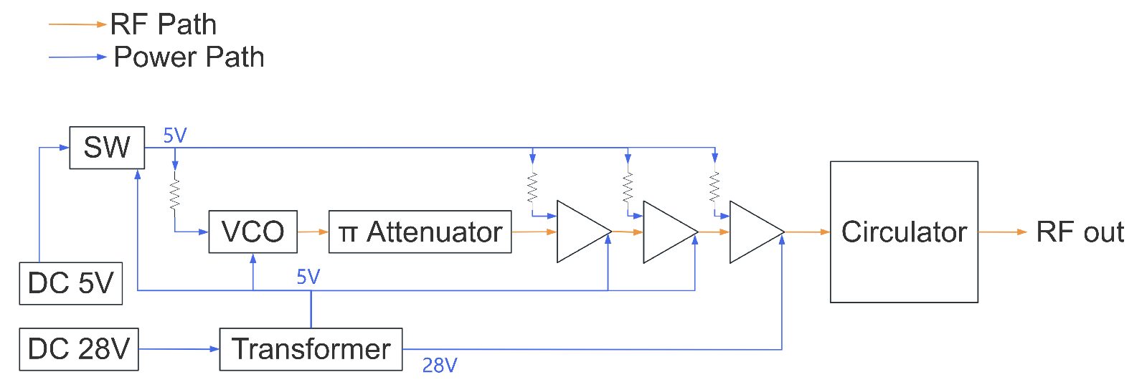
Figure 2 Functional Block Diagram

Frequency Band
Bands(MHz) | Power(dBm) | Current | Signal Source | Transistor
430-440 | 47±1dBm | ≤4.5A | VCO | GaN
840-930 | 47±1dBm | ≤4.5A | VCO | GaN
1170-1280 | 47±1dBm | ≤4.5A | VCO | GaN
1430-1444 | 47±1dBm | ≤4.5A | VCO | GaN
1550-1620 | 47±1dBm | ≤4.5A | VCO | GaN
2400-2485 | 47±1dBm | ≤5A | VCO | GaN
5150-5350 | 47±1dBm | ≤5.5A | VCO | GaN
5725-5850 | 47±1dBm | ≤5.5A | VCO | GaN
Note: This table is an example of a typical frequency band. Specific product specifications are subject to actual conditions.
RF indicators
Test Items | Index | Mark
Operating voltage | 28V | 24-30V
In-band fluctuation | ±2dB | Peak-to-Peak
Maximum allowable input power | ≤10dBm | Lasts for 1 minute without damage
Output voltage standing wave ratio | ≤1.50 | Power on, dual directional coupler test
Operating temperature | -25～+85℃
RF output connector | SMA-F
Module protection | Over temperature protection, standing wave protection
Weight | 153g
Dimensions
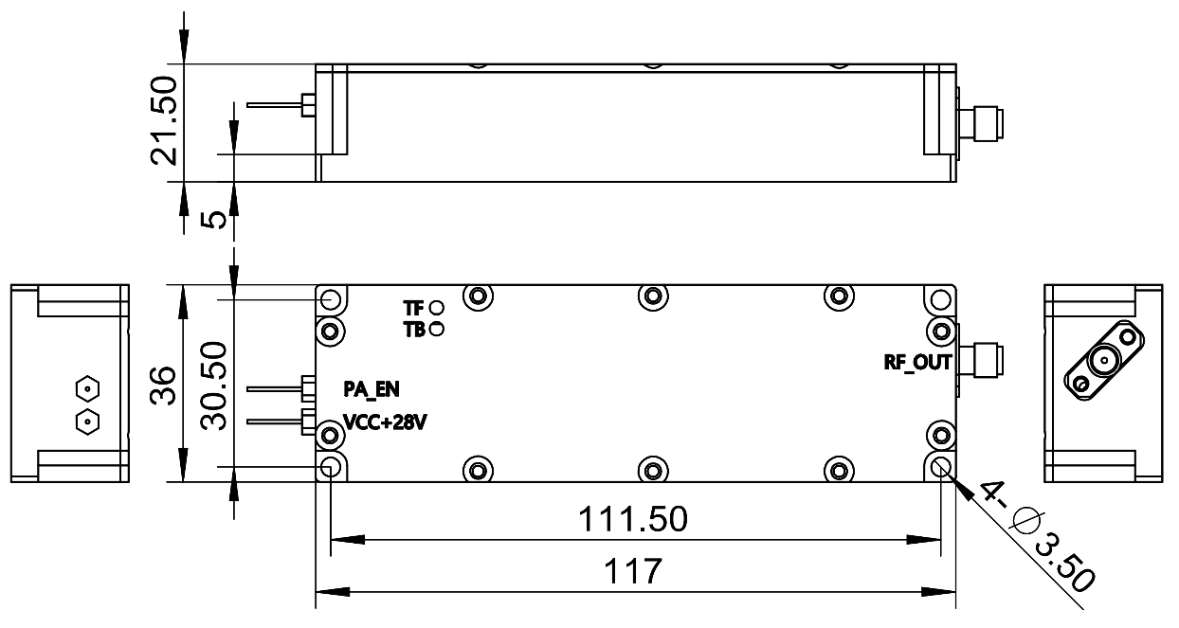
Figure 3 Dimensions

