VPA1407120 Series Module Data Sheet
Specification
Test items |  | Indicator | Remark
Operating Voltage |  | 28V | 28-30V
Maximum Output Power |  | 47±0.5dBm
Operating Current |  | ≤5A | @50W Typical
Gain |  | 47±1.0dB
In-band Fluctuation |  | ±1.5dB | Peak-to-peak value
Maximum Allowable Input Power |  | ≤10dBm | Lasts 1min without damage
Input VSWR |  | ≤1.50 | Add +28V, standard network output -10dBm
Output VSWR |  | ≤1.50 | No power applied, standard network output -10dBm
 |  | ≤1.50 | Power applied,bidirectional coupler testing
Temperature Test | Operating Environment Temperature | -10～+55℃ | Low-temperature startup, monitoring functions properly
Temperature Test | Gain Stability | ±1.5dB@-10℃～+55℃ | Low-temperature startup, monitoring functions properly
Temperature Test | Power Stability | ±1.5dB@-10℃～+55℃ | Low-temperature startup, monitoring functions properly
Power Requirements |  | ≥4.5A @+28Vdc； | Continuous wave output of 50W
Power Connector |  | Feedthrough Capacitor core: VCC+28V; Ground plate: GND
Function of 5Pin XH-2.54mm |  | 1.TEMP_DET: Temperature detection AD voltage value  2.PA_FWD: Forward power detection AD voltage value  3.PA_REV: Standing wave alarm, high-level alarm, low-level elimination  4.PA_EN: Enable switch; open with high-level 3V~5V, close with low-level<2V.(For installation, please confirm with sales.)  5.PA_ADJ: NC
RF output connector |  | SMA-F
Module Protection |  | Over-temperature protection; VSWR protection
Signal Source Input |  | Built-in high-speed noise modulation signal source
LED Module Indicators |  | POWER: Power indicator；  RUN: Operation indicator；  VSWR: VSWR alarm indicator
Size |  | 140*71*21mm
Weight |  | 390g
Packing Size |  | 210*108*38mm
Packing Weight |  | 445g

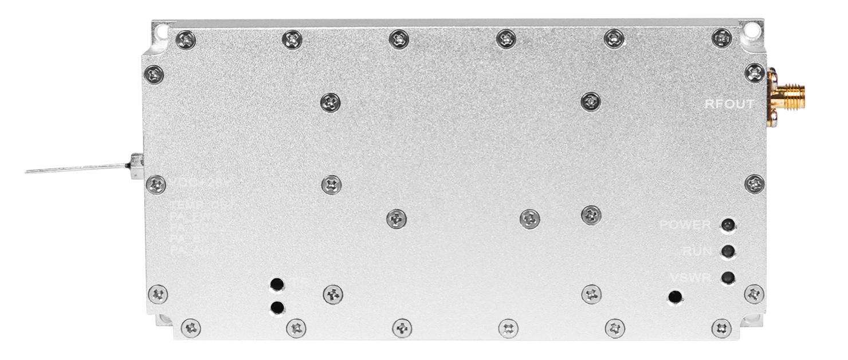

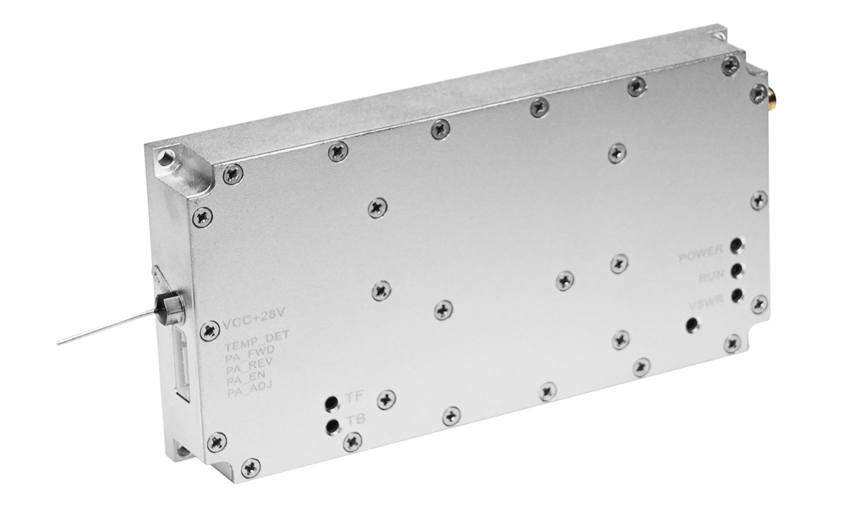
Produce Range
Supported Frequency Range (MHz) | Max Bandwidth (MHz) | Max Power (W)
400-700 | 300 | 50W
700-1000 | 300 | 100W
1100-1200 | 100 | 80W
1200-1500 | 300 | 50W
1500-1600 | 100 | 100W
1600-4000 | 300 | 50W
4000-5800 | 300 | 45W
5800-6000 | 200 | 40W
Note: The "Supported Frequency Range (MHz)" in this table is not the actual interference frequency band of a single module. It is the production range supported by the module. The actual interference frequency band of the module is included in the "Supported Frequency Range (MHz)" and is limited by the "Maximum Bandwidth (MHz)".
Dimensions
Frequency＜4800MHz :
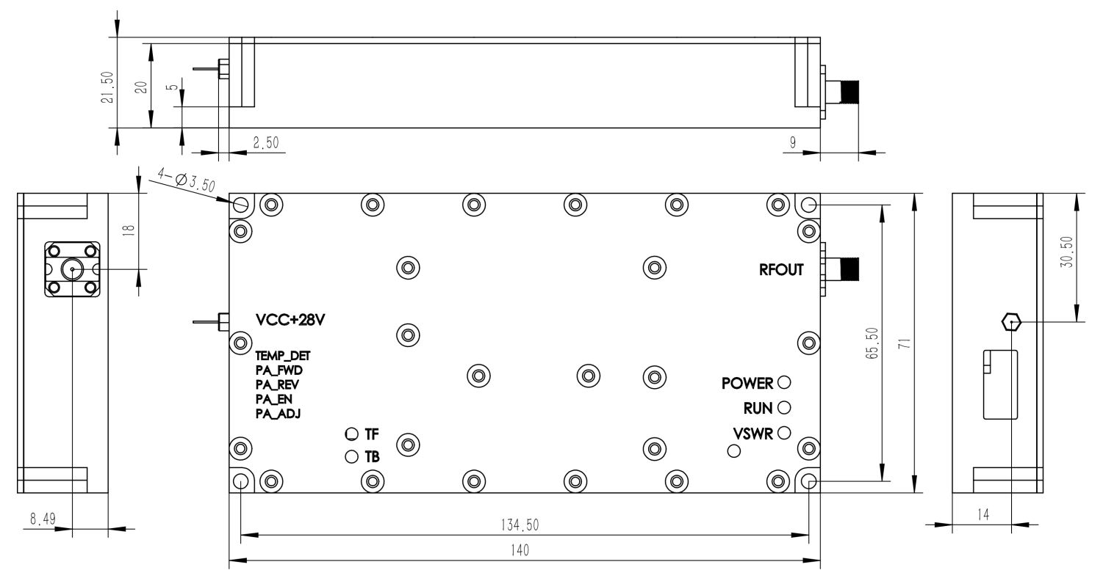
Frequency＞4800MHz :


