Pine-INT-5

Large Sphere 5-Band Detection & Jamming Integrated Quad Array
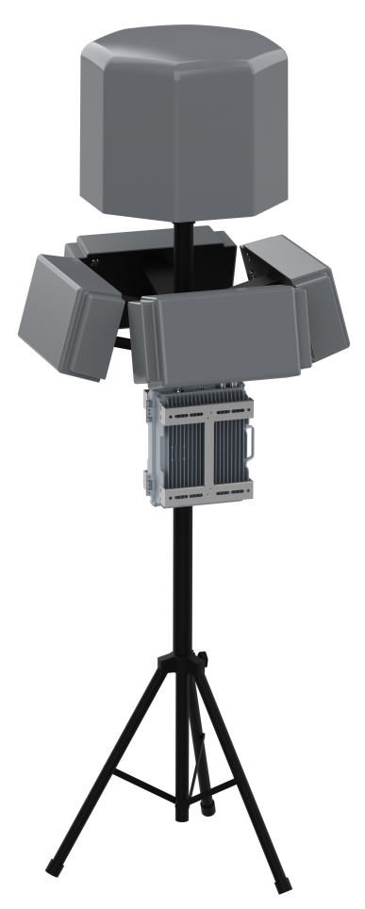 | 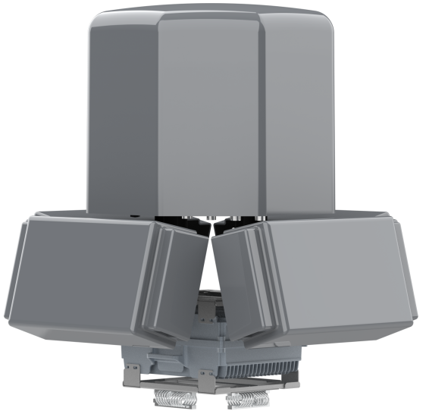
Fixed – Detection Large Sphere + 5-Band Jamming | Vehicle-Mounted – Detection Large Sphere + 5-Band Jamming

Product Introduction
The 5-band detection and jamming integrated quad array system consists of a detector and a four-sided directional jamming array, capable of detecting, identifying, and jamming UAVs. It can cause UAVs to hover in place, force-land, or return to home, effectively protecting low-altitude airspace safety and preventing UAVs from entering the defense zone. It features excellent detection and defense performance, long-distance operation capability, requires no personnel on duty, and is capable of automatic UAV detection and defense. It can be deployed in fixed or vehicle-mounted configurations according to different scenario requirements. Direction-finding functionality is also available as an option.

Features
- Omnidirectional Transmission: Four-sided directional jamming devices form a 360° omnidirectional jamming enclosure.
- Networked Management: Multiple systems can be networked and centrally managed via LAN/Internet.
- Unattended Operation: Automatic response strategies can be configured in the software backend for 24-hour unattended operation.

Product Specifications
 | Parameter Name | Parameter Value
System | Overall Dimensions | 700 × 700 × 445 mm (excluding tripod and vehicle-mounted base)
System | Overall Weight | 26 kg
System | Deployment Mode | Fixed, vehicle-mounted
System | Power Supply | AC 220 V mains power
System | Power Consumption | Directional jamming chassis: 1120 W (full load operation)
System | Operating Temperature | -20 ~ 50 ℃
Detection (large sphere) | Detection Range (radius) | 1 ~ 10 km+ (varies with environment and UAV model)
Detection (large sphere) | Detection Frequency | 2.4 GHz, 5.2 GHz, 5.8 GHz, 0.4 GHz, 0.9 GHz, 1.4 GHz
Detection (large sphere) | Detection Angle | Omnidirectional 360°
Detection (large sphere) | Direction Finding Accuracy | ≤ 3° (RMS)
Detection (large sphere) | Positioning Accuracy | ≤10m(RMS)
Jamming | Jamming Frequency | 800 M, 900 M, 2.4 G, 5.2 G, 5.8 G
Jamming | Jamming Power | 50 W (800 M), 50 W (900 M), 65 W (2.4 G), 50 W (5.2 G), 65 W (5.8 G)
Jamming | Jamming Range | 3 km (in open line-of-sight environment)
Jamming | Jamming Angle | Horizontal: 65°, Vertical: 30° (directional)
Jamming | Protection Functions | Temperature control protection, reflection protection

