Traveler-CM Backpack Type Signal Jammer

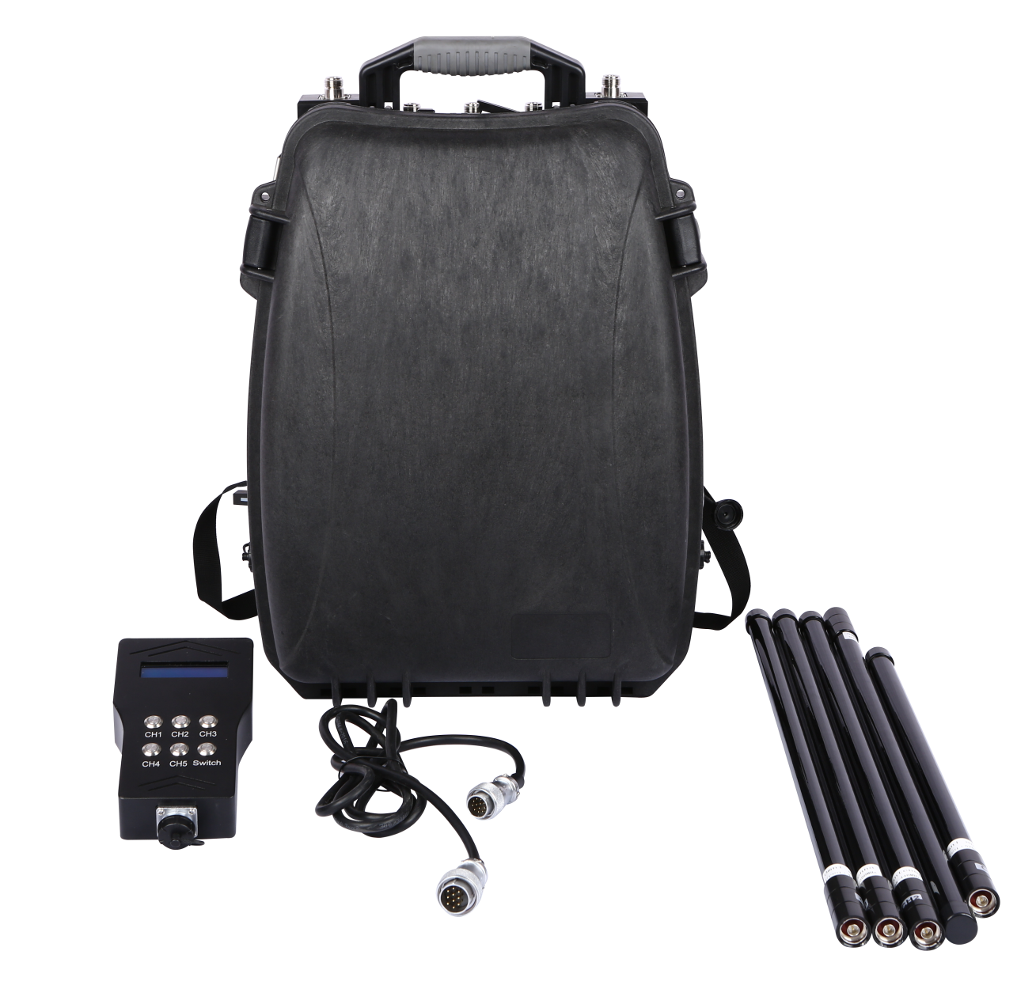

V1.1

Product Description: The Traveler-CM backpack jammer is designed for portability and equipped with an omnidirectional antenna, enabling omnidirectional countermeasures against drones within a 2,000-meter range. Its lightweight design and simple operation facilitate user training for frontline personnel. A detection module can be added to achieve integrated detection and strike capabilities, meeting the needs of low-altitude drone countermeasures in a variety of scenarios, including important meetings, cultural and sports events, and border inspections.

Features:
Omnidirectional Transmission: Transmits radio blocking signals in all directions, meeting all-round protection needs;
Flexible and Convenient: Portable design, lightweight, easy to operate, and highly maneuverable;
Long Battery Life: Built-in high-quality battery for long battery life;
Multi-Band Countermeasures: Capable of countering the communication, image transmission, and navigation links of various drones;

⚠Risk Warning:
- Do not use the device outdoors during thunderstorms
- Do not allow the device near fire
- Do not disassemble the device while it is powered on
- Avoid dropping the device into water or allowing liquid to enter the device
- Avoid severe impact to prevent the internal lithium battery from igniting
- Before turning on the device, check that the antenna is fully connected to the corresponding port
- When the device is turned on, patients with implantable electronic therapeutic devices (such as pacemakers) should maintain a distance of at least 10 meters from the device.
Jamming Bands
Bands | Frequency | Power | Current | Signal Source
CH1 | 860-930MHz | 30W | ≤2A | VCO
CH2 | 1170-1280MHz | 30W | ≤2A | VCO
CH3 | 1550-1620MHz | 30W | ≤2.3A | VCO
CH4 | 2400-2485MHz | 30W | ≤2.3A | VCO
CH5 | 5150-5350MHZ | 30W | ≤2.5A | VCO
CH6 | 5725-5850MHz | 30W | ≤2.5A | VCO
Note: This table is a typical interference frequency table for eight-channel equipment. The actual number of channels and interference parameters of the finished product need to be confirmed after communication with the customer.

Specifications:
Jamming Distance | 200m-2000m
Main unit dimensions | Length 350mm * Width (Depth) 190mm * Height 490mm
Main unit weight | 16kg
Power consumption | 220V / 2.36A, total power consumption 518W
Omnidirectional antenna | Weight: 260g; Length: <650mm
Power supply method | Powered by built-in battery or AC 220V
System protection | Overtemperature protection, standing wave protection
Cooling system | Built-in intelligent cooling system, continuous operation >12 hours
Built-in battery | Built-in 20A battery, continuous use >1 hour
Charging method | External 4A charger
Battery level indicator | Battery indicator on the main unit
Single-channel control | Switch any frequency band on or off individually, or with one-touch start
Reliability of the entire system | MTBF no less than 1000 hours
System response time | No more than 30 seconds (from power on to normal operation)
Temperature/humidity | -20°C - +50°C / ≤80%

Packing List:
NO. | ITEM | Description | Quantity | Unit
1 | Main unit |  | 1 | pcs
2 | Omnidirectional Fiberglass Antenna |  | 6 | pcs
3 | Charging adapter |  | 1 | pcs
4 | 220V AC power cord | 1.8m | 1 | pcs



