Praetorian-CM Non-Stop signal jammer
Introduction

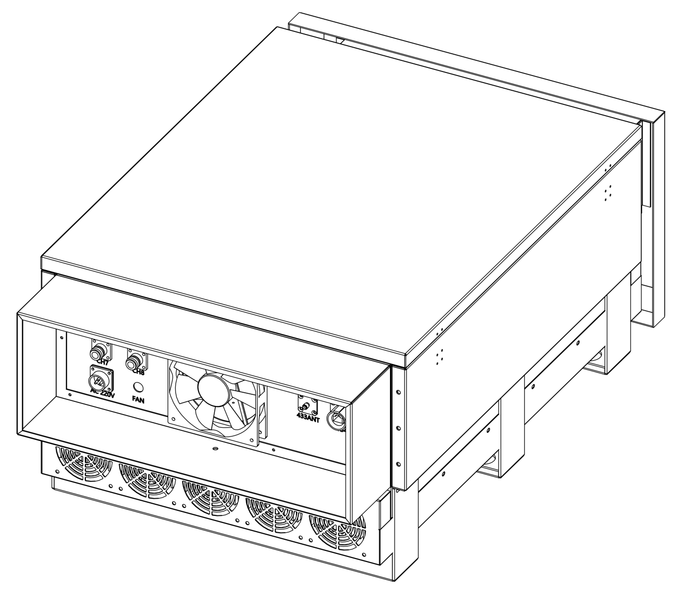

V1.2

Table of Content
Product Introduction: 1
Functional features: 1
Schematic diagram of heat dissipation structure 2
Jamming Frequency 5
Machine parameters 5
Packing List* 6
Feeder 6
Panel antenna parameters 7
Network topology diagram 9
Software operation 11

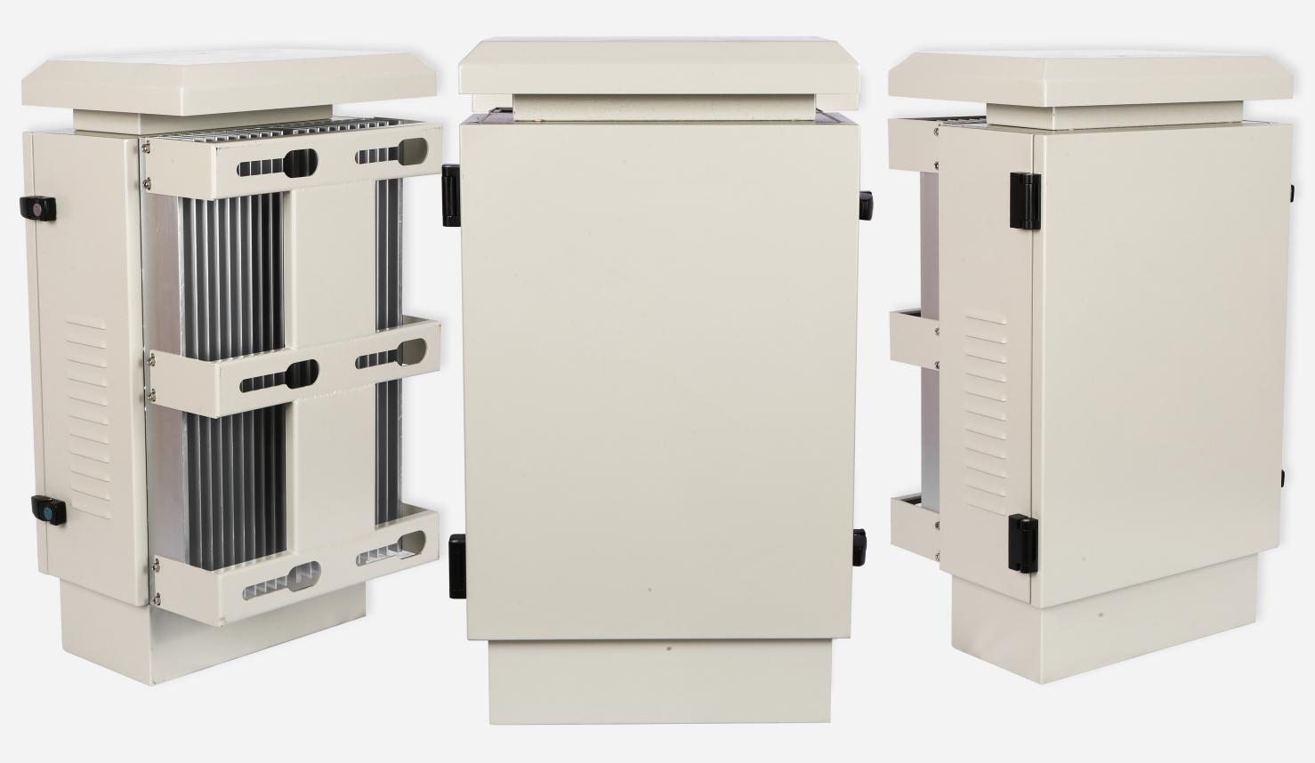

Product Introduction:
Praetorian-CM uninterrupted drone jammer is made of sheet metal processing, designed for outdoor environment, durable and can effectively maintain operation in various meteorological environments, such as thunderstorm, fog, snow and other extreme weather. The equipment can be mounted on a pole or wall, and multiple devices can be networked to achieve regional coverage of drone countermeasures. It is suitable for key security fields such as prison guards, important gatherings, petroleum and petrochemicals.

Functional features:
Uninterrupted operation: dual redundant design of power supply and heat dissipation to ensure continuous operation of the equipment 7*24 hours;
Durable: sheet metal processing, effectively adapt to various extreme weather;
Multi-band countermeasure: can counter the communication, image transmission and navigation links of various drones;
Strong anti-interference: the equipment can effectively resist the interference of complex electromagnetic signals in the city;

Schematic diagram of heat dissipation structure:
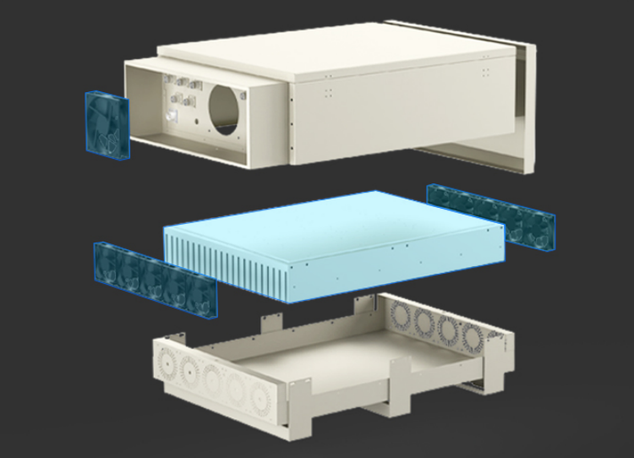
Note: The device has built-in large heat sinks and a multi-fan cooling system to meet the heat dissipation requirements of 24/7 non-stop operation.
The device is available in two sizes:

Praetorian-CM-S (Small Size)
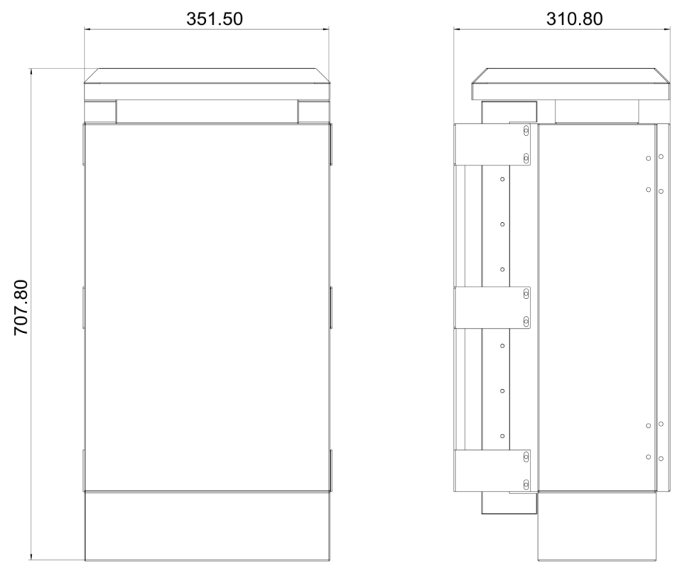

- Praetorian-CM-L (Large Size)
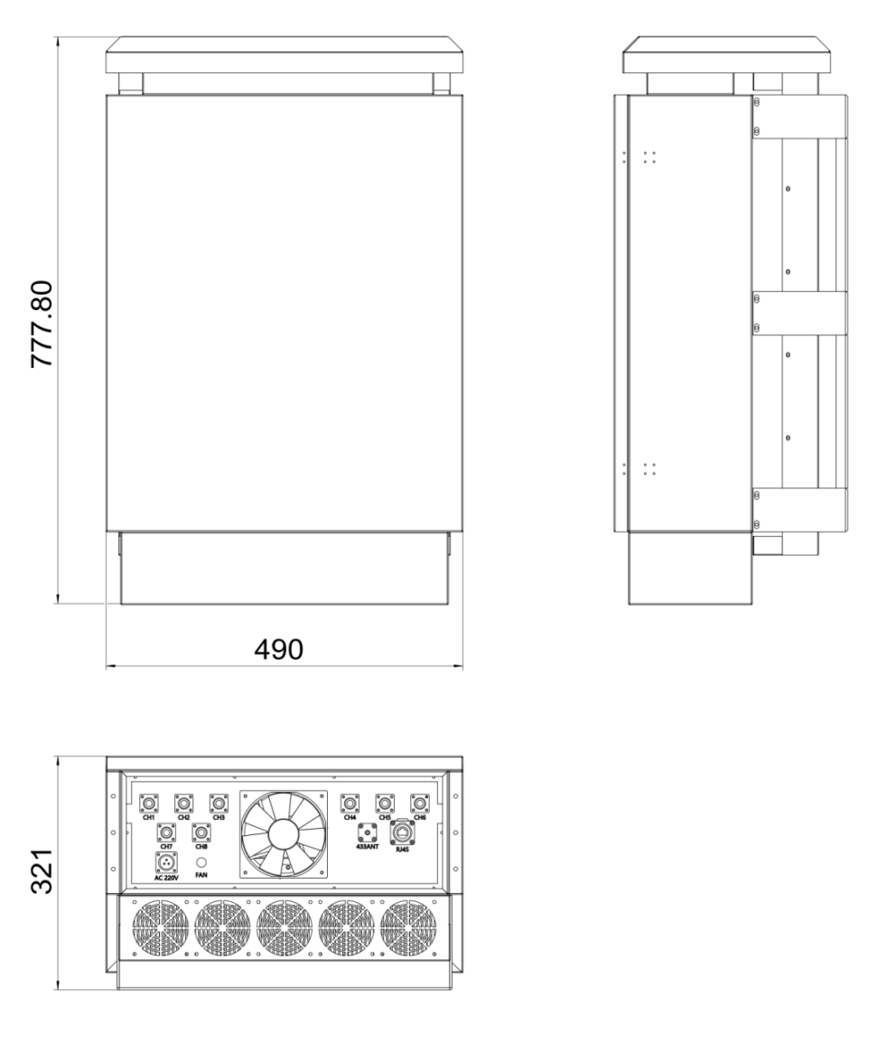
Note: The final size and model of the product is determined by customer needs, such as: RF module power requirements, module quantity requirements, etc.

Jamming Frequency

50W Version
Channel | Frequency | Power | Current
CH1 | 880-915MHz | 50W | 4.5A
CH2 | 1710-1785MHz | 50W | 4.5A
CH3 | 1920-1980MHz | 50W | 4.5A
CH4 | 2300-2400MHz | 50W | 4.5A
CH5 | 2500-2690MHz | 50W | 4.5A
CH6 | 3400-3600MHz | 50W | 4.5A

100W Version
Channel | Frequency | Power | Current
CH1 | 880-915MHz | 100W | 9A
CH2 | 1710-1785MHz | 100W | 9A
CH3 | 1920-1980MHz | 100W | 9A
CH4 | 2300-2400MHz | 100W | 9.5A
CH5 | 2500-2690MHz | 100W | 9.5A
CH6 | 3400-3600MHz | 100W | 10A

Machine parameters
Jamming Distance | 200m~3km
Complete machine weight | 40~60kg (depending on actual specifications)
Power input | AC 210V～240V
Communication interface | RJ45
Installation environment | Wall-mounted/pole-mounted
Installation height | 5～15m
Casing material | Iron paint
Operation environment temperature | -40℃～60℃
Operation environment humidity | 35～85%

Packing List*
Name | quantity | Unit | Remark
Host | 1 | pcs
Multi-band plate antenna | 2 | pcs
Feeder | 6 | pcs
Power supply line | 1 | pcs
Expansion screw | 4 | set | Wall mount installation
Dogtooth baffle bolt | 2 | set | Pole mount installation
*Note: This list is a typical 6-channels equipment packing list. The actual list of each item shall prevail.

Feeder
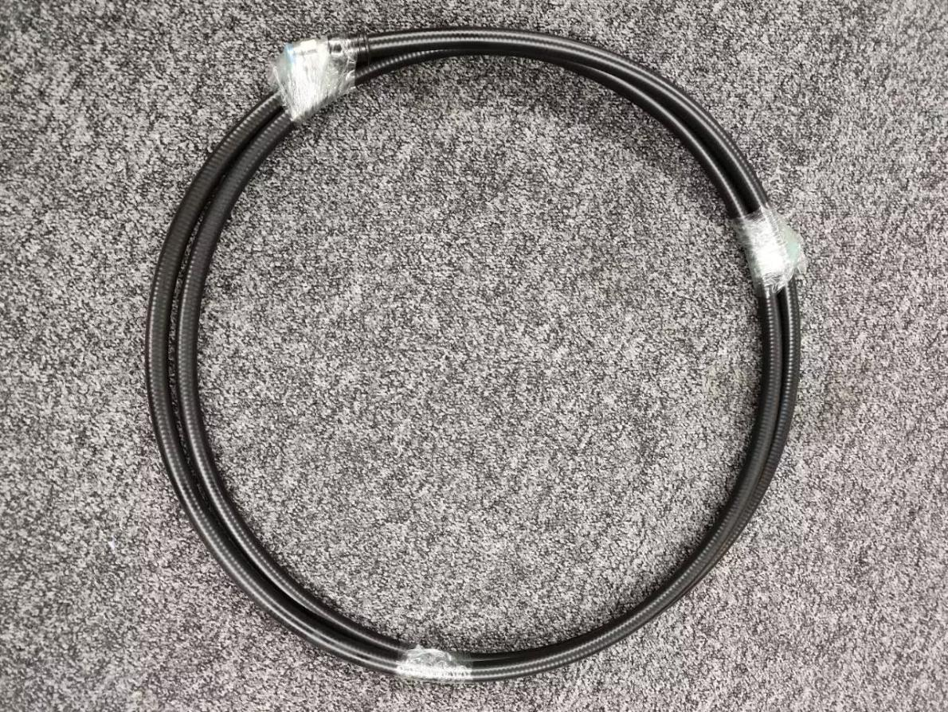
Connection method:
1. Connect one end of the feeder to the RF connector at the bottom of the device;
2. Connect the other end of the feeder to the RF connector of the corresponding frequency band at the bottom of the panel antenna;
3. Ensure that the connector is tightly and firmly connected.

Panel antenna parameters
Panel antenna A | Frequency | 880-915 | 1710-1785 | 1920-1980
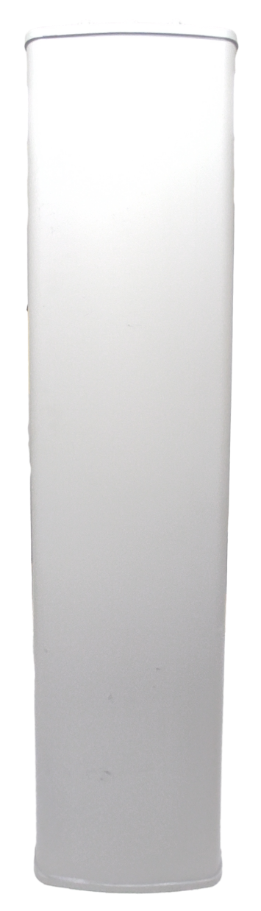 | Gain | 13±0.5dBi | 15±0.5dBi | 15±0.5dBi
 | Horizontal Beamwidth | 120±15º
 | Vertical Beamwidth | 20±3º
 | F/B Ratio | ≥22dB
 | VSWR | ≤1.5
 | Impedance | 50 Ω
 | Polarization | Vertical polarization (V)
 | Max. Power | 100W
 | Connector | N-K
 | Lightning Protection | DC grounding
 | Dimension | 800x160x80mm
 | Weight | 3.2kg
 | Rated Wind Velocity | 36.9 m/s
 | Operational Humidity | <95%
 | Operating temperature | -40～55℃
 | Radome material | PVC

Panel antenna B | Frequency | 2300-2400 | 2500-2690 | 3400-3600
 | Gain | 17±0.5dBi | 17±0.5dBi | 17±0.5dBi
 | Horizontal Beamwidth | 120±15º
 | Vertical Beamwidth | 20±3º
 | F/B Ratio | ≥22dB
 | VSWR | ≤1.5
 | Impedance | 50 Ω
 | Polarization | Vertical polarization (V)
 | Max. Power | 100W
 | Connector | N-K
 | Lightning Protection | DC grounding
 | Dimension | 800x160x80mm
 | Weight | 3.2kg
 | Rated Wind Velocity | 36.9 m/s
 | Operational Humidity | <95%
 | Operating temperature | -40～55℃
 | Radome material | PVC

Network topology diagram
Wireless connection:
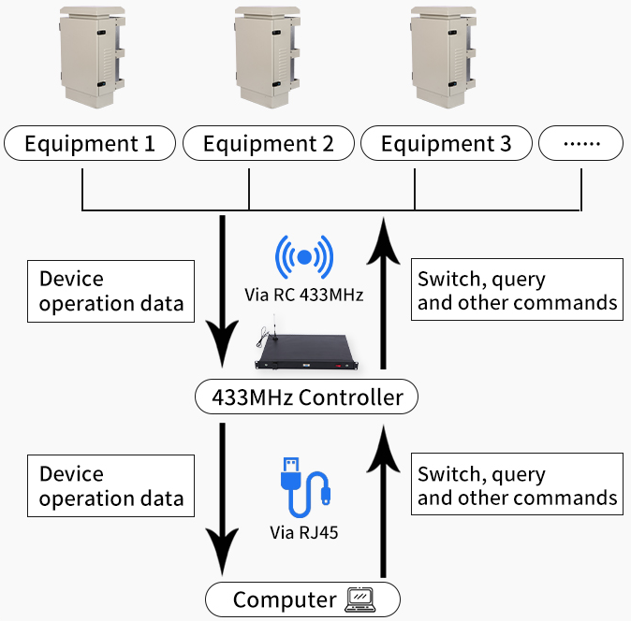

Wired connection:
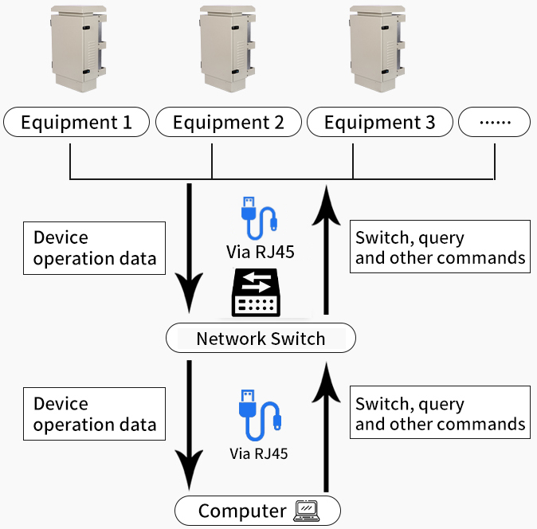

Software operation
- Device IP settings
  - Local Ethernet settings
Connect the server to the PC through the network port, install the receiving antenna on the device and server, power on the device, server, and PC, open the control panel on the PC device, find the network connection, right-click Ethernet and select Properties, click to open Internet Protocol Version 4(TPC/IPV4), and set the properties as follows:

IP address: 192.168.0.8
Subnet mask: 255.255.255.0
Default gateway: 192.168.0.1

  - Enter the software URL
Open the browser (edge or google browser is recommended), enter the URL in the address bar:
local URL: localhost:1500
public URL: https://2153be027jc8.vicp.fun/
Username: Admin
Password: 123456

As shown below:
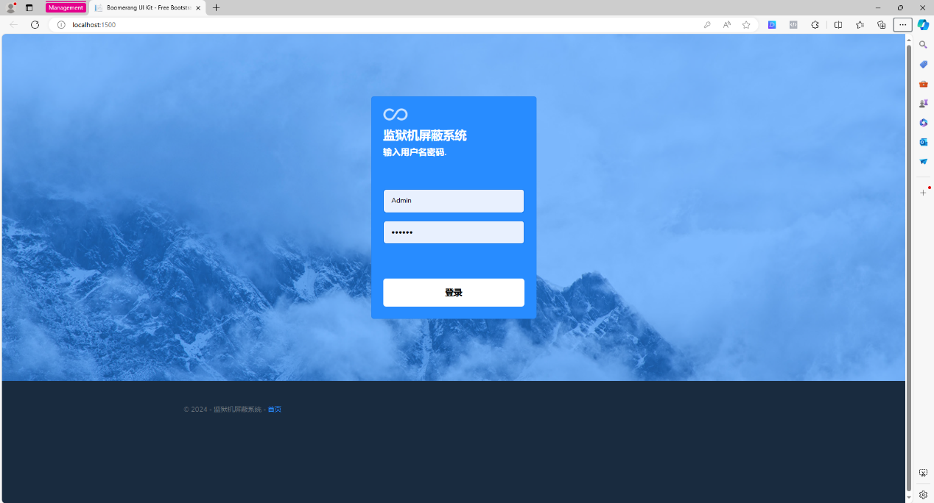
After successful login, enter the main interface, as shown in the figure:
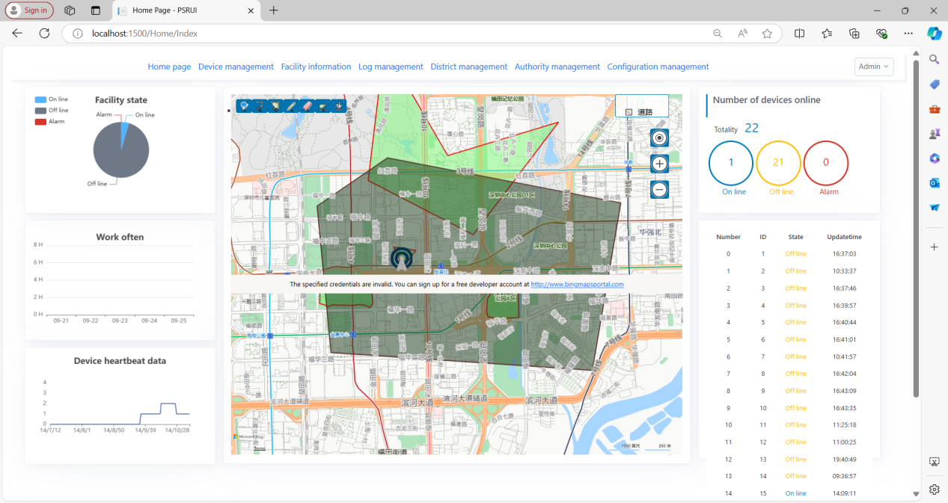
- Web control terminal functions
  - Introduction to the web control terminal interface
The main interface application includes:
- Application functions;
- Device status;
- Working cycle;
- Heartbeat data;
- Map information;
- Number of online devices;
- Device number and online time.
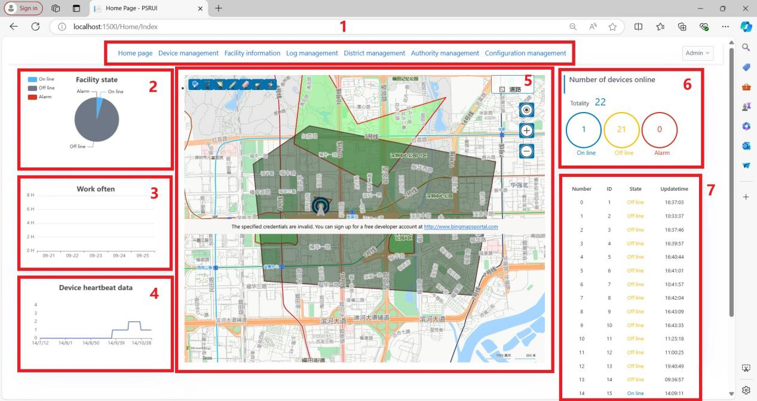
  - Function Usage Steps
Step 1: Click Configuration Management to enter the configuration management (you can switch between Chinese and English and between digital and analog), and select analog module here.
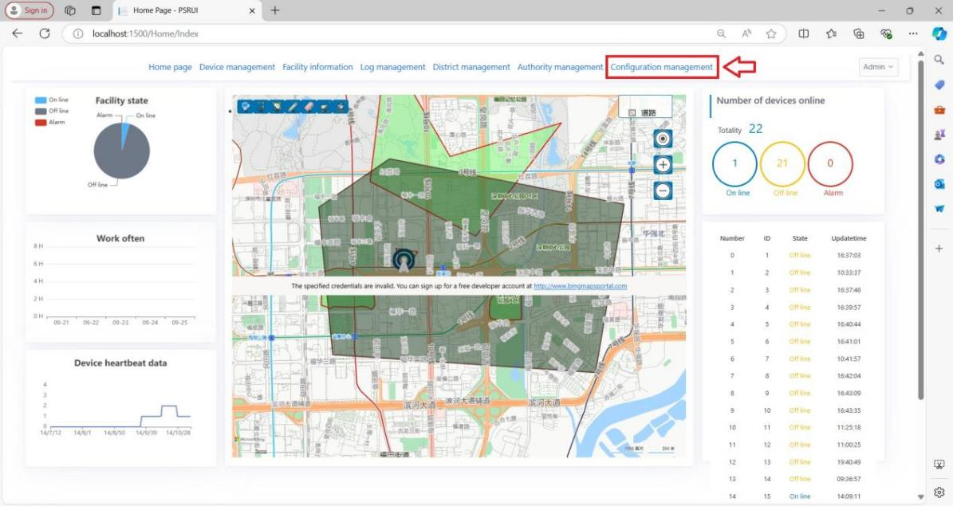
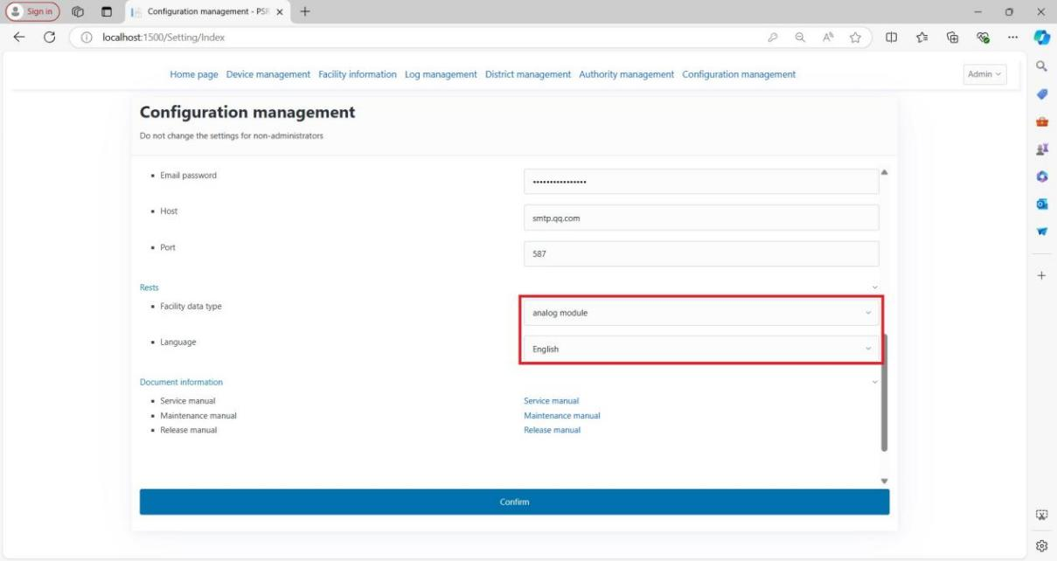
Step 2: Click Facility information to enter the device information.
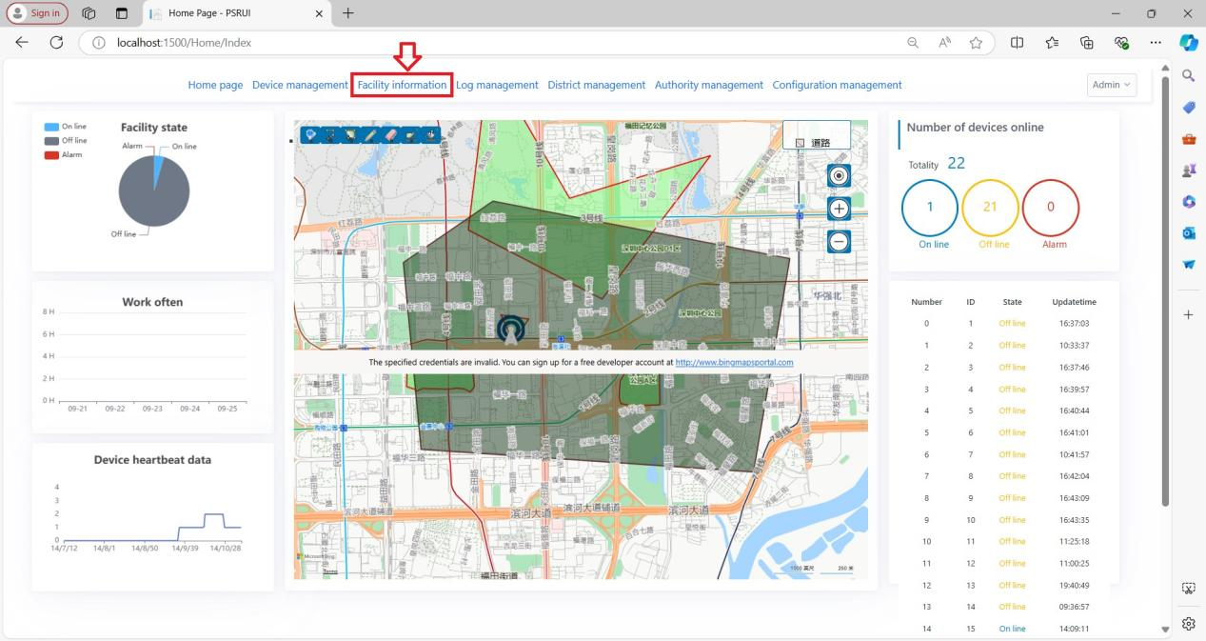
Device information interface introduction: including device search, deletion and addition, status information, modification information and console settings
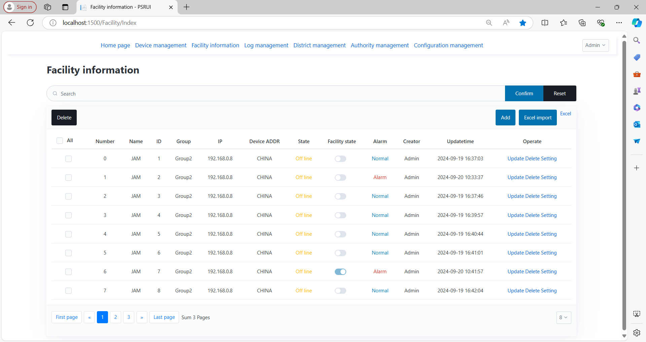
Step 4: Add a device (if you need to add a new device), click Add to enter the new device information filling interface

Introduction to the new device information adding interface:
- Device name
- Address
- Group
- IP port and location information
- Detailed address
- Remarks
- Device status.
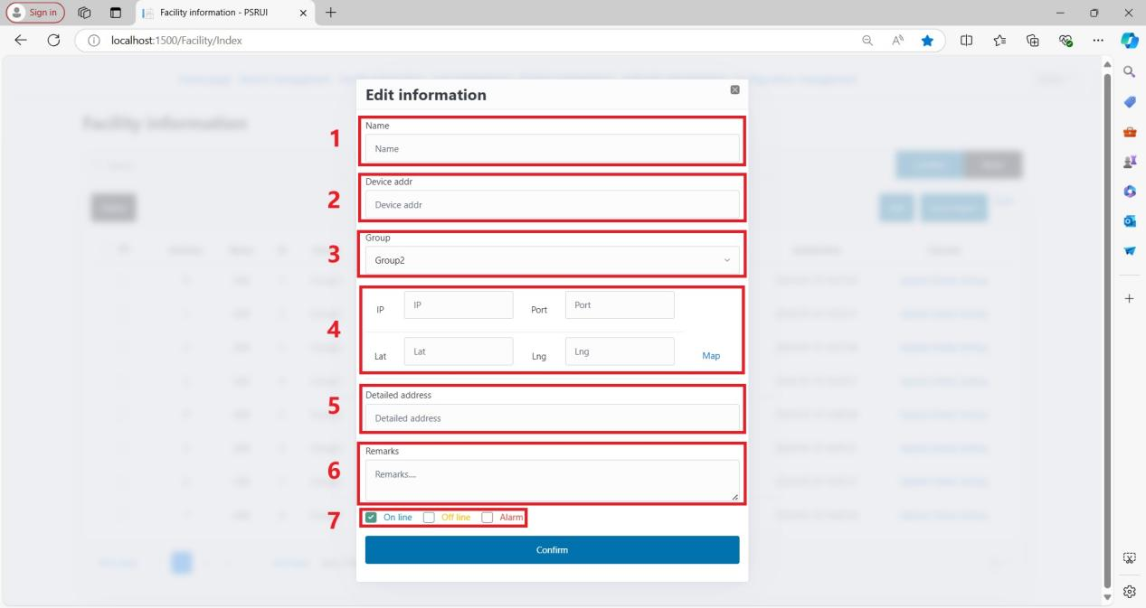
Step 5: Mainly fill in the IP and port of the device. The device IP and port must be consistent with the IP and port of the corresponding control server (the device can connect to the server). For location information, click Map to enter the custom device location interface (manual input of latitude and longitude is supported).
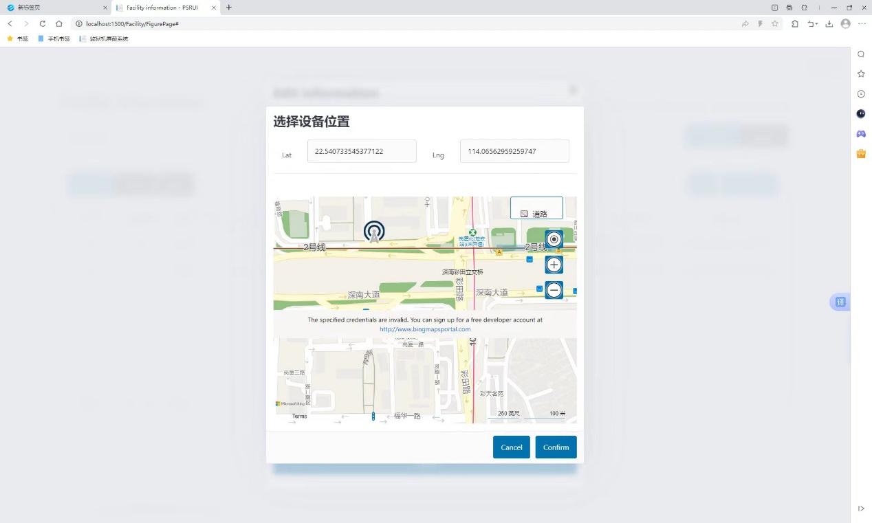
After adding the new device, enter the console settings interface.
Step 6: Click Setting to enter the console settings
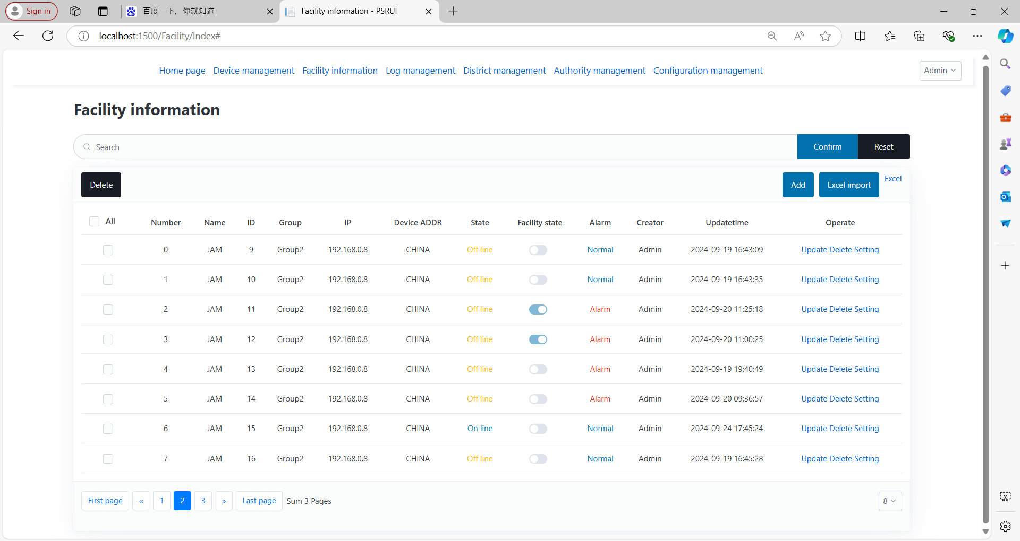
Console interface introduction: The first column contains the device's IP and port information, update date, full on/off, manual acquisition and automatic refresh functions; the second column contains the module's channel information, module frequency information, power settings and status, switch settings and status, power alarm, access control alarm, temperature alarm, and standing wave alarm.
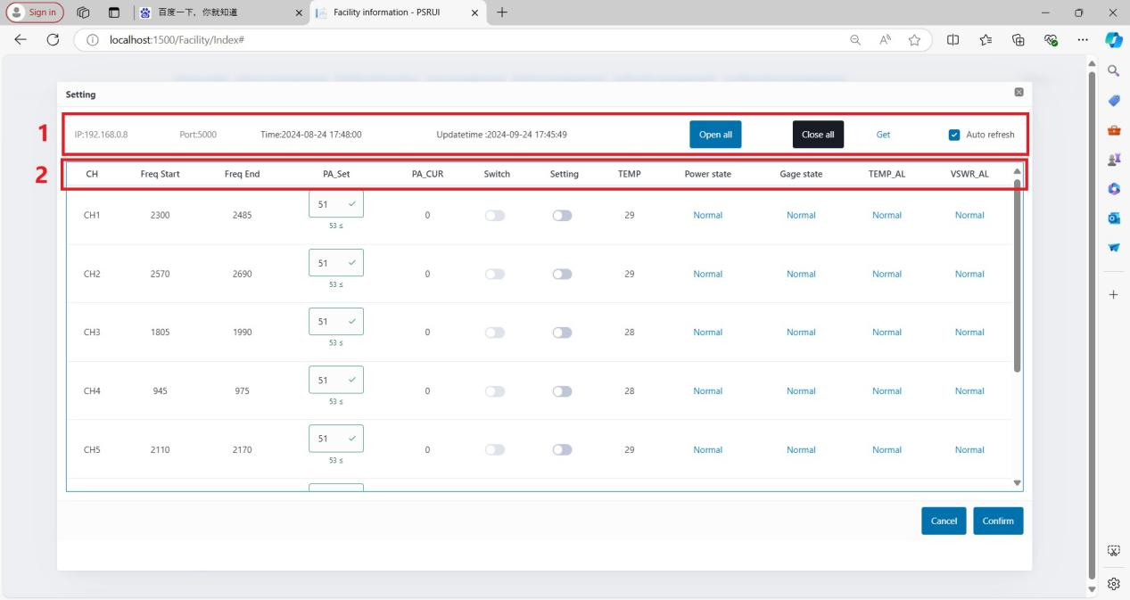
  - Console function test
    - Switch control and information acquisition function
You need to turn on a module, click the switch button corresponding to the module, click OK, check automatic update, and the control interface will automatically update the display module startup information (switch status and actual output power). The module enable light will light up, indicating that the module is turned on normally.
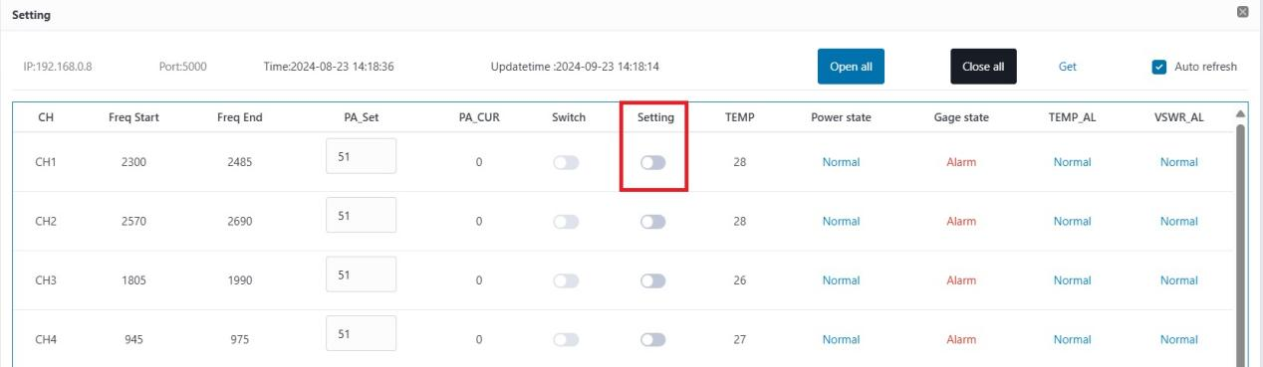
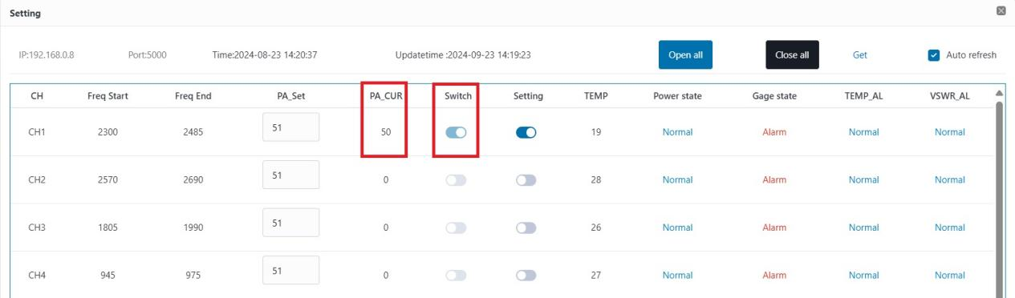
    - Power adjustment function
Input 47dB power, click OK, the module power status changes at the same time, indicating that the module power is adjustable
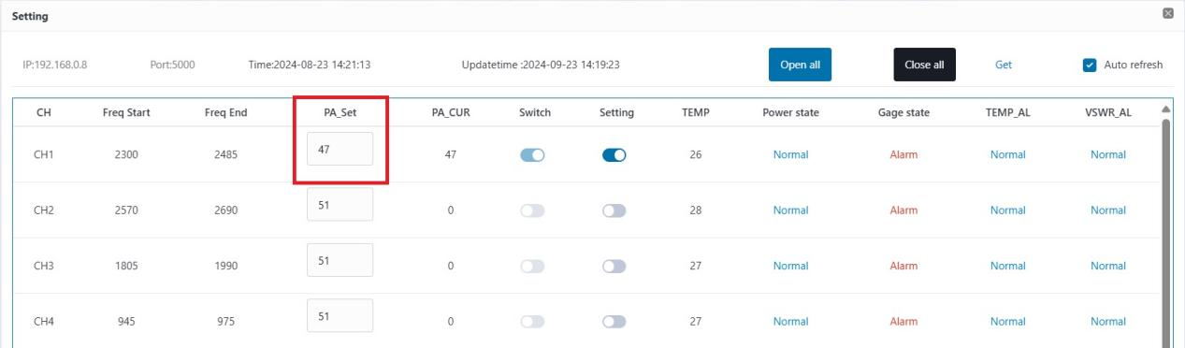
    - Access control alarm
The access control alarm function is to detect whether the top cover of the device is closed. When the top cover is closed, the access control function is displayed as normal. When the top cover is opened, it is displayed as an alarm.
When closed:
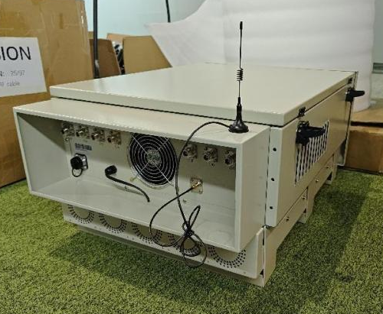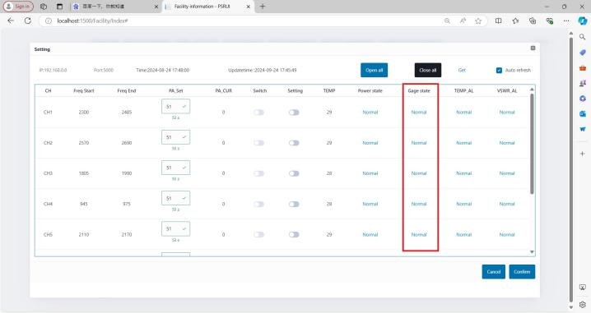
When open:
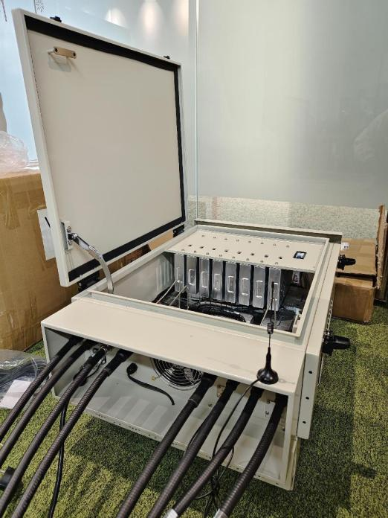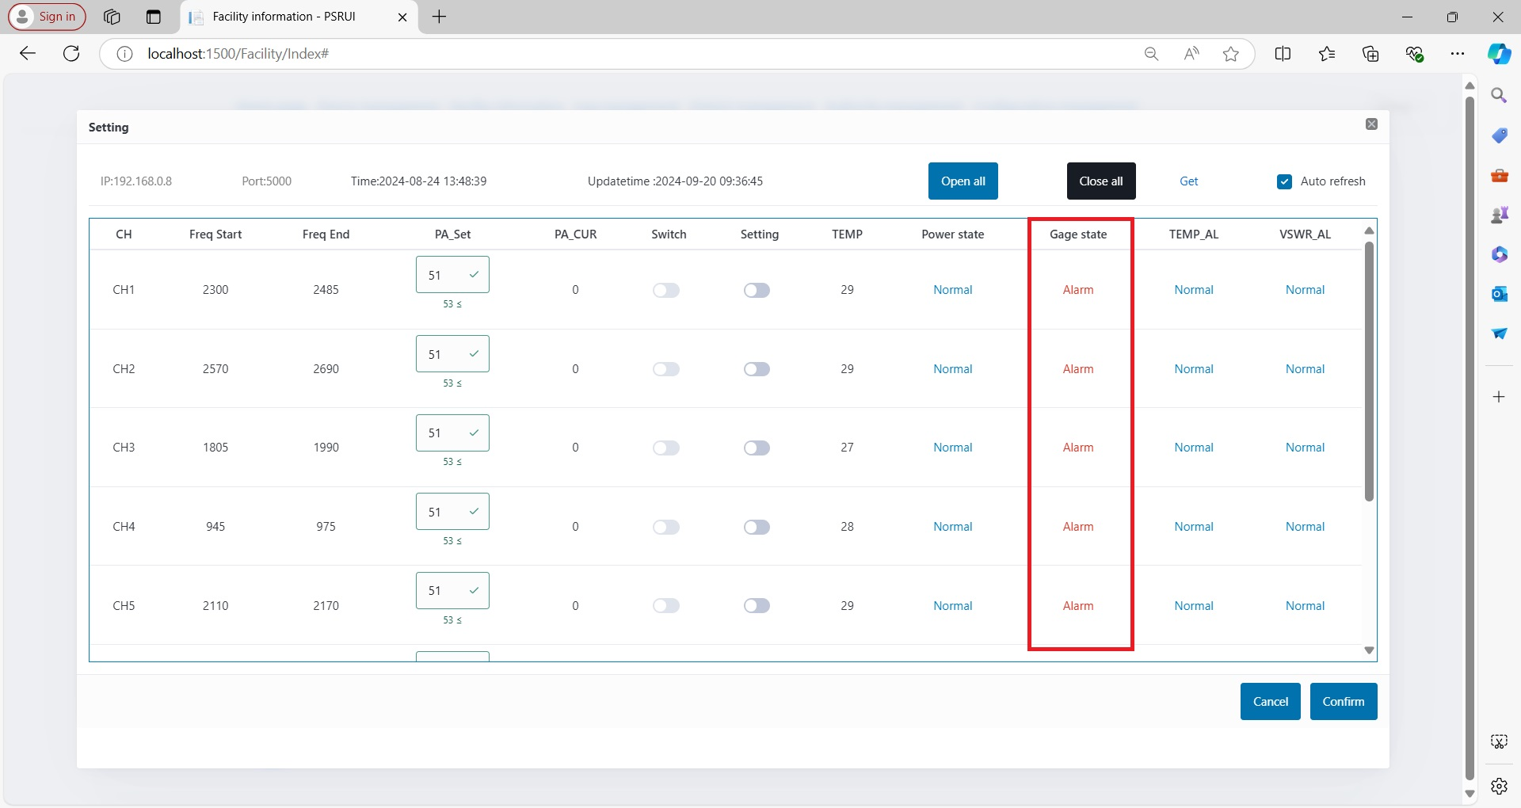
    - Other alarms
When an alarm occurs inside the device, you can see it in advance on the device information page, quickly lock the alarm device and take emergency measures. The following is a demonstration:
      - The equipment is normal
      - The device generates an alarm
      - Quick lock
  - Defense zone settings
The first step is to click District management to enter the defense zone editing page.
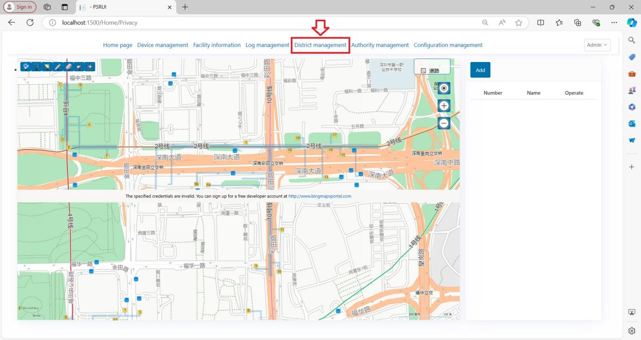
In the second step, click Add to add a new defense zone. The page for adding a new defense zone is shown as follows:
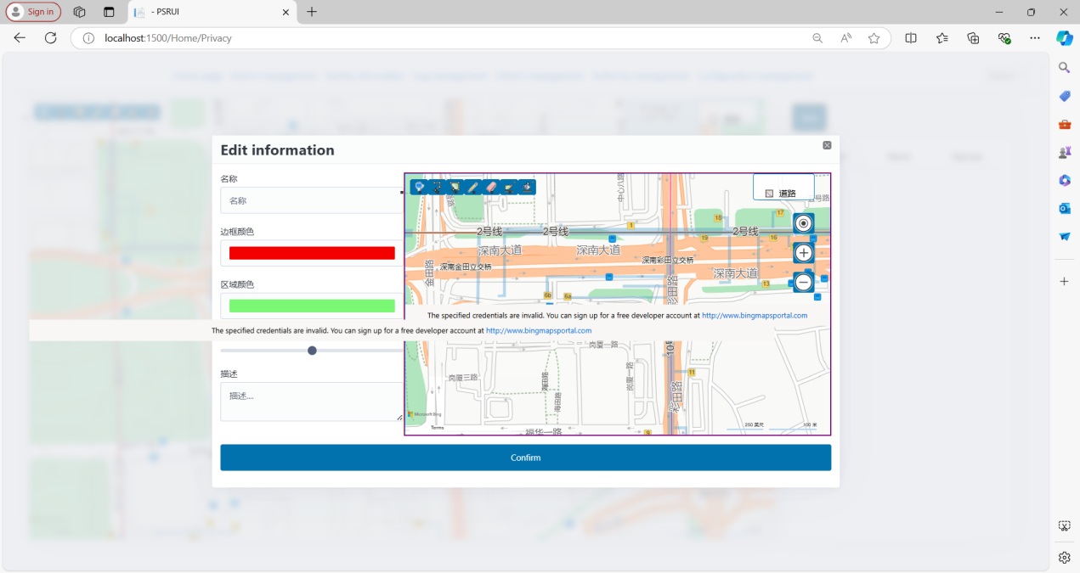
The third step is to complete the defense zone name, drawing range, and description. Click OK to display the defense zone on the map. (Drawing instructions: After drawing the range with the tool in the upper left corner, you need to double-click the left mouse button to complete the drawing.) The test results are shown in the figure:


