Dome-DET-3 User Manual

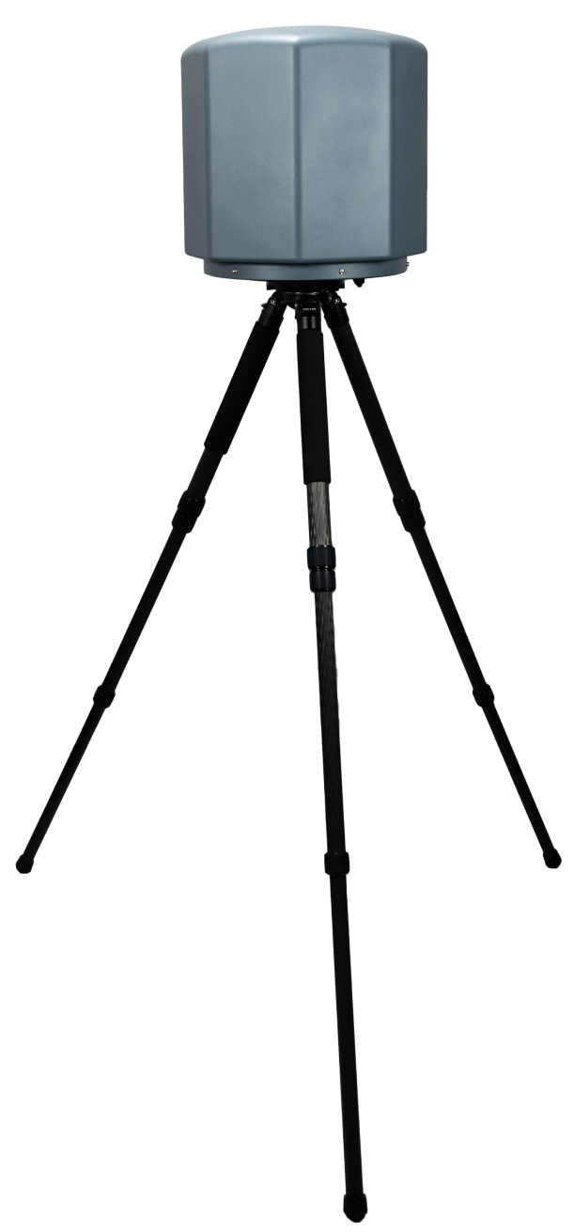

V1.1

Catalog
1. Functional Description 3
1.1. Basic Introduction 3
1.2. Characteristic 5
1.3. Specification 6
2. Installation 7
2.1. Lightning protection 7
2.2. Power Supply 8
2.3. Interface 8
3. Management Platform 9
3.1. System Initialization 9
Account: websuper 9
3.2. Drone Detection​ 10
Initial interface 10
3.3. Functional modules: 11
3.3.1. User Management 11
3.3.2. System Status 11
3.3.3. Query Report 12
3.3.4. System Settings 13
3.3.5. User Configuration 14
3.3.6. Interference Mode 14
3.3.7. Whitelist 14
4. Packing List 15

Functional Description

Basic Introduction

Dome-DET-3 is a wireless RF passive automatic detection system that supports 360-degree omnidirectional coverage. It has advanced warning, blacklist and whitelist functions, identity recognition, and supports automatic counter-drone defense systems. It uses a high-performance directional antenna and has drone direction finding capabilities.
Function | Description
Drone Detection | Dome-DET-3 can detect drones flying in a given area and obtain the broadcast GPS coordinates, flight altitude speed, direction, model, serial number and Home Point of each aircraft.  Number of drones inspected simultaneously: ≧ 60  Minimum detection altitude: ≤0 meters  Detection rate: ≧ 95%  Detection spectrum band: 900Mhz, wireless network, 2.4Ghz, 5.8Ghz
Automatic defense | Automatically jam drones when untrusted drones are detected. The jamming frequency is optional.
Whitelist and blacklist | Dome-DET-3 can identify ≧ 220 different types of drones except DJI series drones, and has the ability to learn autonomously. Dome-DET-3 can accurately identify targets, deeply analyze drone signals, identify unique IDs, and distinguish between blacklists and whitelists. Whitelists and blacklists can be set for different targets of the same location, same frequency band, same manufacturer, and same model of drones.
Interference defense | Dome-DET-3 has jamming capabilities of 900MHz, 1.5Ghz, 2.4ghz, and 5.8Ghz (customizable), covering most drone communications on the market.
Unattended operation/remote OAM | After turning on fully autonomous mobile defense, it can enter unattended mode, autonomous reconnaissance, autonomous strikes, and work with remote servers to provide a variety of OAM functions, including firmware updates, resets, status queries, self-tests, parameter configurations, etc.
GPS | Dome-DET-3 can use built-in GPS to detect its current location
Networking | Dome-DET-3 can connect multiple devices to the cloud server, observe the online/abnormal status of each device, and remotely control the device through the mobile terminal (mobile phone IPAD), including but not limited to viewing the device system operation interface, receiving alarm information, viewing black and white lists, and turning on the deployment function.
Environmental spectrum detection | Dome-DET-3 can scan environmental interference and provide installation references.
Data security | Certificate management and data encryption are used between the device and the server to ensure data reliability and security.

Characteristic
Functional Description
Long-range detection | In an interference-free environment, the signal reception range may vary when using different antennas. When using an omnidirectional enhanced antenna unit, the detection range can reach 10 kilometers.
Drone location | Locate the drone and controller in real time, capture the home view of the DJI drone, and the positioning range can reach 3km.
All-round protection | Based on the two-dimensional turntable, PS Dome-DET-3 has a horizontal 360° omnidirectional interference handling capability, and the minimum interference range can reach 1-2km.
Networking | Support Ethernet and 2G/3G/4G wireless networks.
Proven technology | PS Dome-DET-3 adopts an integrated design. A two-dimensional turntable is set at the bottom of the jammer. The jammer power amplifier, multi-frequency antenna, and control panel are all integrated in one cavity. Compared with radar detection systems and optoelectronic detection equipment, PS Dome-DET-3 does not have technical loopholes in radar detection of drones and is less affected by the environment.
Easy installation | PS Dome-DET-3 can be installed and configured within 15 minutes. The device is installed with a fixed pole plus a tripod, which can meet the protection needs of long-term deployment in key areas.
Error management | When a recoverable software error occurs, the device will reset; when an unrecoverable software error or hardware error occurs, the device will issue a fault warning.

Specification
Size​ | 380mm x 180 mm x 180mm
Detection frequency | 9 00MHz、2.4GHz、5.8GHz
Weight | 10kg
Power consumption | 300W
Protection rating | IP65
Operating temperature | -25℃~+55℃
Power supply | AC 100~240V，50/60Hz

Installation

Lightning protection

If the Dome-DET-3 is not in the Dome-DET-3 Fixed Unit System, surge protection modules are included in the antenna module, power module and Ethernet port. The Dome-DET-3 does not include a lightning sensing system. It should be installed within the protection area of another lightning sensing system. The protection area is calculated using the rolling ball method.

The lightning sensing system specified should be designed by a qualified professional to protect the nearest lightning rod.

Finally, please pay attention to the following points:
- Make sure that rainwater does not flow into the Dome-DET-3 along the antenna cable.
- If the pole is made of metal, the frame and pole should be separated by an insulation layer.
- Indoor power sockets must have surge protection.
- Indoor Ethernet sockets must have surge protection.

Power Supply

The Dome-DET-3 is designed to operate at 100~240 V, 50/60Hz, 2.5A Max, and 50W in detection mode.

The Dome-DET-3 Power Cord is used to connect the PS Dome-DET-3 fixture to a power source. It can also operate with DC power if needed.

Interface

There are five interfaces under the device, corresponding to:
1) LAN port: used for local area network (LAN) connection; by default, we insert the network cable into this port.
2) WAN port: used to access the cloud server. This port must be connected through the company's internal network and is not recommended for general use.
3) RF: used for suppliers to debug the device. Customers do not need to use this port.
4) AC IN: power port: please insert the power cord into this port.
5) J AM: used to connect the jammer, connect the jammer box to jam the drone.
6) The power button is the power on/off switch.

Management Platform

System Initialization
Please enter the login URL on your computer browser: http://169.254.1.1:8081
Then, enter your account and password on the website

Account: websuper
Password(default):ddp123&*(

If you are unable to log in, please wait patiently for 2-3 minutes and
check whether the network cable is plugged into the "LAN port"

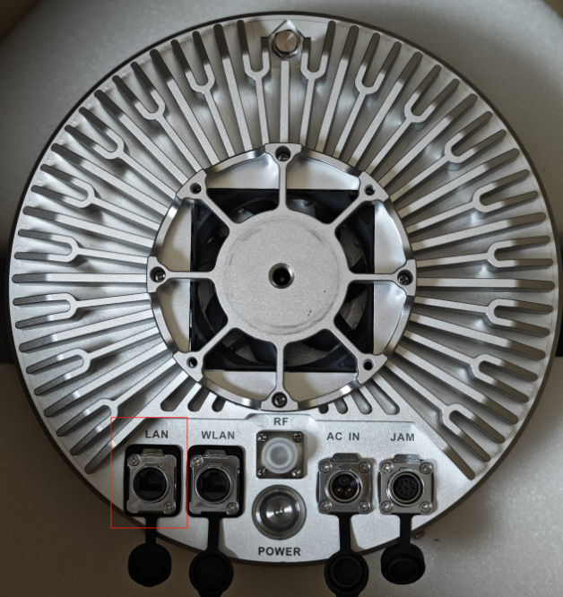

Drone Detection​
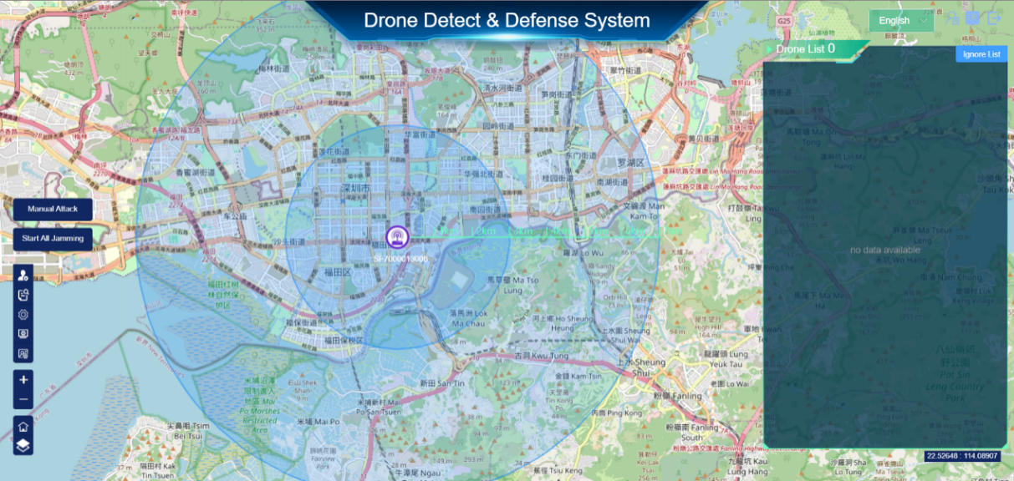

Initial interface
When the device detects a drone, an alarm will sound and the system page will display information about nearby drones.

The detection description includes the following information:
- The frequency band the drone is operating on.
- Drone model
- The approximate azimuth of the drone
When the signal is strong enough, the device will recognize the drone's GPS signal and display it in the drone list.
- The coordinates of the target drone
- The exact angle of the drone
- The drone's unique identification code
- The distance between the drone and the device
- The frequency band the drone is operating on

Icon explanations:
Indicates the change in the detection signal;
Indicates that it has been added to the whitelist;
Indicates that it has not been added to the whitelist;
Precision strike;
Indicates that the drone supports precision strikes. No icon indicates that the drone does not support precision strikes.;
Indicates that the drone supports adding to the ignore list. No icon indicates that the drone does not support adding to the ignore list.

The map will update the drone's location, trajectory, and status in real time and associate it with the drone list. When you click a drone icon, the drone will be selected in the list. When an item in the list is selected, the drone will appear on the map.
Indicates the drone detection target;
Indicates the location of the target (the drone has a GPS location);
Represents a fuzzy target;
Indicates that it belongs to the white list target;

Functional modules:

User Management
Click this button to enter the system settings.
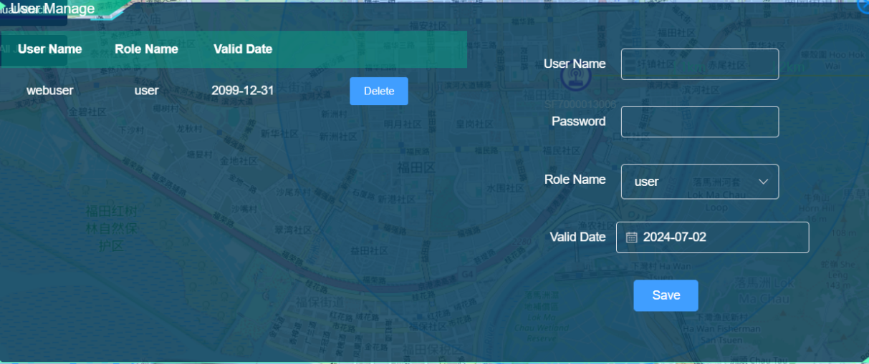
Add user: You can add a new login account and password and assign the corresponding permission level. Super is the highest permission, admin is the administrator permission, and user is a common user who can only view but not operate. Users can change permissions according to their needs.

Delete user: You can click the Delete button in the list to delete a user.

System Status
Click this button to enter the system settings;
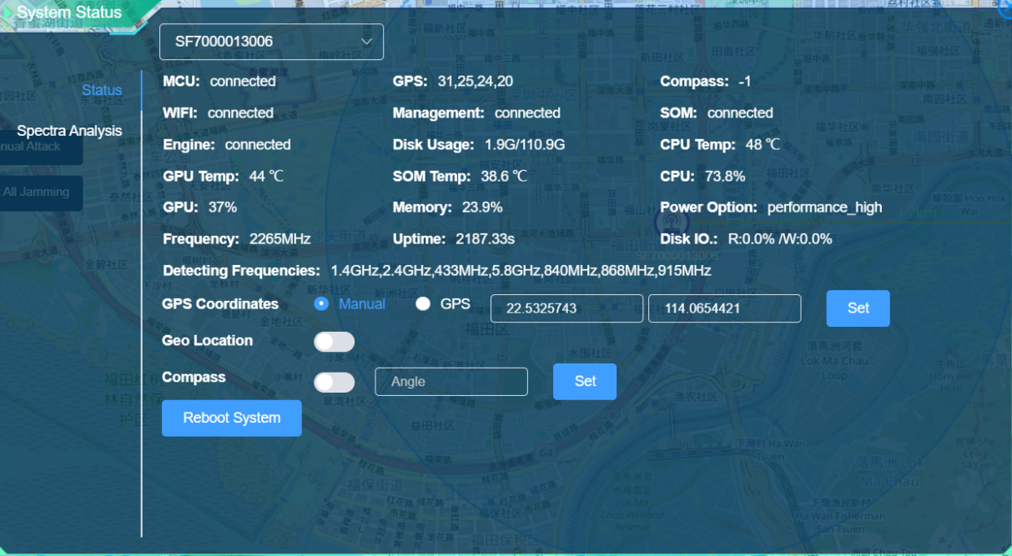
The system status includes the status information of built-in devices such as MCU, GPS, compass, WIFI, Management, SOM, Engine, CPU temperature, GPU temperature, SOM temperature, disk space, detection frequency, etc.

Geolocation: Switching to the blue state means that the function is enabled and the location can be analyzed, but the detection of some models will be lost; switching to the gray state means that the function is disabled, which can enhance the sensitivity of detection for other models, but the location cannot be analyzed.
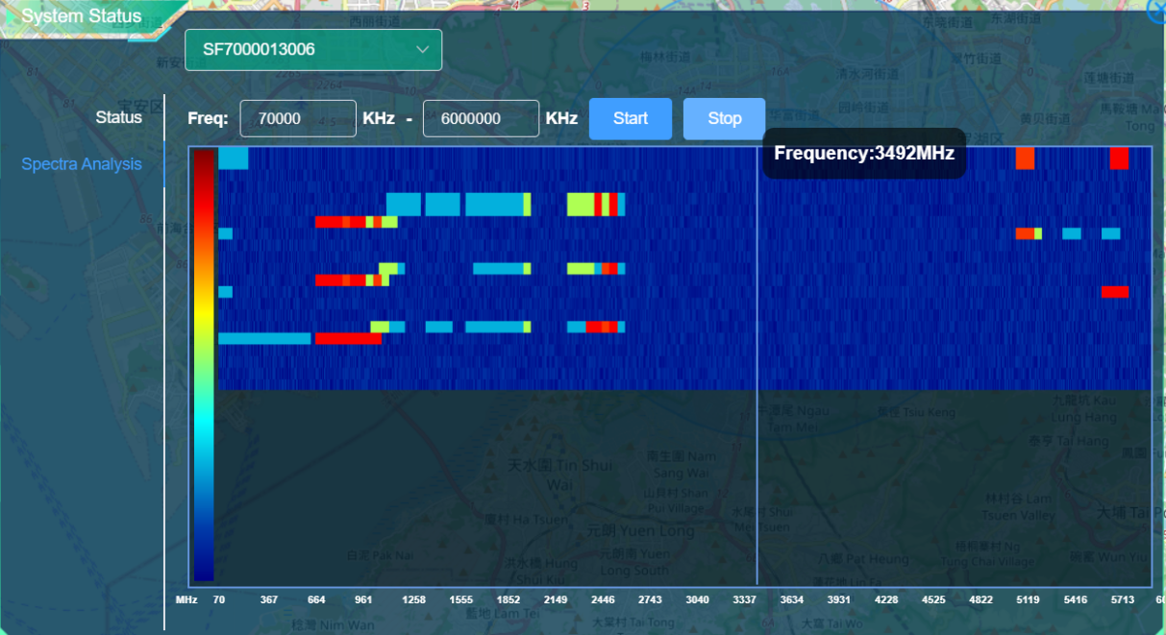
The spectrum analysis mode is used to analyze the environment around the device and obtain the spectrum of the surrounding signals through an independent algorithm.

Query Report
Click this button to enter the query report
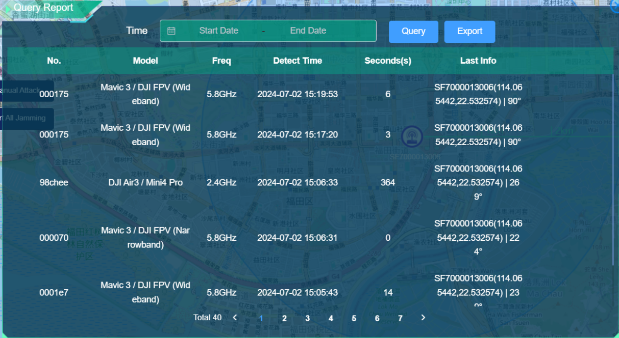
In the report, you can view the detection count of the device, view each entry and access data analysis charts. Similarly, you can also view the number of drone defense instances.

System Settings
Click this button to enter the system settings
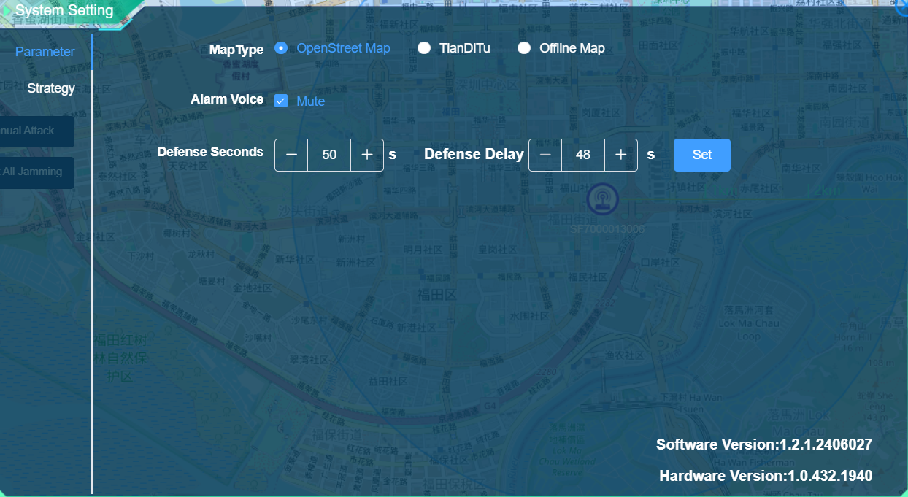
In this mode you can switch map types and adjust the alarm sound on/off.

Please note: Openstreet Maps requires VPN connection, if you don't use VPN, please choose Tiandi Maps
Please note: Openstreet Maps requires VPN connection, if you don't use VPN, please choose Tiandi Maps

User Configuration
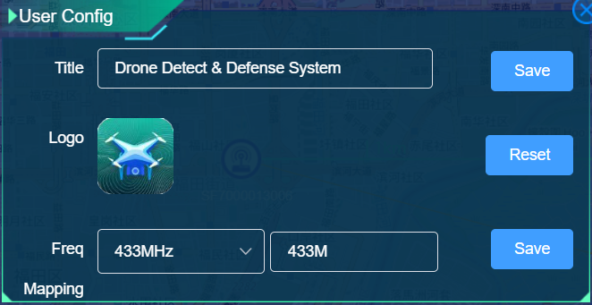
Click the button in the upper right corner to open the user configuration interface, where you can modify the system title and logo. Click the "Reset" button to reset the title and logo to the default value. Select the Freq item to change the Freq display value, and click the "Save" button. A prompt will pop up asking whether to restart the device. Generally, restart the device after the modification is completed.

Interference Mode
Click the device icon to enter the Interference mode
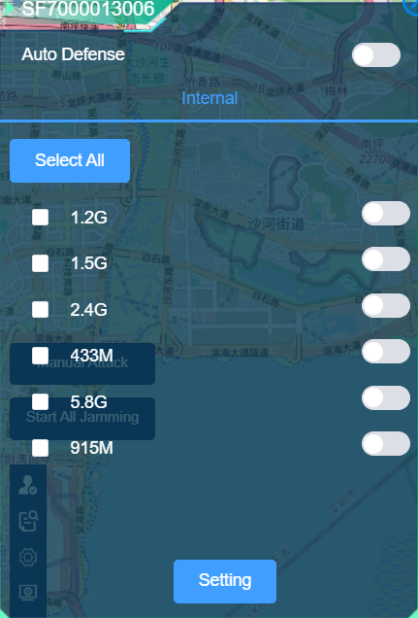
The interference mode contains supported interference frequency bands, which can be freely selected in combination. The automatic defense function (unattended) can also be turned on here.

Whitelist
Click this button to enter the whitelist
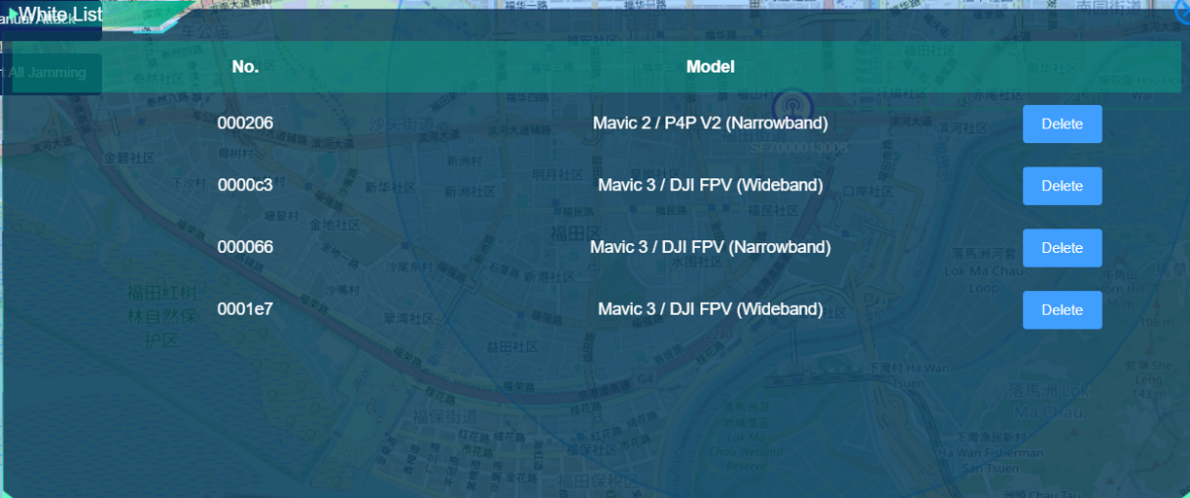
You can add your own drone to the whitelist so that the device will not warn your device. The whitelist list mainly displays the drone number and model, and you can delete the whitelist in the list by clicking the delete button in the list.

Packing List
- Dome-DET-3 detector * 1
- Tripod * 1
- Data cable * 1
- Power cable * 1
- Network cable * 1

