Handheld Drone Passive Detection System
Hummingbird-DET-2
Technical Data Sheet

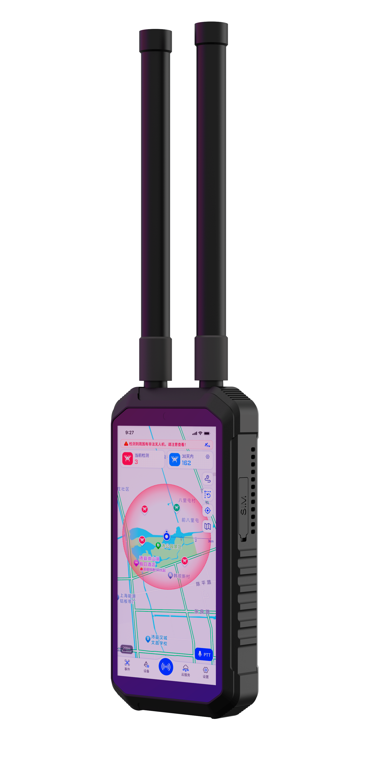

PRODUCT OVERVIEW
Figure 1. Hummingbird-DET-2 | Based on CRPC 2.0 technology, it adopts a deeper data chain decoding solution to analyze and extract real-time flight attribute information from data in specific formats, and accurately identifies the drone’s graphic and video stream, serial number, geo-location, trajectory, altitude, speed and remote control position, etc., to detect, identify and locate the unauthorized drones more quickly and accurately. The device has an integrated design, small in size, light in weight, and easy to carry, which is suitable for all kinds of single-soldier low-altitude protection.

KEY FEATURES

Passive Detection: Passively receives only, does not emit any electromagnetic signals, no impact on the surrounding environment.
Precise Identification: Precisely identify the SN, model, geo-location, speed, altitude, trajectory, and remote controller information of the drones in real time.
Trajectory Tracking: Multi-target trajectory tracking, pilot (remote control) tracking.
Position Navigation: Detect the pilot’s (remote control) position in real-time, one-click to track the pilot and the drone.
Black and White List: One-click to mark the whitelist, there will be no alarm for white-listed drones.
Network Management: Support network access to the control platform, to achieve multi-device collaboration, and to achieve a wide range of prevention and control scenarios.
Analog Video Transmission: The system can provide a live FPV stream of detection, identification, and real-time video transmission.
Compact and Portable: Light in weight and small in size. Portable, shockproof and drop-proof.

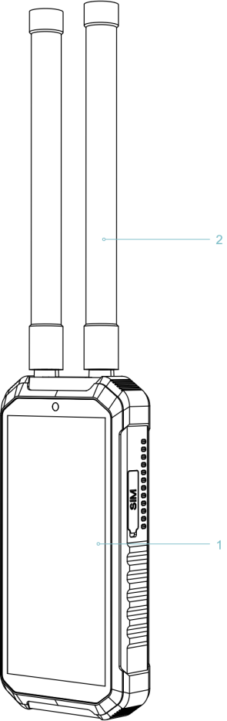
1. Main unit | 2. Antennas
Dimensions: 177mm × 89mm × 29.5mm

Figure 2. Hummingbird-DET-2 Appearance
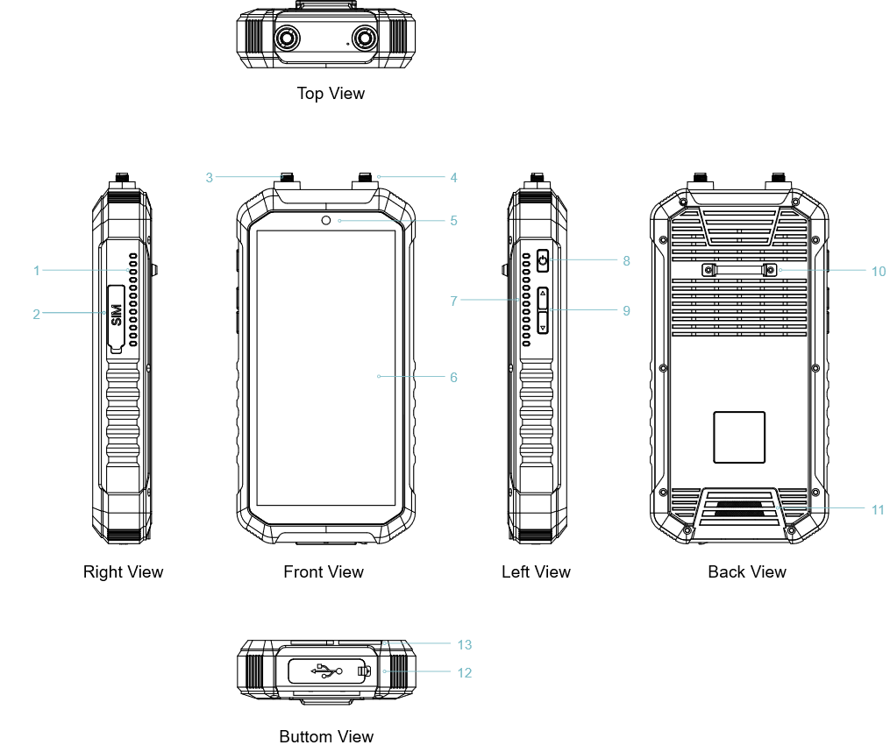
1. Ventilation Holes | 8. Power On/Off Button
2. SIM Card Slot | 9. Volume Keys
3. Wi-Fi Detection Antenna Port | 10. Wristband Mount
4. Full-band Detection Antenna Port | 11. Speaker
5. Front Camera | 12. Type-C Port & 3.5mm Audio Jack
6. Touch Screen | 13. Wristband Slot
7. Ventilation Holes
Figure 3. Diagram of the ports

PACKAGING INFORMATION
Packaging Dimensions | Specifications
Device Dimensions | 177mm × 89mm × 29.5mm
Packaging Dimensions | 375mm × 310mm × 115mm
Weight | ≤3.5kg
Packaging Method | Packaging Box
*The packaging information is for your reference only.

TECHNICAL SPECIFICATIONS
Detection Bands (Customizable) | 800MHz&900MHz, 1.2GHz, 2.4GHz, 5.2GHz&5.8GHz, Wi-Fi
Detection Distance | 0~3km(Differences exist due to different environments and drone types)
Sensitivity | -95dBm
Position Accuracy | ≤3m (RMS)
Detection Quantity | ≥15 Drones (Simultaneous)
Number of Trajectories Tracking | ≥11 Drones (Simultaneous)
Response Time | ≤5s
Dynamic Detection | 0~80km/h (Vehicle speed)
Power Supply | Built-in lithium battery
Battery Capacity | 12000mAh
Charging Power | Charging Input: DC 12V, 2~3A  Fast Charging Supports Power Delivery 3.0 (PD 3.0)
Charging Time | ≤3 hours (0% to 100%, powered off)  ≤4 hours (0% to100%, during operation)
Power Consumption | ≤15W
Continuous Runtime | ≥4h (Support charging while using)
Dimensions | 177mm × 89mm × 29.5mm
Screen Size | 6.0 inch
Weight | ≤580g (±0.05kg, without antenna)  ≤46g per antenna
Operating Temperature | -25℃ to +65℃

