Chariot-CM Trolley-Case Type Drone Jammer
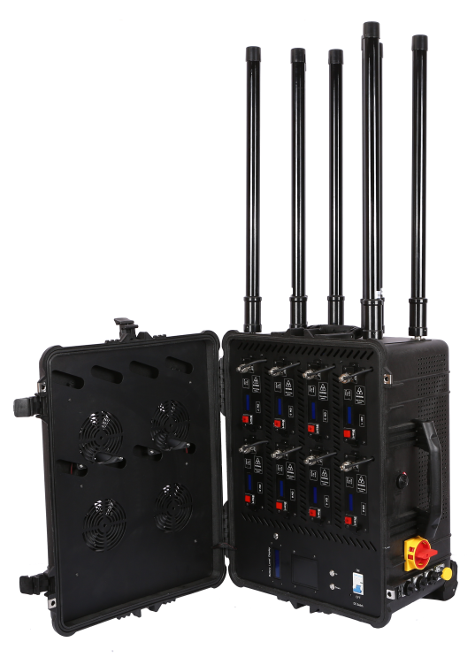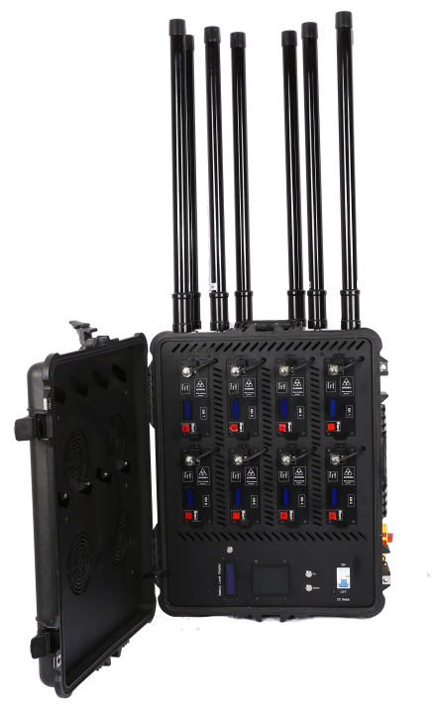

Catalog
Product Introduction: 1
Functional features: 1
⚠Risk warning: 1
The device is available in four channel quantities: 2
Jamming Frequency: 3
Specifications: 3
Size： 4
Packing List: 5
Device Description: 6
How to use: 9
Module Replacement: 9
Appendix: Software Instructions 10
Appendix: Parameters of DPA15512560 14

Product Introduction:
Trolley Case Type Jammer is designed for portable deployment. The body shell is made of Pelican protective trolley case with four ventilation holes. It is sturdy and reliable, and can effectively meet the needs of drone countermeasures for various flexible special missions. It can be installed with eight or more high-power channels, and the countermeasure range reaches 2km to 3km. It is suitable for key drone security fields such as important meetings, cultural and sports activities, special bomb disposal, border inspections, etc.

Functional features:
Omnidirectional transmission: omnidirectional transmission of radio blocking signals, taking into account the needs of multi-directional protection;
Flexible and convenient: portable design, light equipment, simple operation, high maneuverability;
Strong endurance: built-in high-quality battery, long service life;
Multi-band countermeasures: can counter the communication, image transmission, and navigation links of various drones;

⚠Risk warning:
- It is forbidden to use the device outdoors in thunderstorms
- It is forbidden to put the device near fire
- It is forbidden to disassemble the device when it is powered on
- Avoid the device from falling into water or liquid flowing into it
- Avoid serious collisions with the device to prevent the internal lithium battery from burning
- Before turning on the device, check whether the antenna has been fully connected to the corresponding interface
- When the device is turned on, patients wearing implantable electronic therapeutic devices (such as pacemakers) should strictly keep a distance of more than 10 meters from the device

The device is available in four channel quantities:
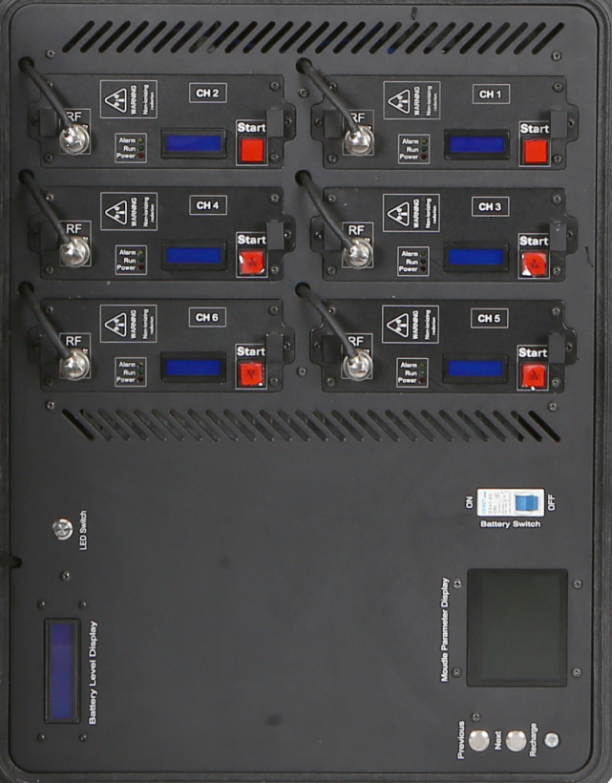 | 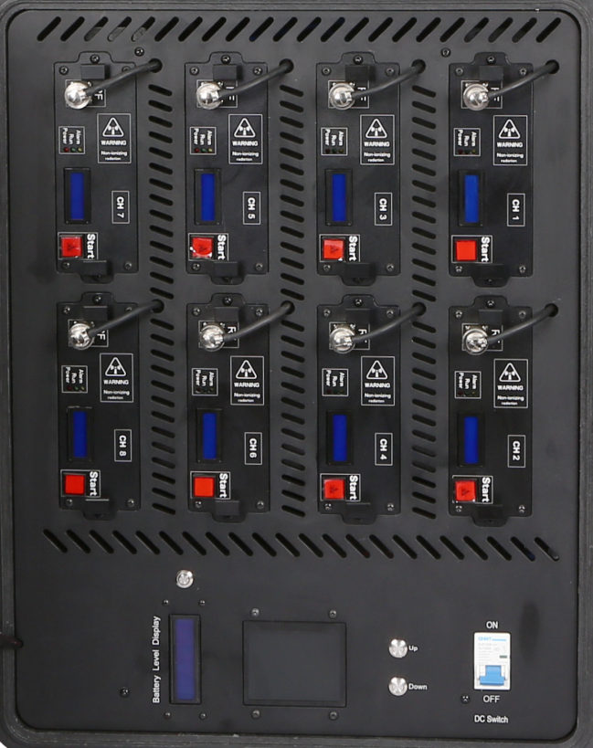
6-channel version panel | 8-channel version panel
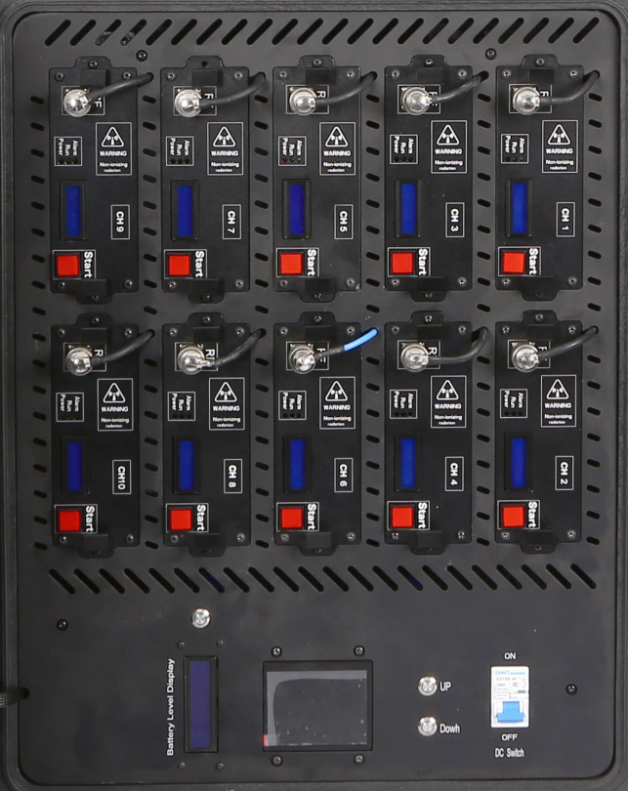 | 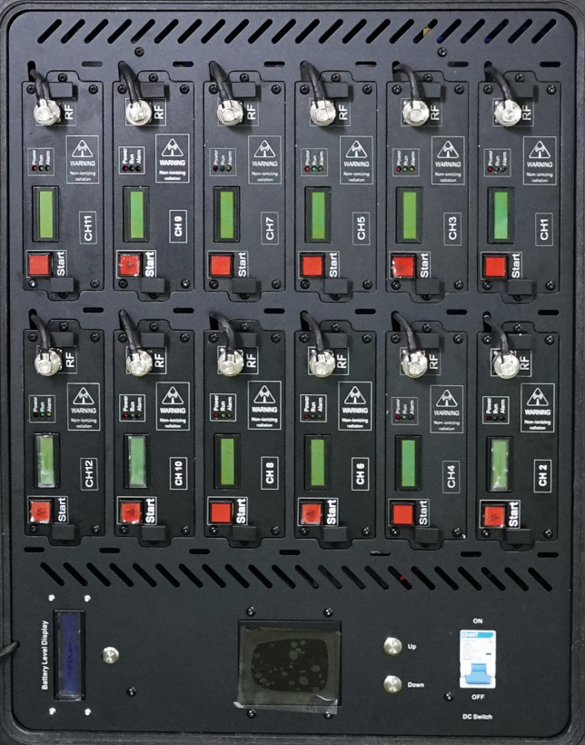
10-channel version panel | 12-channel version panel

Jamming Frequency:
Channels | Frequency(MHz) | Signal Source | RF Out Power
CH1 | 430-440 | DDS | 50W
CH2 | 840-930 | DDS | 50W
CH3 | 1170-1280 | DDS | 50W
CH4 | 1430-1444 | DDS | 50W
CH5 | 1560-1620 | DDS | 50W
CH6 | 2400-2485 | DDS | 100W
CH7 | 5150-5350 | DDS | 80W
CH8 | 5725-5850 | DDS | 80W
Note: This table is a typical interference frequency table for 8-channel equipment. The number of channels and interference parameters of the actual finished product need to be confirmed after communication with the customer.

Specifications:
Interference distance | - Mavic 2, OcuSync 2.0, effective jamming distance ≥ 2000m;  - DJI Mavic 3 Classic, OcuSync 3+, effective jamming distance about 1000m~1500m, jamming communication ratio about 3:2;  - DJI Air 3S, OcuSync 4, effective jamming distance about 800m~1200m, jamming communication ratio about 1:1  Note: The above data is measured in a normal interference environment in a city 2000m away from the jammer, with the remote controller and the drone taking off at the same place. The effective jamming distance (the drone image transmission and remote controller signals are completely interrupted and trigger the return) is not guaranteed, and is only used as a distance reference for users when jamming the drone.
Antenna size | 60*2cm
Antenna type | 8 high-gain omnidirectional antennas
Power supply method | Power supply: AC 220V  Internal lithium battery: DC 28V
Weight | 6-Channels:36kg;  8-Channels:45kg;  10-Channels:49kg;  12-Channels:53kg
Temperature/humidity | -20℃-+50℃/≤80%
Complete machine reliability | MTBF no less than 1000 hours
System response time | No more than 30 seconds (from power on to normal system operation)
Software | DDS Radio Equipment Config V1.03

Size：
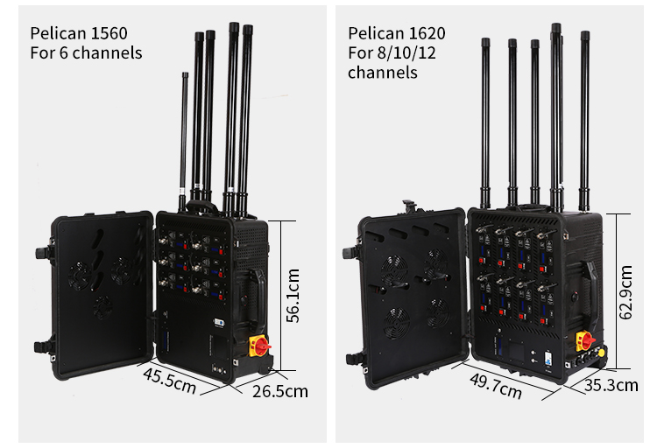

Packing List:
Product | Quantity | Picture
Device | 1 | 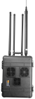
Wire control box | 1 | 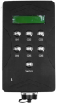
European standard AC power cord | 1 | 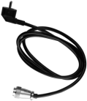
Wire control box connection cable | 1 | 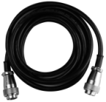
Charging power adapter | 1 | 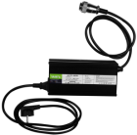
Omnidirectional fiberglass antenna | 8

Device Description:
(The demonstration picture takes the 12-channel device as an example, and the functions are the same as those of the 6-channel, 8-channel, and 10-channel devices)

Side:
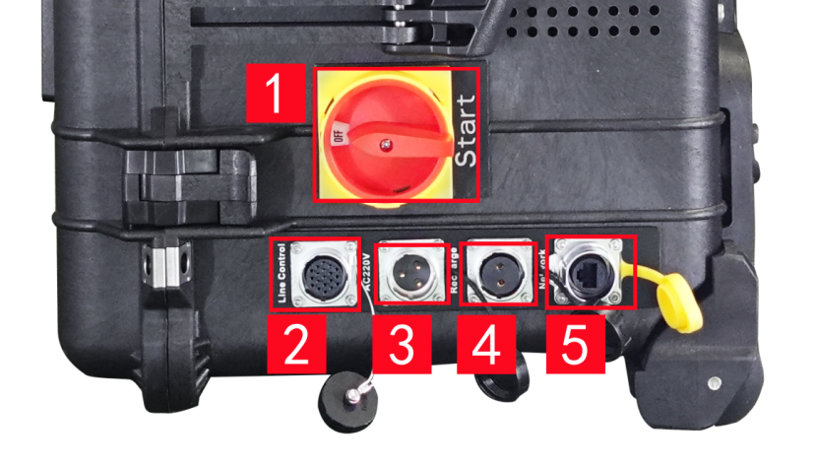
- Device power switch;
- Cable control box interface;
- Device power interface, externally connected to AC220V, directly powered by AC power; (This interface cannot charge the device battery)
- Device battery charging interface;
- RJ45 network interface

Top:
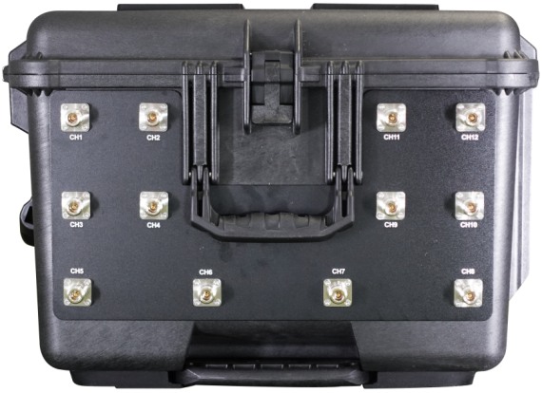

The top is the RF output connector

Module Panel:
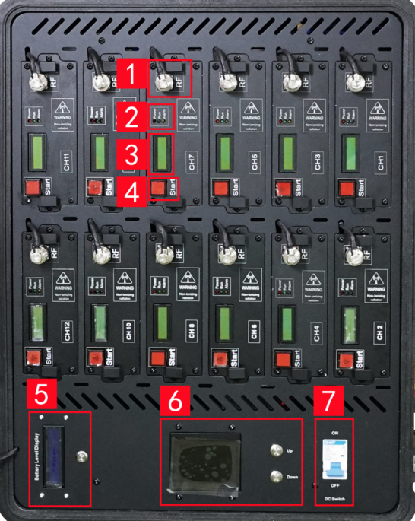
1. Feeder connector
2. Module operation indicator
3. Module frequency band and power display
4. Module switch
5. Whole machine power display and switch
6. Whole machine parameter display and page turning button
7. Battery switch (it is recommended to turn off this switch when using AC 220V power supply)

Wire control box:
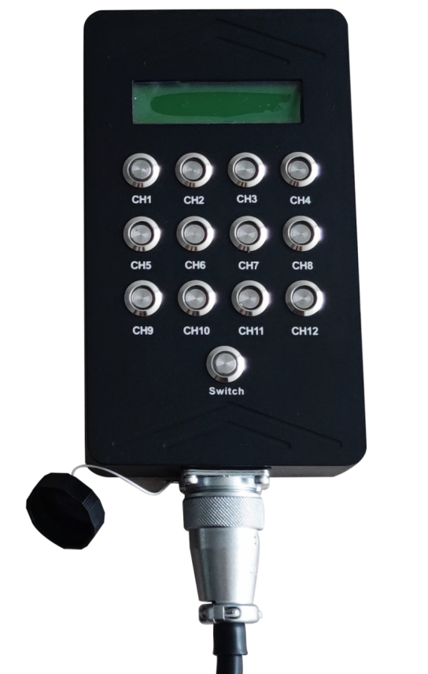

The Switch button in the wire control box is the main switch of the wire control box. Other buttons can be controlled only after the main switch is turned on.

How to use:
- Stand the device up, with the RF output interface facing upwards, and place it vertically on the ground;
- Insert all omnidirectional antennas into the corresponding interfaces, and tighten the nuts on the antenna interfaces;
- Connect to the wire control box;
- If powered by AC power, directly connect the power cord to the AC220V interface;
- If powered by battery, please make sure that the battery has sufficient power;
- Turn on the power switch of the chassis;
- Turn on the corresponding channel switch through the wire control box as needed;
- After use, the device should be powered off first, and then the antenna should be removed.

Module Replacement:
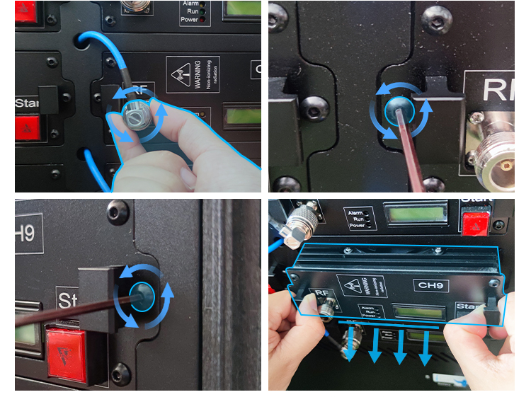
After unscrewing the screws on both sides of the feeder connector and the module, the module can be disassembled and replaced.

Appendix: Software Instructions
- Type Control Panel and open the Control Panel app from the results.
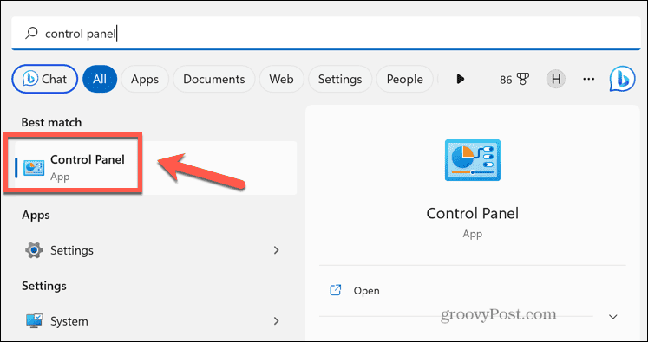
- Select Network and Internet.
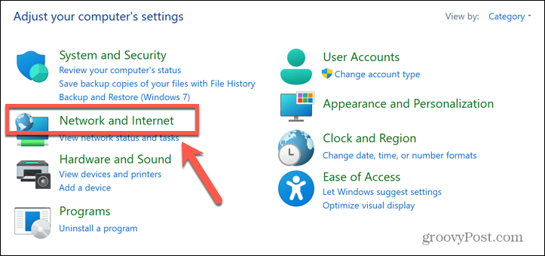
- Click Network and Sharing Center.
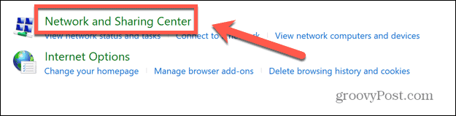

- In the left-hand menu, click Change Adapter Settings.
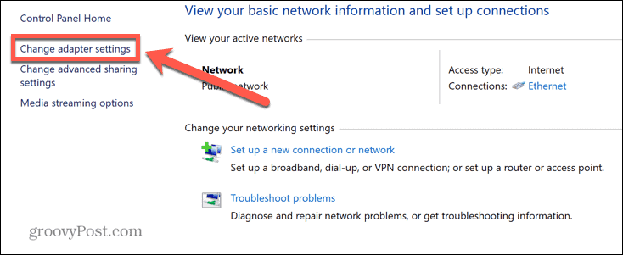
- Right-click on your network adapter and select Properties.
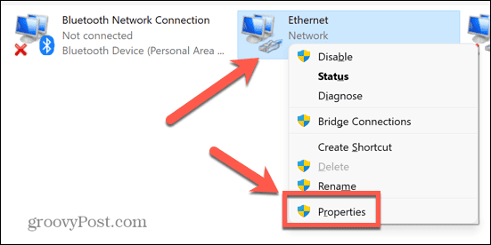
- Double click Internet Protocol Version 4 (TCP/IPv4).
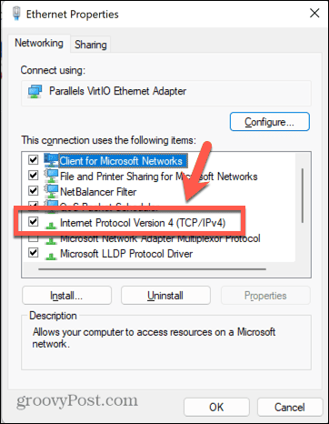
- Select Use the Following IP Address and Set the following options:
IP address: 192.168.0.X (X≠0/1/7)
Subnet mask: 255.255.255.0
Default gateway: 192.168.0.1
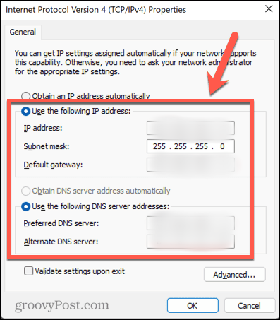
- Click OK.
- Open the software, confirm that the IP address in the text box on the left of "Set IP" is "192.168.0.7", then click "Search", "Connect", and "Inquiry" in sequence to view all current DDS modules.
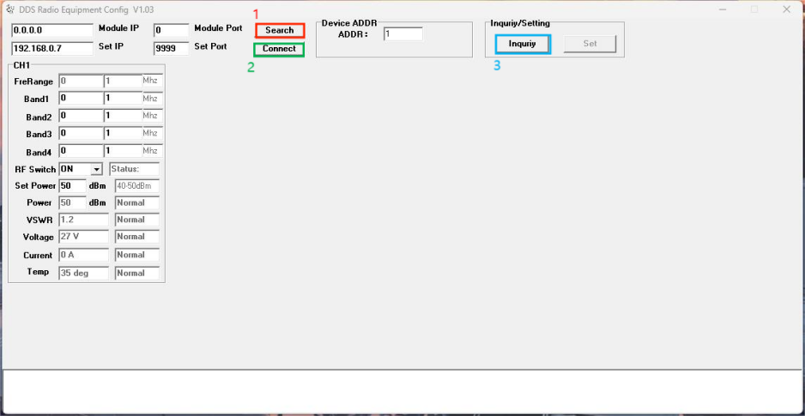

- FreRange will show the maximum bandwidth of the module. Band1-4 allows the user to set up to four sub-bands for the module. RF Switch can turn the module on or off. After changing the settings, click "Set" to apply.
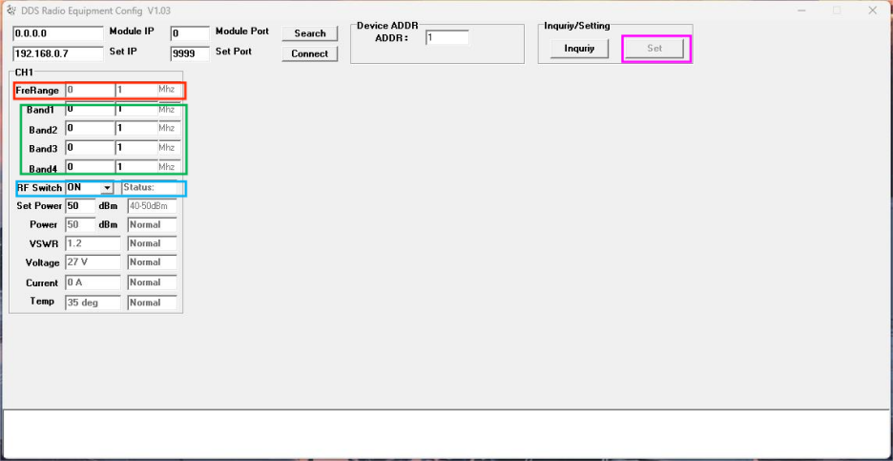

Appendix: Parameters of the RF module DPA15512560 used by the device
DPA15512560
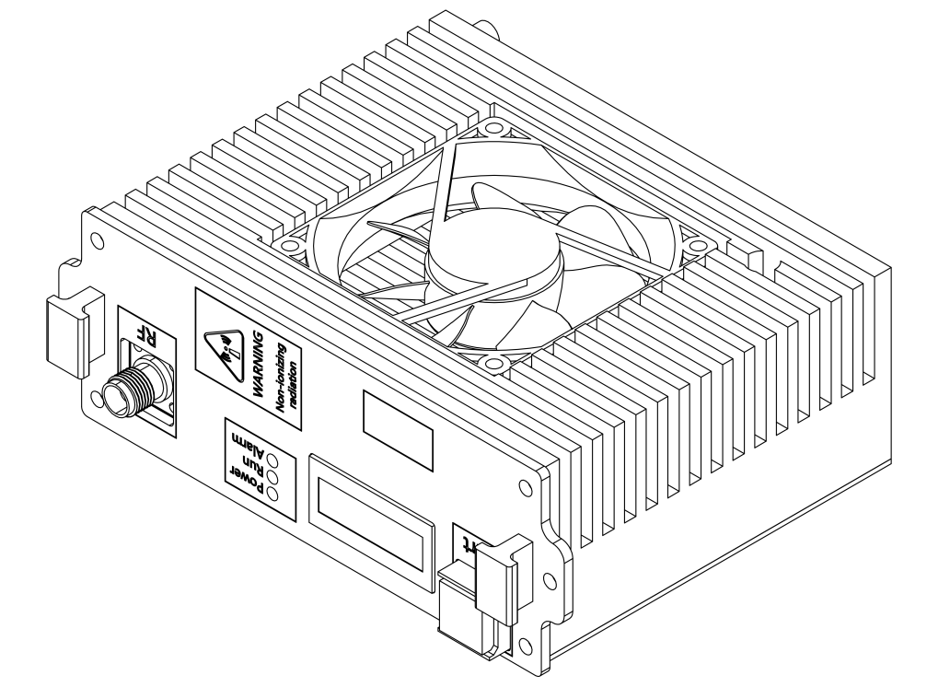
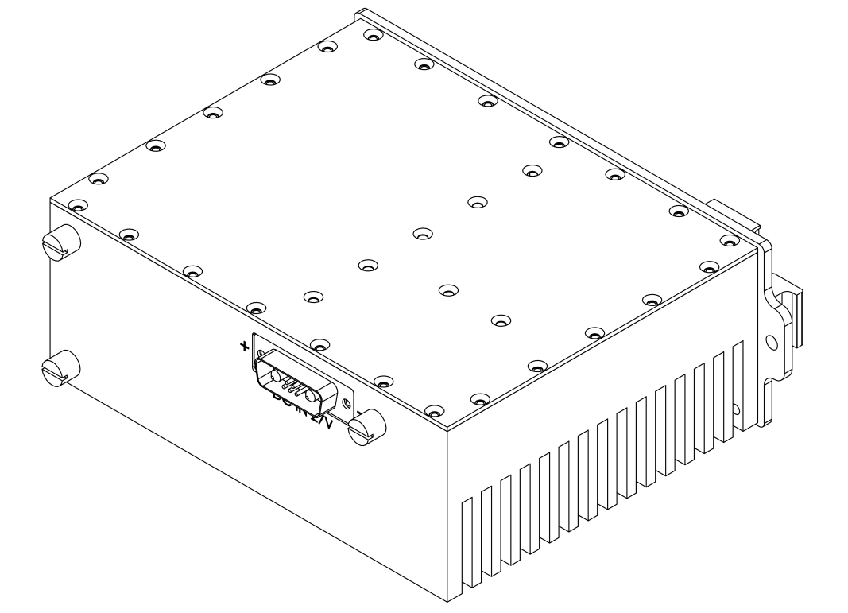

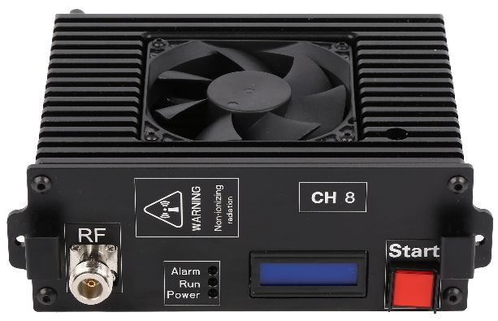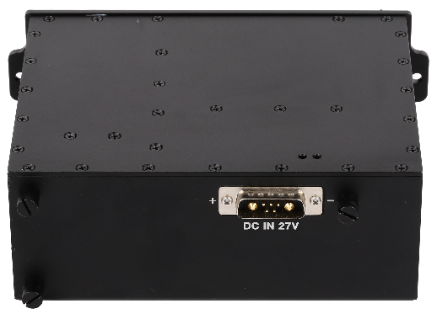

Introduction
This module is developed based on SDR (Software-defined Radio) technology, generating and amplifying a maximum bandwidth of about 300MHz between 20MHz and 6GHz.
Application range: Signal jammer for wireless communication products such as mobile phones/walkie-talkies/RC Drone/RC Car/RC Boat.

Produce Range
Supported Frequency Range (MHz) | Max Bandwidth (MHz) | Max Power (W)
20-100 | 80 | 100
100-500 | 250 | 100
700-1000 | 300 | 100
1000-1400 | 300 | 70
1400-1550 | 150 | 70
1550-1990 | 300 | 100
2010-2700 | 300 | 100
3300-3600 | 300 | 80
4800-6000 | 300 | 50

Note: The "Supported Frequency Range (MHz)" in this table is not the actual output frequency band of a single module. It is the production range supported by the module. The actual interference frequency band of the module is included in the "Supported Frequency Range (MHz)" and is limited by the "Maximum Bandwidth (MHz)".

Radio Frequency Indicators
Test items |  |  |  |  | Indicator | Remark
Operating Voltage |  |  |  |  | 28V | 28-30V
Conversion Efficiency |  |  |  |  | ≥42% | @100W Typical
Controllable Output Power |  |  |  |  | 10W～Actual maximum power | Software-configurable power
ALC Power Adjustment Range |  |  |  |  | ≥30dB | Voltage-Controlled Attenuation
Gain |  |  |  |  | 50±1.0dB
In-band Fluctuation |  |  |  |  | ≤2.5dB | Peak-to-peak value
Spurious Emission | In-band |  |  |  | ≤-15dBm/1MHz | Measure at the center frequency with CW signal at maximum output power
Spurious Emission | Out-of-band |  | 9KHz～1GHz |  | No higher than normal background noise and interference
Spurious Emission |  |  | 1G～12.75GHz |  | No higher than normal background noise and interference
Maximum Allowable Input Power |  |  |  |  | ≥+10dBm | Lasts 1min without damage
Input VSWR |  |  |  |  | ≤1.35 | Add +28V, standard network output -10dBm
Output VSWR |  | ≤1.30 |  | No power applied, standard network output -10dBm
 |  | ≤1.35 |  | Power applied, bidirectional coupler testing
Temperature Test |  | Operating Environment Temperature (°C) |  |  | -10～+65℃ | Low-temperature startup, monitoring functions properly
 |  | Gain Stability |  |  | ±1.5dB @-40℃～+65℃
 |  | Power Stability |  |  | ±1dB @-40℃～+65℃
Power Requirements |  |  |  |  | ≥8A @+28Vdc； | Continuous wave output of 100W
Power interface, communication interface RS485 |  |  |  |  | 7W2 | Male connector
RF Output Connector |  |  |  |  | N-F
LCD Liquid Crystal Display |  |  |  |  | Display frequency, power, and on/off status.
LED Module Indicators |  |  |  |  | POWER: Power indicator，RUN: Power operation indicator，ALARM: Alarm indicator
Built-in cooling fan |  |  |  |  | The module can run independently.
Size |  |  |  |  | 155*125*60mm
Weight |  |  |  |  | 1.6Kg
Appearance Design |  |  |  |  | Black integrated module with fan (can be used separately or portable)

Module Software Configuration
Monitoring Function |  | Description | Remark
Amplifier Configuration Parameters | Amplifier Switch | Turn the amplifier on or off.
Amplifier Configuration Parameters | Alarm Switch | Enable or disable the alarm function.
Amplifier Configuration Parameters | Downlink Power Control | Adjustable maximum output power of the amplifier, with an adjustable range of ≥20dB, and the ability to set high, medium, and low power levels.
Amplifier Configuration Parameters | Amplifier Over-Temperature Alarm | It will automatically shut down when the temperature exceeds 85°C and automatically resume operation when the temperature drops to 65°C
Amplifier Configuration Parameters | Amplifier Over-Power Alarm | The system will be automatically shut down when the actual power value is 2dB higher than the downlink ALC control threshold.
Amplifier Configuration Parameters | Amplifier Standing Wave Alarm | Automatically shut down when the standing wave ratio is greater than 4
Amplifier Configuration Parameters | Amplifier Over-Current Alarm | Automatically shut down when current exceeds 12A
Amplifier Configuration Parameters | Amplifier Under-Power Alarm | When the power is less than 37dBm, an under-power alarm is displayed.
Amplifier Configuration Parameters | Amplifier Over-Voltage Alarm | If the amplifier voltage exceeds 32V, the amplifier will automatically shut down.
Amplifier Configuration Parameters | Amplifier Under-Voltage Alarm | If the amplifier voltage is less than 20V, it will display an under-voltage alarm.
Amplifier Query Parameters | Amplifier Switch Status | If the amplifier is set to "OFF", the corresponding query should indicate that the amplifier is in the "OFF" state. Conversely, if the amplifier is set to "ON", the query should indicate that the amplifier is in the "ON" state.
Amplifier Query Parameters | Downlink Output Power Level | Detect the output power value of the amplifier within the detection range of (Pomax+2, Pomax-20). | Detection accuracy: Pout±1dB.
Amplifier Query Parameters | Downlink Standing Wave Ratio | The normal standing wave ratio is 1.2. When there is a mismatched load, the query value will be 4.0.
Amplifier Query Parameters | Temperature Query | Detect the internal temperature of the module within a detection range of -40℃ to +100℃. | Detection error: ±3°C.
Amplifier Query Parameters | ALC Value Query | The displayed value is equal to the actual set ALC value.
Amplifier Query Parameters | Voltage Detection | Detecting module operating voltage.
Amplifier Query Parameters | Current Detection | Detecting module operating current.
Signal Source Configuration | Frequency Setting Mode 1 | Setting arbitrary single frequency point within the range. | Frequency setting accuracy of 1MHz, maximum frequency bandwidth of 500MHz, and highest frequency of 6GHz.
Signal Source Configuration | Frequency Setting Mode 2 | Configure wideband sweep mode, frequency, interval, step size, and other parameters.
Signal Source Configuration | Frequency Setting Mode 3 | Set any 4 sub-frequency segments within the bandwidth, with the sub-segments incrementing.
Module Communication Protocol |  | RS485
Interface Definition |  | +:28V, -: GND; Control bit 1:485A, 2:485B.

Single module software control instructions
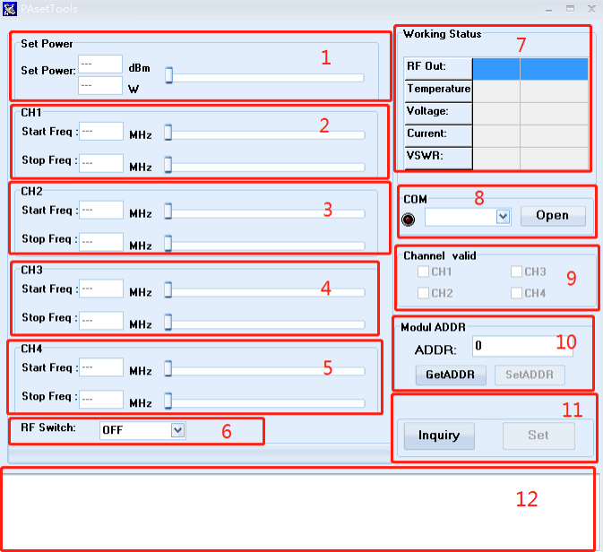
- Power setting adjustment, the left side displays the power value in dBm and W units respectively, and the right scroll bar can be dragged left and right to adjust the power.
- The default frequency range of the first channel, Start Freq is the starting frequency, Stop Freq is the ending frequency, and the ending frequency must be greater than the starting frequency. The default frequency step is 1M, which can be adjusted accurately.
- The frequency range setting of the second channel, the starting frequency of the second channel must be greater than the ending frequency of the first channel.
- The frequency range setting of the third channel, the starting frequency of the third channel must be greater than the ending frequency of the second channel.
- The function is the same as above, which is the frequency range setting of the fourth channel.
- The power amplifier module switch setting. ON is turned on, and OFF is turned off the power amplifier.
- Working status display:
Out Power: output power, the real-time power of the current module when it is working normally.
Temperature: module temperature.
Voltage: module supply voltage.
Current: module current.
VSWR: standing wave state.
8. Serial port settings, RS485 communication interface. Select the serial port number in the drop-down list box, Open to open, Close to close.
9. Frequency channel selection box, a total of 4 channels are available.
10. Module address code query and setting.
11. Query or set parameters, Inquiry is to query parameters, Set is to apply all modified parameters.
12. Display information feedback when querying or setting parameters.

Sub-band setting effect display
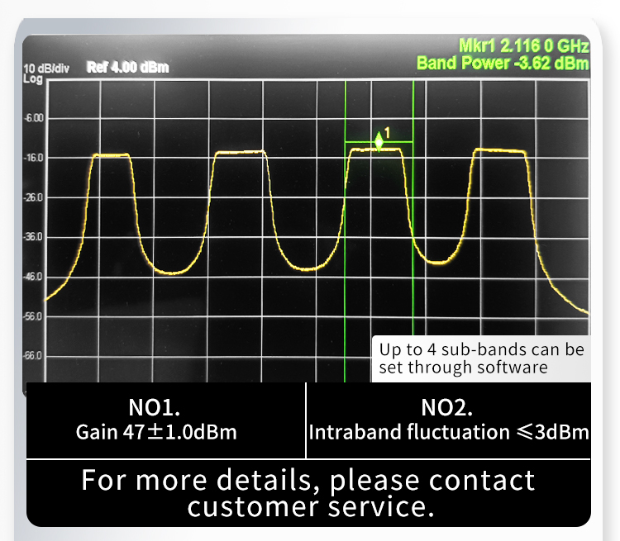

Dimensions
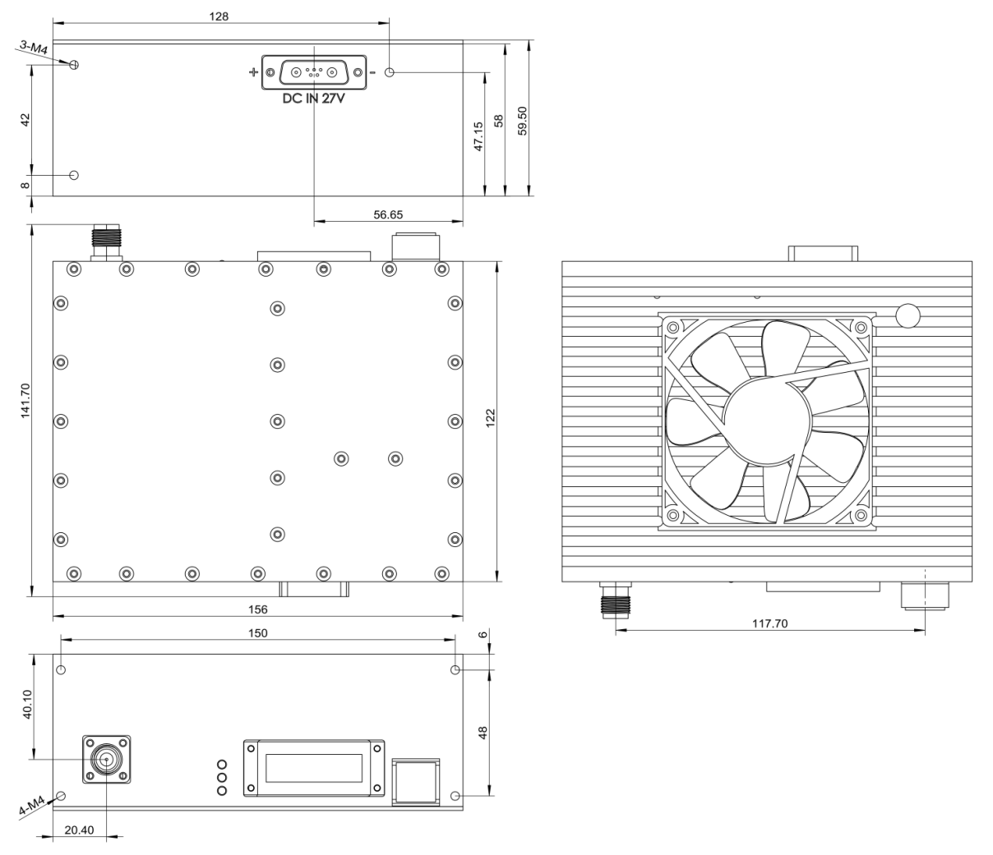

DDS RS485 communication connection diagram


