Forger-CM Introduction and Operation Guide

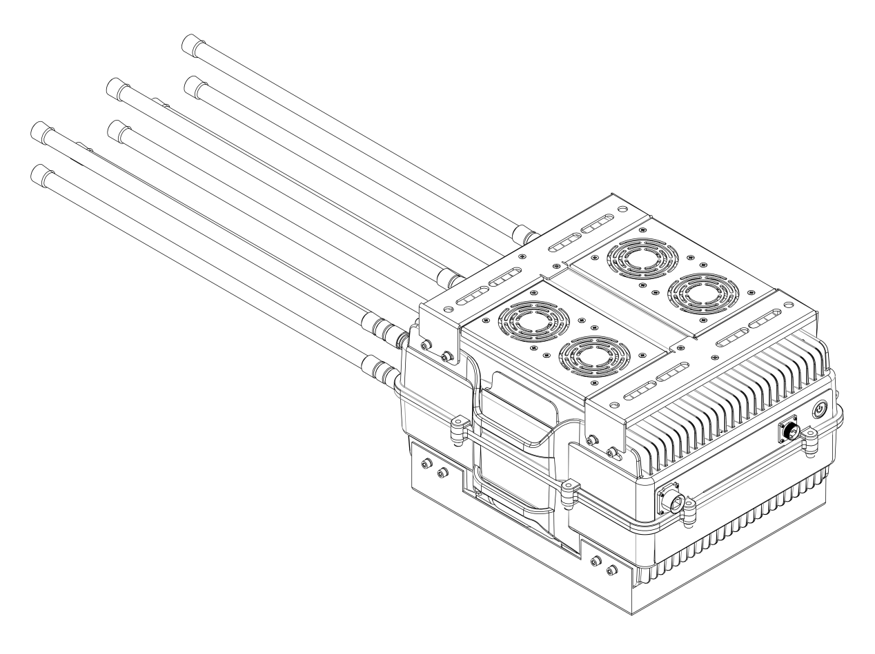

V1.0

⚠Risk warning:
- It is forbidden to use the device outdoors in thunderstorms;
- It is forbidden to put the device near fire;
- It is forbidden to disassemble the device when it is powered on;
- Avoid the device from falling into water or liquid flowing into it;
- Avoid serious collisions with the device to prevent the internal lithium battery from burning;
- Before turning on the device, check whether the antenna has been fully connected to the corresponding interface;
- When the device is turned on, patients wearing implantable electronic therapeutic devices (such as pacemakers) should strictly keep a distance of more than 10 meters from the device

- Specification
*Channels | Frequency(MHz) |  | Output Power
CH1 | 420-480 |  | 50W
CH2 | 860-930 |  | 50W
CH3 | 1160-1300 |  | 50W
CH4 | 1300-1400 |  | 50W
CH5 | 1520-1620 |  | 50W
CH6 | 2400-2483.5 |  | 100W
CH7 | 5150-5350 |  | 80W
CH8 | 5720-5850 |  | 80W
Jamming Distance |  | 3km
Weight |  | 26.5kg（without antenna）
Size |  | 47*38*28cm（without antenna）
Power Supply |  | AC 210V~240V
Temperature/humidity |  | -20℃-+50℃/≤80%
Machine reliability |  | MTBF not less than 1000 hours
System response time |  | No more than 30 seconds (from power-on to normal system operation)
*Note: This table is a typical interference frequency table for 8-channel equipment. The number of channels and interference parameters of the actual finished product need to be confirmed after communication with the customer.

- Connection
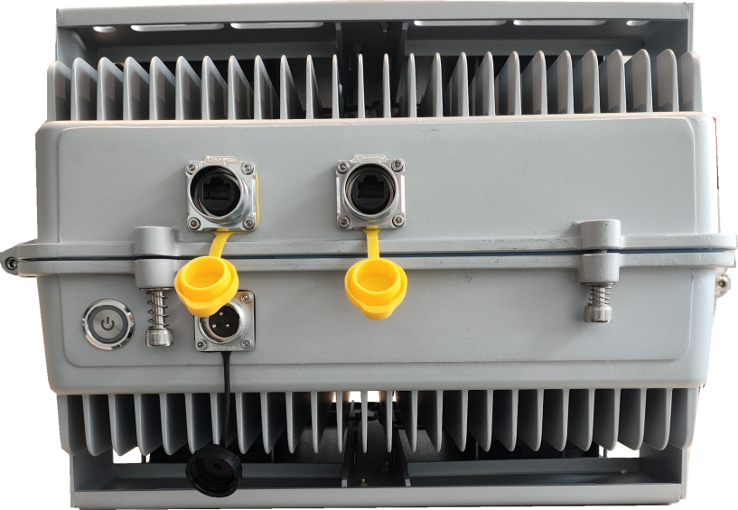

The device has a built-in switch, and users can choose one of the two RJ45 sockets to connect the detection device and use the other socket to connect the computer.

- How to modify the IP address of the device:
- Open USR-MO software. (The software version in the picture is for demonstration only, please refer to the actual version sent)

- Change the IP address in the following order:
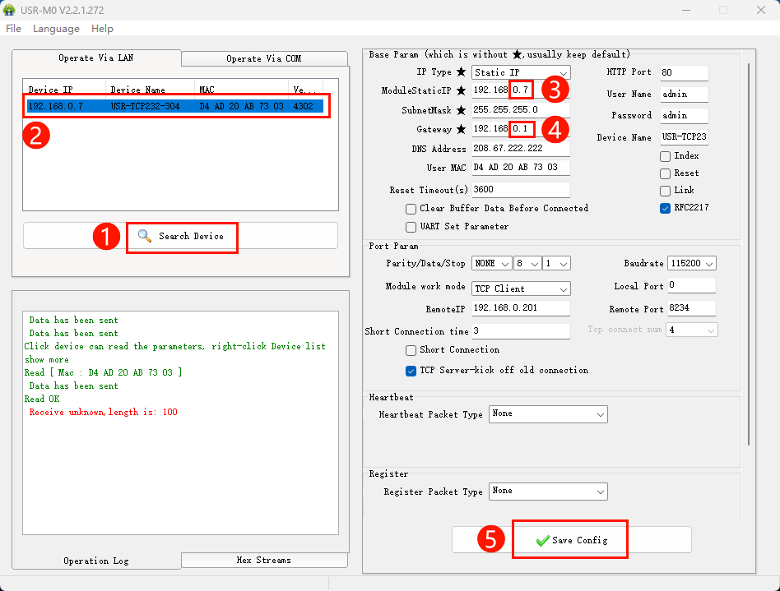
1) Click "Search Device";
2) Click the device in the search results bar;
3) Modify the static IP address of the device;
4) Modify the device gateway;
5) Click Save.

- CAD of Size
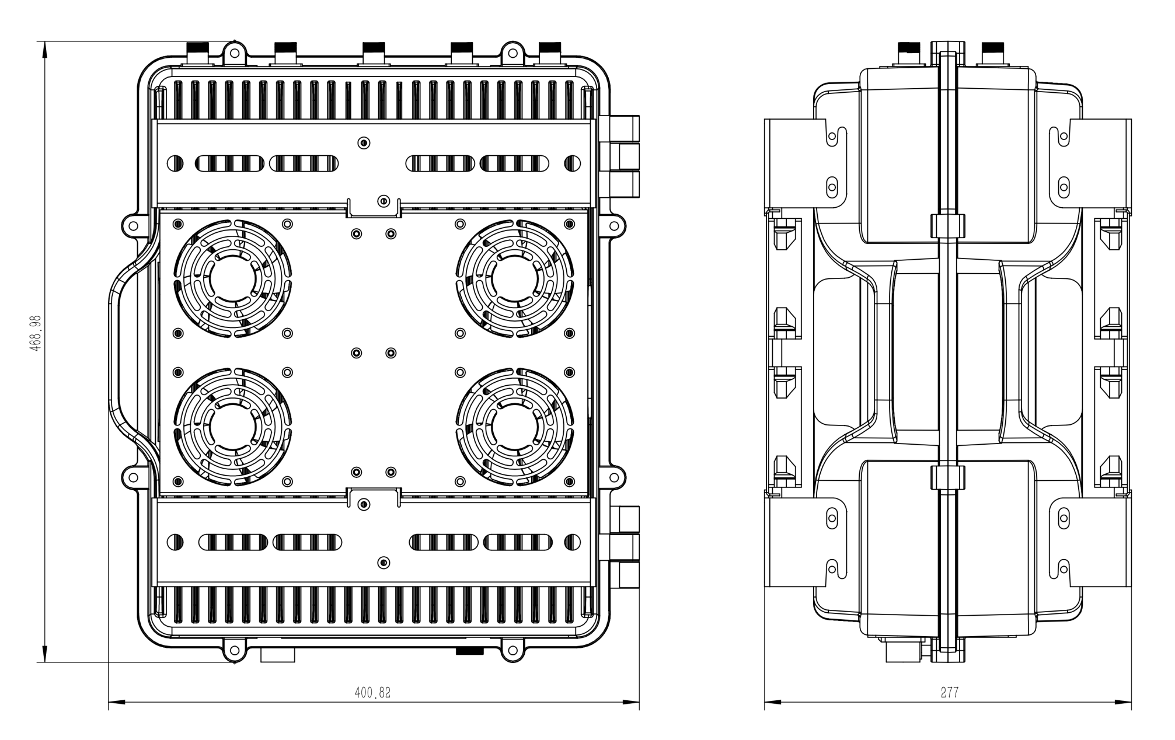
- Pole Mounting Example
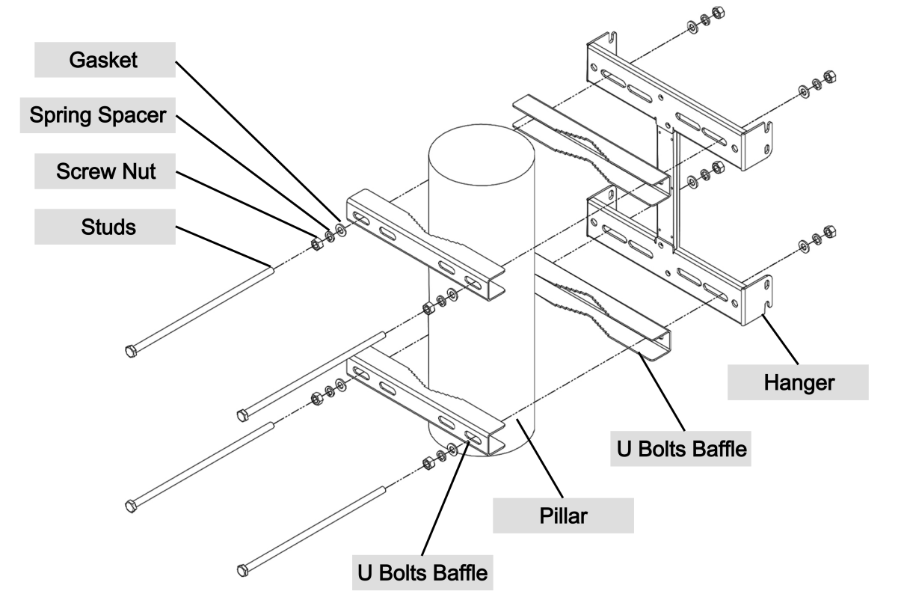
Installation structure diagram

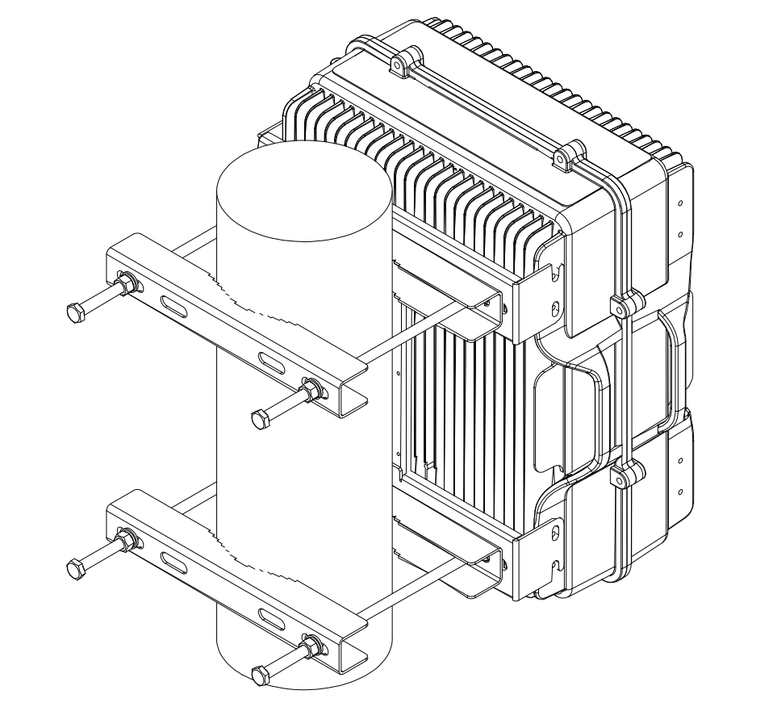
Installation completed diagram

