DPA15712328 DDS Module Data Sheet

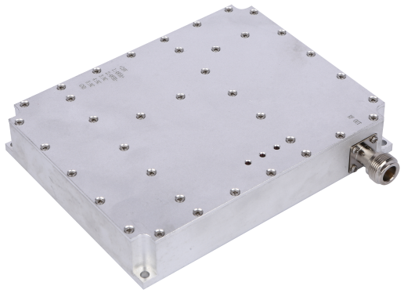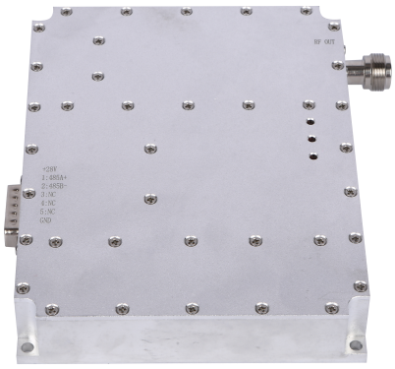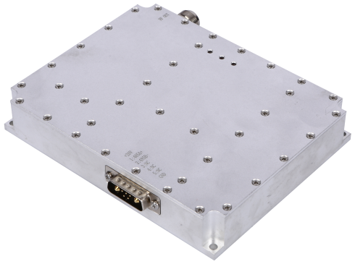

Introduction
This module is developed based on SDR (Software-defined Radio) technology, generating and amplifying a maximum bandwidth of about 400MHz between 20MHz and 6GHz.
Application range: Signal jammer for wireless communication products such as mobile phones/walkie-talkies/RC Drone/RC Car/RC Boat.

Produce Range
Selectable Frequency Range (MHz) | Maximum selectable bandwidth (MHz) | Maximum selectable output power (W)
20-100 | 80 | 100
100-500 | 250 | 100
700-1000 | 300 | 100
1000-1550 | 300 | 70
1550-1990 | 300 | 100
2010-2700 | 300 | 100
3300-3600 | 300 | 80
4800-6000 | 300 | 80

Note: The "Selectable Frequency Range" shown in this table refers to the manufacturing coverage, not the exact output range of a single module. Each module must operate within this range, with an actual output bandwidth that does not exceed the “Maximum Selectable Bandwidth.”

Radio Frequency Indicators
Test items |  |  | Indicator | Remark
Operating Voltage |  |  | 28V | 28-30V
Conversion Efficiency |  |  | ≥42% | @100W Typical
Controllable Output Power |  |  | 10W～100W | Software-configurable power
ALC Power Adjustment Range |  |  | ≥30dB | Voltage-Controlled Attenuation
Gain |  |  | 50±1.0dB
In-band Fluctuation |  |  | ≤2.5dB | Peak-to-peak value
Spurious Emission | In-band |  | ≤-15dBm/1MHz | Measure at the center frequency with CW signal at maximum output power
Spurious Emission | Out-of-band | 9KHz～1GHz | No higher than normal background noise and interference
Spurious Emission | Out-of-band | 1G～12.75GHz | No higher than normal background noise and interference
Maximum Allowable Input Power |  |  | ≥+10dBm | Lasts 1min without damage
Input VSWR |  |  | ≤1.35 | Add +28V, standard network output -10dBm
Output VSWR |  |  | ≤1.30 | No power applied, standard network output -10dBm
 |  |  | ≤1.35 | Power applied, bidirectional coupler testing
Temperature Test |  | Operating Environment Temperature | -10～+65℃ | Low-temperature startup, monitoring functions properly
 |  | Gain Stability | ±1.5dB @-40℃～+65℃
 |  | Power Stability | ±1dB @-40℃～+65℃
Power Requirements |  |  | ≥8A @+28Vdc； | Continuous wave output of 100W
Power interface, communication interface RS485 |  |  | 7W2 | Male connector
RF Output Connector |  |  | N-F
LCD Liquid Crystal Display |  |  | Display frequency, power, and on/off status.
LED Module Indicators |  |  | POWER: Power indicator，RUN: Power operation indicator，ALARM: Alarm indicator
Built-in cooling fan |  |  | The module can run independently.
Size |  |  | 157*123*28mm
Weight |  |  | 863g

Module Software Configuration
Monitoring Function |  | Description | Remark
Amplifier Configuration Parameters | Amplifier Switch | Turn the amplifier on or off.
Amplifier Configuration Parameters | Alarm Switch | Enable or disable the alarm function.
Amplifier Configuration Parameters | Downlink Power Control | Adjustable maximum output power of the amplifier, with an adjustable range of ≥20dB, and the ability to set high, medium, and low power levels.
Amplifier Configuration Parameters | Amplifier Over-Temperature Alarm | It will automatically shut down when the temperature exceeds 85°C and automatically resume operation when the temperature drops to 65°C
Amplifier Configuration Parameters | Amplifier Over-Power Alarm | The system will be automatically shut down when the actual power value is 2dB higher than the downlink ALC control threshold.
Amplifier Configuration Parameters | Amplifier Standing Wave Alarm | Automatically shut down when the standing wave ratio is greater than 4
Amplifier Configuration Parameters | Amplifier Over-Current Alarm | Automatically shut down when current exceeds 12A
Amplifier Configuration Parameters | Amplifier Under-Power Alarm | When the power is less than 37dBm, an under-power alarm is displayed.
Amplifier Configuration Parameters | Amplifier Over-Voltage Alarm | If the amplifier voltage exceeds 32V, the amplifier will automatically shut down.
Amplifier Configuration Parameters | Amplifier Under-Voltage Alarm | If the amplifier voltage is less than 20V, it will display an under-voltage alarm.
Amplifier Query Parameters | Amplifier Switch Status | If the amplifier is set to "OFF", the corresponding query should indicate that the amplifier is in the "OFF" state. Conversely, if the amplifier is set to "ON", the query should indicate that the amplifier is in the "ON" state.
Amplifier Query Parameters | Downlink Output Power Level | Detect the output power value of the amplifier within the detection range of (Pomax+2, Pomax-20). | Detection accuracy: Pout±1dB.
Amplifier Query Parameters | Downlink Standing Wave Ratio | The normal standing wave ratio is 1.2. When there is a mismatched load, the query value will be 4.0.
Amplifier Query Parameters | Temperature Query | Detect the internal temperature of the module within a detection range of -40℃ to +100℃. | Detection error: ±3°C.
Amplifier Query Parameters | ALC Value Query | The displayed value is equal to the actual set ALC value.
Amplifier Query Parameters | Voltage Detection | Detecting module operating voltage.
Amplifier Query Parameters | Current Detection | Detecting module operating current.
Signal Source Configuration | Frequency Setting Mode 1 | Setting arbitrary single frequency point within the range. | Frequency setting accuracy of 1MHz, maximum frequency bandwidth of 500MHz, and highest frequency of 6GHz.
Signal Source Configuration | Frequency Setting Mode 2 | Configure wideband sweep mode, frequency, interval, step size, and other parameters.
Signal Source Configuration | Frequency Setting Mode 3 | Set any 4 sub-frequency segments within the bandwidth, with the sub-segments incrementing.
Module Communication Protocol |  | RS485
Interface Definition |  | +:28V, -: GND; Control bit 1:485A, 2:485B.

Dimensions
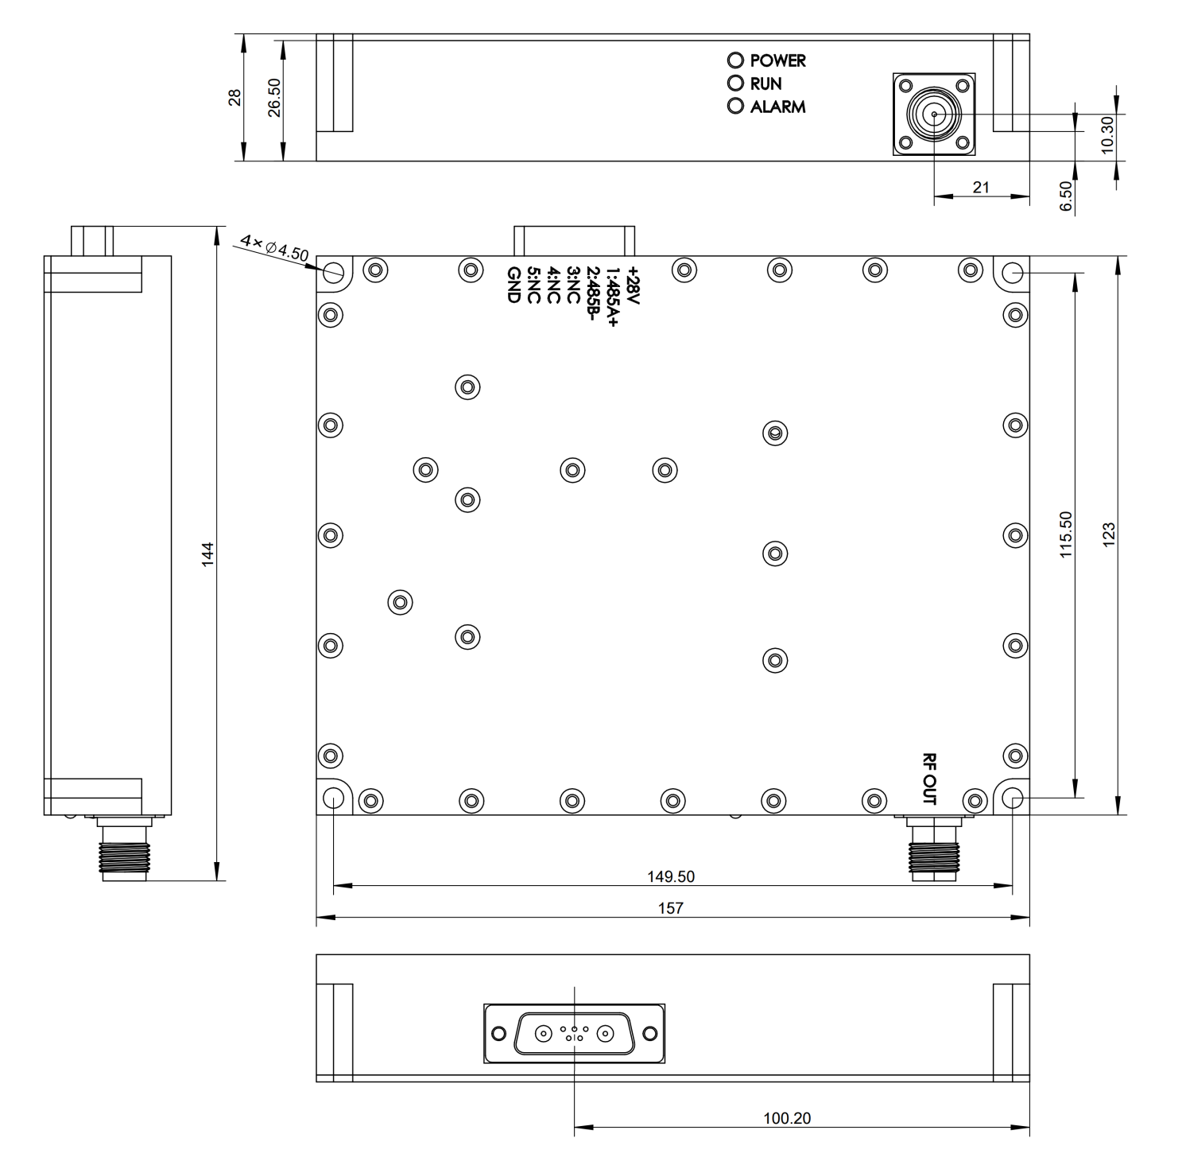

Single module software control instructions
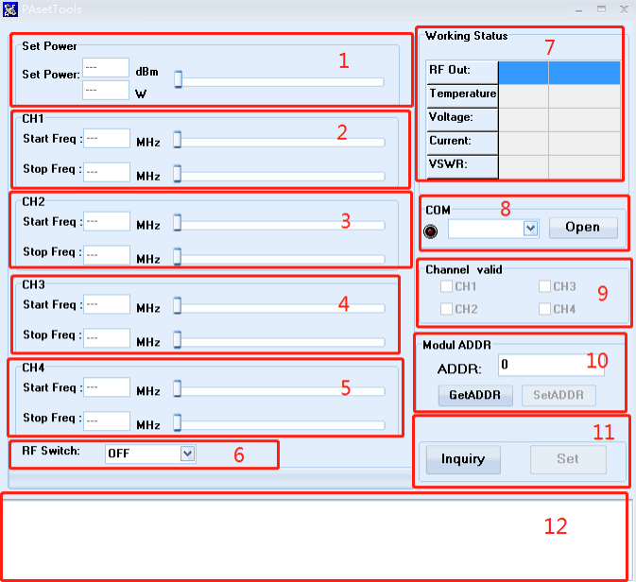
- Power setting adjustment, the left side displays the power value in dBm and W units respectively, and the right scroll bar can be dragged left and right to adjust the power.
- The default frequency range of the first channel, Start Freq is the starting frequency, Stop Freq is the ending frequency, and the ending frequency must be greater than the starting frequency. The default frequency step is 1M, which can be adjusted accurately.
- The frequency range setting of the second channel, the starting frequency of the second channel must be greater than the ending frequency of the first channel.
- The frequency range setting of the third channel, the starting frequency of the third channel must be greater than the ending frequency of the second channel.
- The function is the same as above, which is the frequency range setting of the fourth channel.
- The power amplifier module switch setting. ON is turned on, and OFF is turned off the power amplifier.
- Working status display:
Out Power: output power, the real-time power of the current module when it is working normally.
Temperature: module temperature.
Voltage: module supply voltage.
Current: module current.
VSWR: standing wave state.
8. Serial port settings, RS485 communication interface. Select the serial port number in the drop-down list box, Open to open, Close to close.
9. Frequency channel selection box, a total of 4 channels are available.
10. Module address code query and setting.
11. Query or set parameters, Inquiry is to query parameters, Set is to apply all modified parameters.
12. Display information feedback when querying or setting parameters.

Sub-band setting effect display
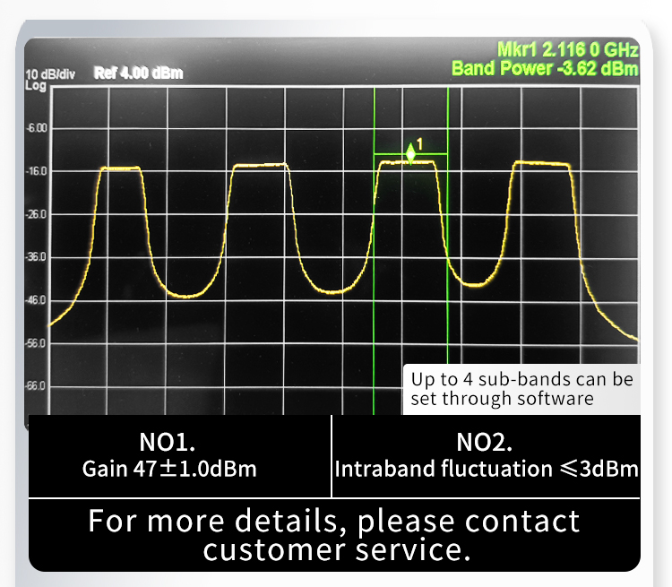

DDS RS485 communication connection diagram


