Lance-CM Drone Jammer Gun
Instruction Manual

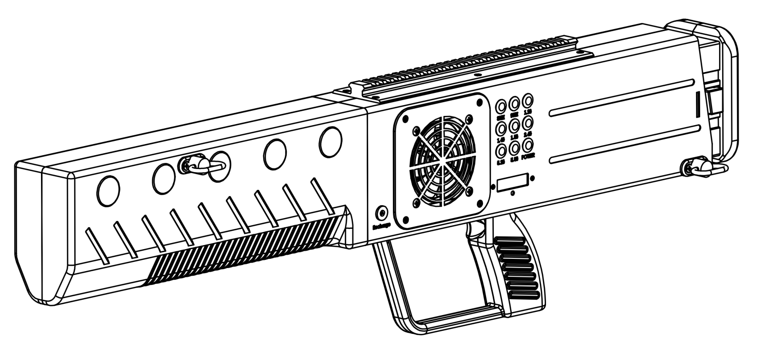

Product images:
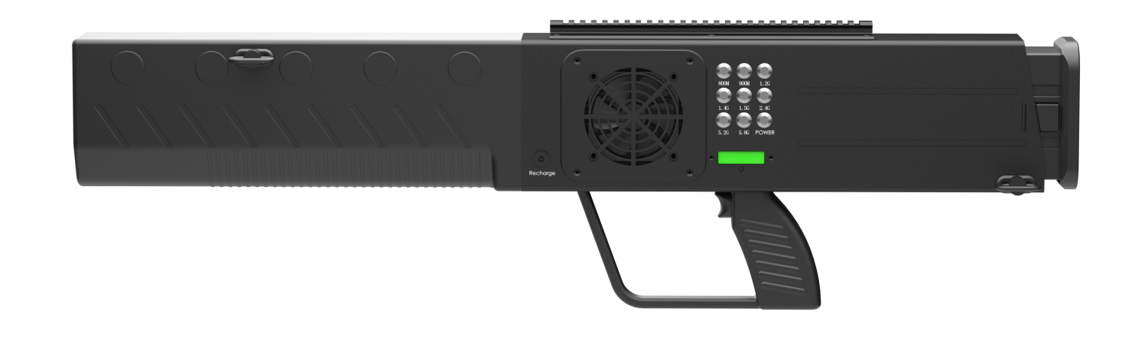
Front
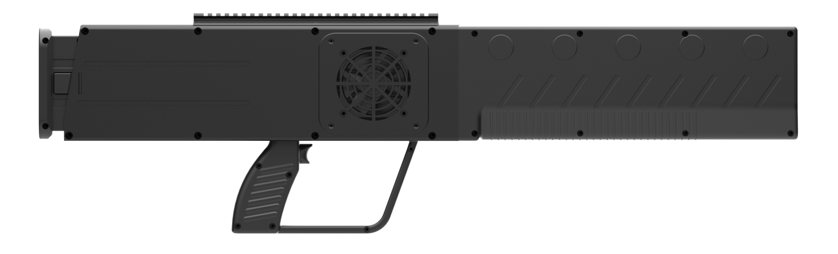
Back
Introduction:
The anti-drone gun emits electromagnetic waves through multiple specific frequency bands to interfere with the signal transmission system of commercial drones, thereby achieving drone countermeasures. The product has a simple design and is easy to operate, which is convenient for front-line personnel to use and train. It is suitable for multiple low-altitude security scenarios such as airports, stations, petrochemical oil depots, border inspections, and gatherings.

Features:
Directional emission: Directed emission of radio blocking signals with concentrated energy;
Flexible and convenient: Portable design, light equipment, simple operation, high maneuverability;
Strong endurance: Built-in high-quality battery, long service life;
Multi-band countermeasure: Can counter the communication, image transmission, and navigation links of various drones.

⚠Risk Warning
- When the equipment is deployed outdoors, ensure that it is within the effective range of the lightning protection facilities;
- It is strictly forbidden to keep the equipment close to fire sources
- It is strictly forbidden to disassemble the equipment when it is powered on.
- Avoid dropping the device into water or allowing liquid to enter the device.
- Before turning on the device, check whether the antenna is fully connected to the corresponding interface.
- When the device is turned on, patients wearing implantable electronic therapeutic devices (such as pacemakers) should strictly keep a distance of more than 10 meters from the device.

Packing List
Item | Quantity | Unit
Jammer gun | 1 | piece
Battery | 2 | piece
Charger | 1 | piece
Baldric | 1 | piece
Aviation box key | 1 | piece

Jamming Frequency Band:
(power and frequency can be customized according to needs)
Channels | Frequency | Power
CH1 | 430-440MHz | 25W
CH2 | 860-930MHz | 25W
CH3 | 1170-1280MHz | 25W
CH4 | 1430-1444MHz | 25W
CH5 | 1550-1620MHz | 25W
CH6 | 2400-2485 MHz | 25W
CH7 | 5150-5350MHz | 25W
CH8 | 5725-5850MHz | 25W

Specifications:
Frequency and power | 433M~5.8G/200W (customizable according to customer needs)
Antenna direction | Built-in high-gain directional antenna
Antenna gain | 5.8G>12dBi, 2.4G>10dBi, 1.5G>8dBi, 1.2G>8dBi
System protection | Output standing wave protection, temperature protection
Appearance | Handheld gun type
Cooling system | Built-in intelligent cooling system
Control direction | Directional 60 degrees
Control distance | >1 km
Battery | Built-in 10A (28V) battery
Charging method | External 4A charger, turn on the external switch to charge, automatically manage the charging current, and automatically disconnect when full
RF output control | 1 main power switch, 8 independent frequency band control switches
Power supply method | Built-in DC-28V battery power supply, sustainable power supply time>1h
Battery power display | Built-in battery indicator light at the buttstock
Sight | High-precision sight
Total weight (including antenna) | About 4.6kg
Operating temperature | -35°C～+70°C
Operating humidity | 80%

CAD of the Size:


