VPA1405025
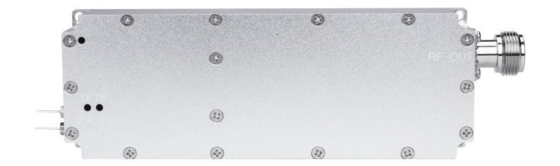

Produce Range
Selectable Frequency Range (MHz) | Maximum selectable bandwidth (MHz) | Maximum selectable output power (W)
100-300 | 100 | 100
300-1500 | 300 | 100
1700-4000 | 300 | 100

Note: The "Selectable Frequency Range" shown in this table refers to the manufacturing coverage, not the exact output range of a single module. Each module must operate within this range, with an actual output bandwidth that does not exceed the “Maximum Selectable Bandwidth.”
RF Specification
Item | Indicator | Mark
Transistor | GaN
Operating Voltage | 28V | 24-30V
In-band fluctuation | ±1dB | Peak-to-peak value
Output VSWR | ≤1.80 | Power on, dual directional coupler test
Operating temperature | -25～+85℃
RF output connector | N-F
Module protection | Over temperature protection, standing wave protection


