Forger-SP Navigation Spoofer introduction

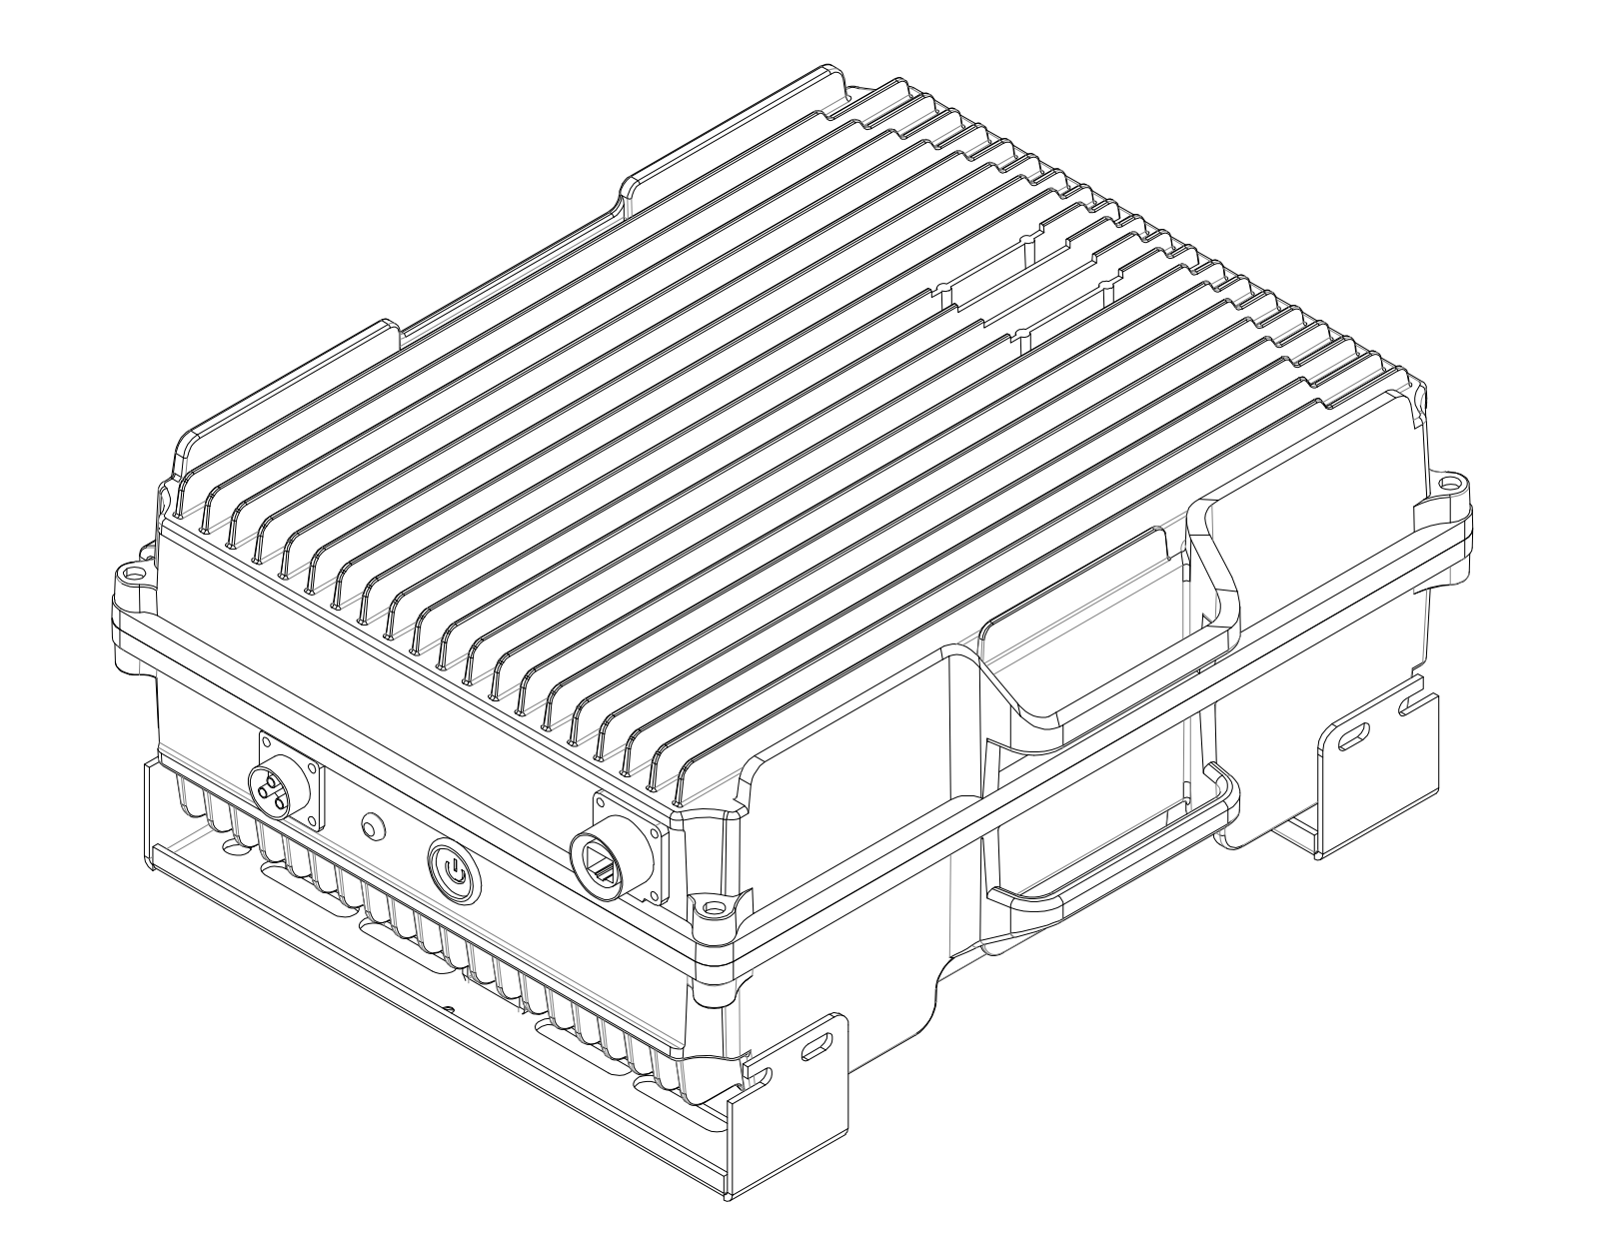

V1.2
Catalog
Product Introduction: 1
Features: 1
⚠Risk warning: 1
Specification: 2
Size: 3
Interface identification diagram: 4
Pole Mounting Example 5
Appendix: Correspondence table of decoy distance and output power 6
Appendix: Web page operation instructions 7

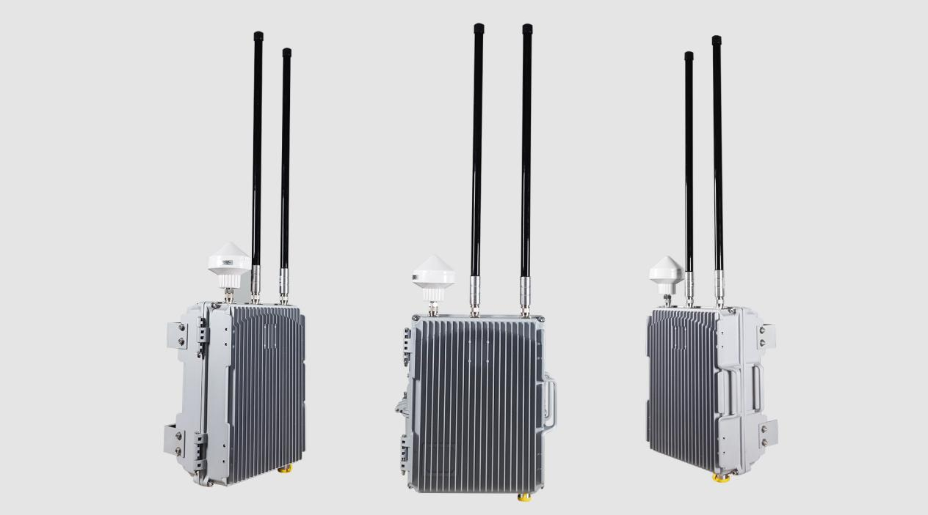
Product Introduction: The die-cast chassis drone Spoofer device uses navigation signal simulation to specifically defend against typical civilian drones of various brands. The device has an aluminum alloy shell, which is sturdy and reliable, with excellent protection performance and suitable for outdoor deployment such as VIP security, oil and gas field facility security.

Features:
Outdoor design: Aluminum alloy die-cast chassis, excellent windproof and waterproof performance.
Low environmental electromagnetic pollution: Low power transmission signal to avoid interference with dangerous facilities such as oil and gas fields.
Directional expulsion: Continuously change the positioning signal to drive the drone away to the preset designated direction.(Not Force Landing)
High-precision timing: 1PPS timing can be input; 1PPS and TOD timing messages and 50MHz high-precision clock can be output;

⚠Risk warning:
- It is forbidden to use the device outdoors in thunderstorms;
- It is forbidden to place the device near fire;
- It is forbidden to disassemble the device when it is powered on;
- Avoid the device from falling into water or liquid flowing into it;
- Before turning on the device, check whether the antenna has been fully connected to the corresponding interface;
- When the device is turned on, patients wearing implantable electronic therapeutic devices (such as pacemakers) should strictly keep a distance of more than 10 meters from the device
Specification:
Spoofing Frequency  (10 frequency points Max) | GPS L1(1575.42M)
Spoofing Frequency  (10 frequency points Max) | BDS B1(1561.098M±2.5MHz)
Spoofing Frequency  (10 frequency points Max) | GLONASS(1602M)
Spoofing Frequency  (10 frequency points Max) | GALILEO E1(1575.42M±2.5MHz)
Spoofing Frequency  (10 frequency points Max) | QZSS L1(1575.42M)
Spoofing Frequency  (10 frequency points Max) | GPS L2(1227.6M)
Spoofing Frequency  (10 frequency points Max) | BDS B2(1207.14M)
Spoofing Frequency  (10 frequency points Max) | GLONASS L2(1246M)
Spoofing Frequency  (10 frequency points Max) | GPS L5(1176.45M)
Spoofing Frequency  (10 frequency points Max) | GALILEO E5(1176.45M)
Spoofing Function | Directional drive: Specify a direction angle in the software to drive all drones within the decoy range to that direction.
Spoofing Function | Circular defense: With the decoy device as the center, the decoy coordinates are continuously projected in a circular shape to form a circular defense circle. UAVs within the decoy range cannot take off, and UAVs that have taken off will lose control and move randomly.
Spoofing Function | No-fly forced landing: Set the decoy coordinates to the airport no-fly zone, making the drone mistakenly believe that it has entered the no-fly zone, and trigger the drone's own forced landing program after 30 seconds
Number of spoofing drones at the same time | ≥8
Power output range | -70dBm~+10dBm(Default output 10dbm)
Power adjustment step | 0.5dB
Spoofing Distance | ≥10km
Spoofing success rate | ≥99%
Power-on start time | <30 seconds
Intrusion time | <2 seconds
Supply voltage | AC 220V
Stray | ≥50dB
Enclosure protection level | IP67
Dimensions | 39.5*31*15.5cm(without antenna)
Weight | 15kg(without antenna)

Size:
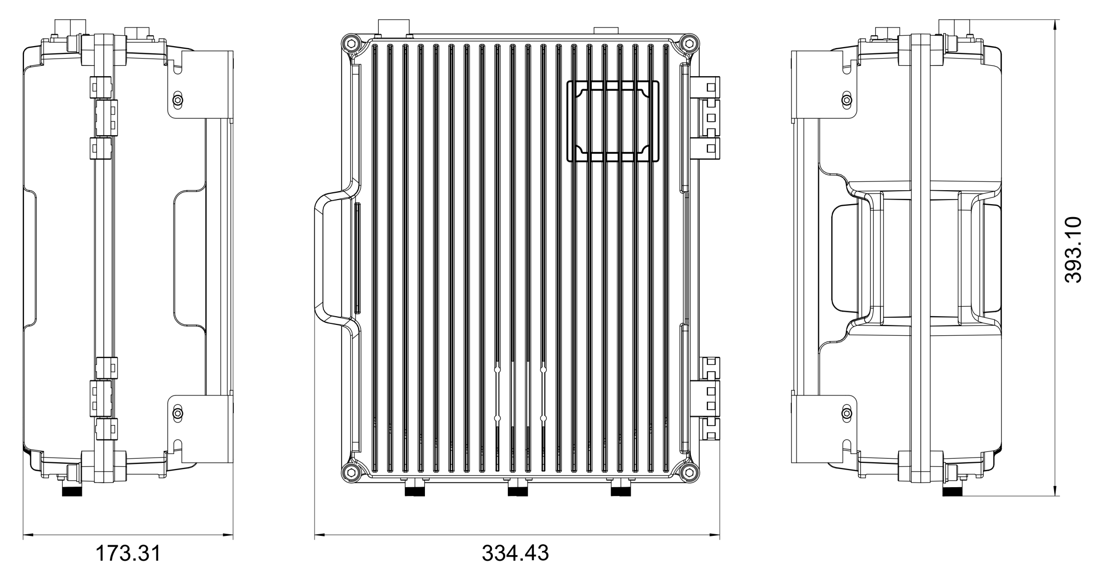

Interface identification diagram:

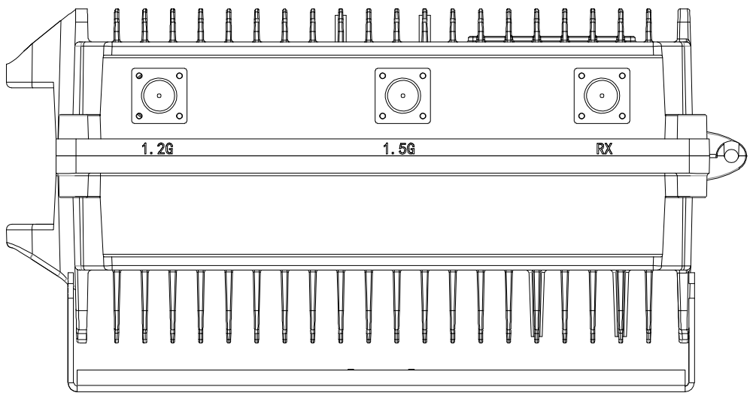
Antenna interface diagram

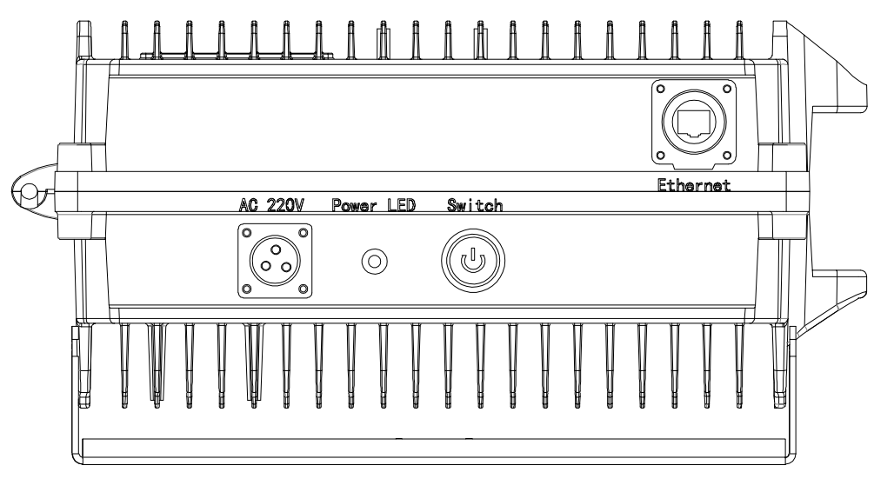
Power supply and communication interface diagram

Pole Mounting Example
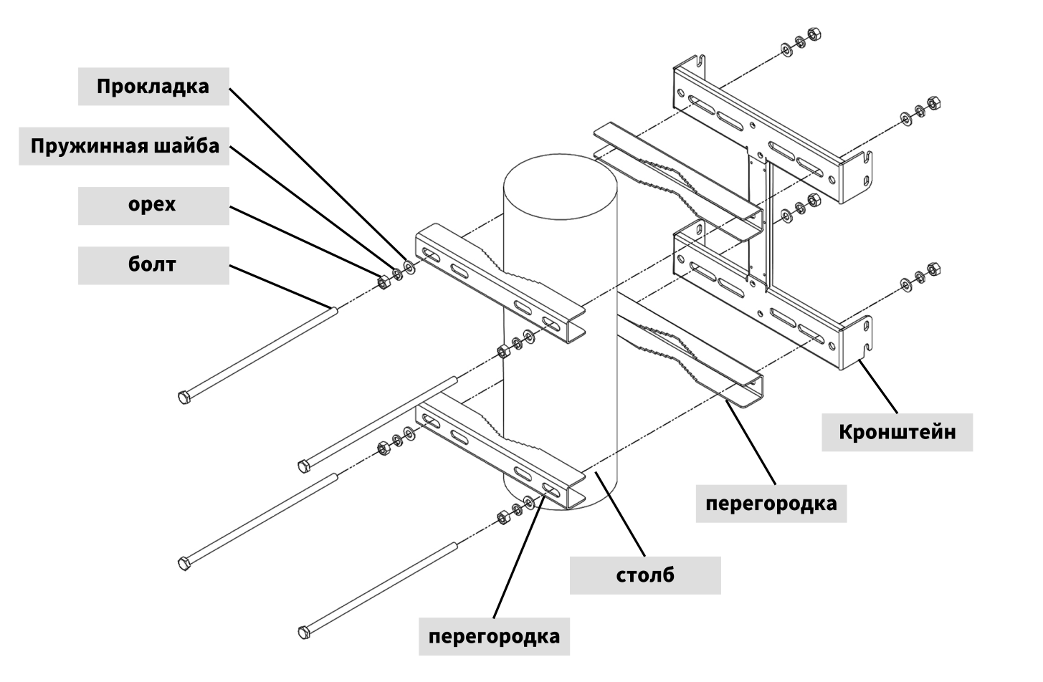
Installation structure diagram

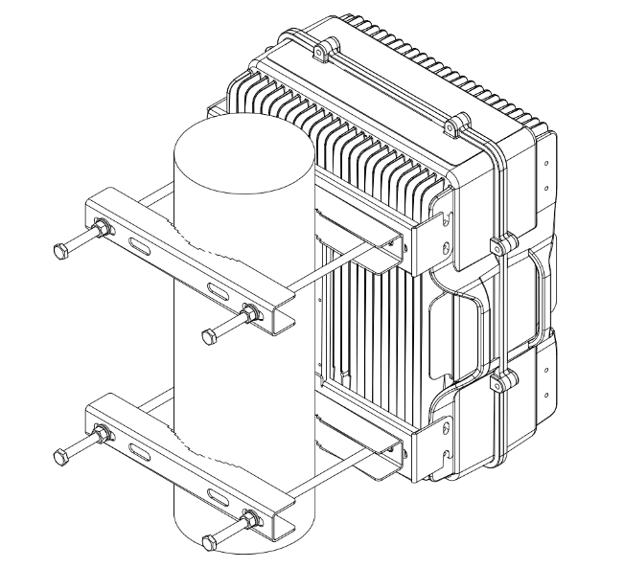
Installation completed diagram

Appendix: Correspondence table of decoy distance and output power (for reference only)
Output power(dBm) | 12 | 22 | 32 | 35 | 38 | 42 | 45 | 47
Output power(W) | 0.016 | 0.16 | 1.6 | 3.16 | 6.3 | 15.85 | 31.6 | 50
Spoofer distance(km) | 1 | 2 | 4 | 5.2 | 6.5 | 8 | 11 | 14

Appendix: Web page operation instructions
- Login:
The default IP of the device is 192.168.101.101 Please set the operating computer to the same network segment. Open the browser (Edge or Google browser is recommended), enter the device IP address in the address bar, and the username and password are: admin, 666, respectively As shown in the following figure: 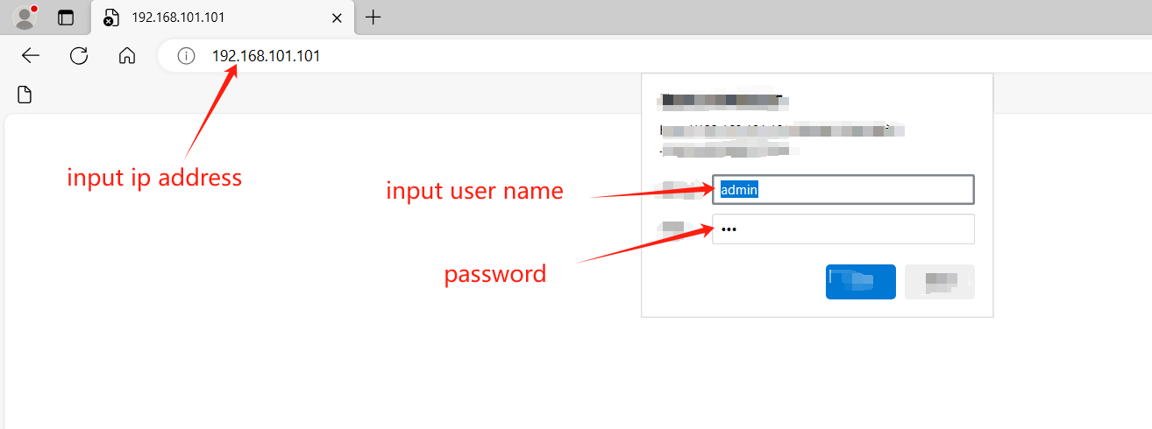
- Homepage-Operation：
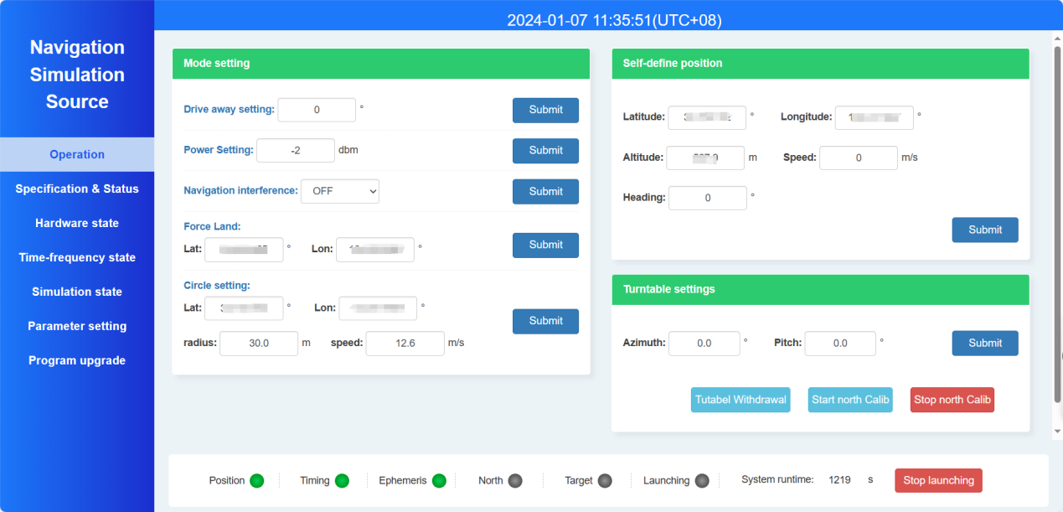
  - Mode setting: This Page is the main anti-uav strategy setting, which includes four functions: Drive-away, Nav-interference, Forced landing, and Circle-setting. Only one of them can be turned on at the same time. To switch strategies, the current mode must be stopped before operation. There are settings with dropdown boxes that require selecting "enable" before submission can be effective.
    - Drive away setting: The angle of the target drone needs to be filled in, with 0 degrees due north and increasing clockwise in a circle, with a range of 0-359 degrees. The meaning of this parameter is to drive the target drone away along a specified direction;
    - Power setting: The range of this power setting can be found in the "Output Power" section on the homepage. If the parameter exceeds this range, the module will automatically perform truncation processing.
    - Navigation interference: Select "Enable" from the dropdown menu and click the corresponding "Submit" button on the right to activate the navigation interference function. The purpose of this function is to interfere with the navigation link (not the communication link) of the drone, making it unable to perform satellite navigation;
    - Force land: When enabled, the module will automatically project the nearest no fly zone position based on the current position. When the drone's position is deceived, it will trigger an internal autonomous emergency landing, So as to lower the flight altitude until landing on the ground (this function is not to make the drone descend in a straight line, but to trigger the drone's own autonomous landing strategy through the projection of the no fly zone. In a calm or slightly windy environment, the landing area radius can be controlled within 100 meters);
    - Circle-setting: After activation, the drone will hover in the air. The purpose of this function is to protect the core area from invasion by the drone, allowing the drone to perform a circular motion in its current position, making it impossible to continue flying to the core area;
  - Self-define position: Users can customize false latitude and longitude information, and the "submit" button can trigger device emission;
  - Turntable setting: only supports directional devices, and can set the rotation angle of the PTZ, as well as enable north calibration and other functions;
- Specification & Status page:
This page mainly contains the specifications, real-time status, and time information of the module. The bottom page contains important device status, as shown in the following figure: 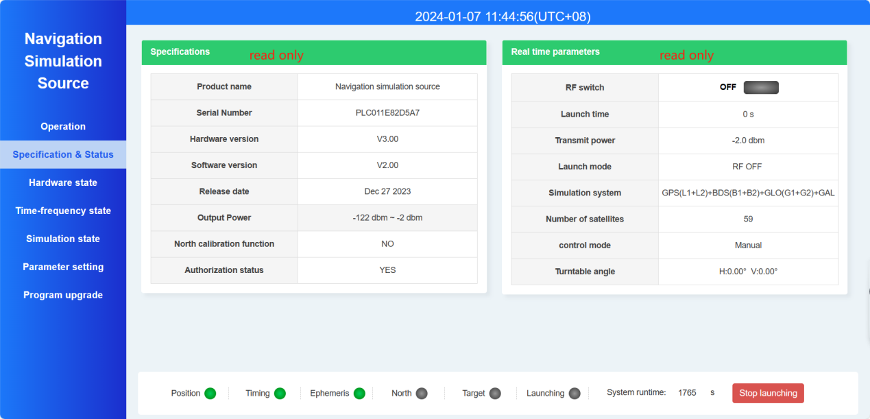
  - Time information: 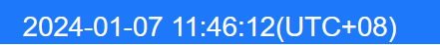，you can select the corresponding local time zone in the parameter settings page. The default display is UTC+8 time zone (Beijing time), which automatically refreshes every 2 seconds. If the time on the webpage stops moving, you can try refreshing the browser.
  - Specification parameters: This information includes factory configuration parameters that cannot be changed. It mainly includes name, serial number, software and hardware version, firmware date (usually the latest date will be displayed after upgrading), output power range, calibration function, and authorization status. The main parameters that users need to pay attention to are output power range, and users can adjust the output power freely within this range.
  - Real time parameters: Display the status of the current module in real time, refreshing every 2 seconds. The specific definition is as follows:
    - RF switch: When the launch is turned on, the font is displayed as “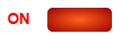 “, When not launched, the font is displayed as”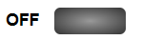”
    - Launch time: Record the duration of signal transmission, measured in seconds;
    - Transmit power: The current set output power, unit in dbm;
    - Launch mode: mainly includes several modes: departure, forced landing, interference, and defense;
    - Simulation system: Factory supported navigation system, this information cannot be changed;
    - Number of satellites: the sum of the number of satellites simulated at all frequency points;
    - Control mode: default to manual, automatic is used in conjunction with detection, and requires factory configuration file support to have this function;
    - Turntable angle: Directional navigation deception devices with turntables have the display of this parameter.
  - Bottom page: mainly includes the important status display, running time, and global stop button of the device. This page is displayed on any web interface. The switching of web pages only refers to the switching of the middle part of the entire web, and does not affect the time display at the top and status display at the bottom. The bottom page is shown in the following figure:
    - Position: When the receiving antenna is connected outdoors, green indicates that the module navigation receiver has been locked and successfully positioned, while gray indicates that the navigation receiver has not been successfully positioned.
    - Timing: After the navigation receiver successfully locates, the module uses satellite time as a reference to tame and adjust the local time frequency. When the local time reaches within 50ns, it can be determined as local time locking, and the timing status is green; When unlocked but being tamed, the timing status is yellow; If the local clock is not currently tamed (usually due to navigation not positioning or being in a transmitting state), the timing status will be gray.
    - Ephemeris: When the number of satellites receiving orbit data reaches the number of satellites that can deceive drones, the status is green; When some frequency points are reached, it is yellow; Otherwise, it will be gray.
    - North: Directional devices with turntables support this function. After the device is powered on, it will display green when the North Campus is successfully completed; Yellow indicates being in the north of the school. If yellow is displayed for a long time (lasting for more than 10 minutes), it is suspected that the north of the school has failed. You can use the "Simulation Settings" page on the webpage to ensure the success of the north of the school again; Gray indicates that the module or device does not support the north calibration function.
    - Target: For integrated equipment containing reconnaissance modules, the indicator light is red to indicate the presence of targets in the surrounding area, and gray to indicate that no targets have been detected;
    - Launching: Gray indicates not launched, red indicates launching；
    - System running time: total number of seconds of operation after startup；
    - Stop Launching button: This button is the stop signal button for the entire web page. In emission mode, clicking this button can turn off signal emission.
- Hardware state:
This page mainly includes the status of the receiving antenna connection, CPU and board temperature information, navigation receiver status, etc., which basically reflects the status information of the module hardware, as shown in the following figure: 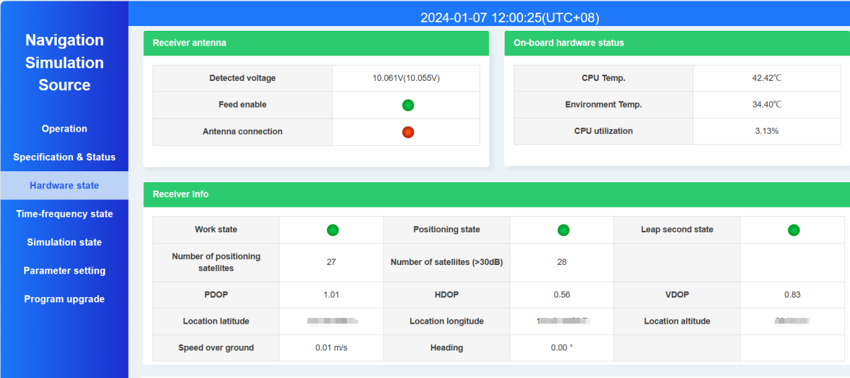
  - Receiver antenna information: including the detection voltage value at the antenna end (the difference between the two after connecting the antenna is about 1V, which is a normal value). The antenna connection status can be determined through voltage detection, but the prerequisite is that an active antenna must be connected. If it is a passive antenna, it cannot be detected.
    - Feed enable: In the parameter settings page, the antenna feed can be switched on or off;
    - Antenna connection: Green indicates connection to active antenna, red indicates disconnection from active antenna.
  - On board hardware status: including temperature information and CPU usage rate;
  - Receiver info:
    - Work status: indicates the communication status between the satellite navigation receiver and the CPU, with green indicating normal and red indicating abnormal;
    - Positioning status: Receiver locked in green, unlocked in red;
    - Leap second status: The receiver's leap second reception flag for time, usually displayed in green within 12.5 minutes after connecting the antenna;
    - Positioning and speed information, including latitude and longitude, positioning accuracy factor, and speed information, etc;
- Time-frequency state:
This page contains status information on timing, as shown in the following figure:
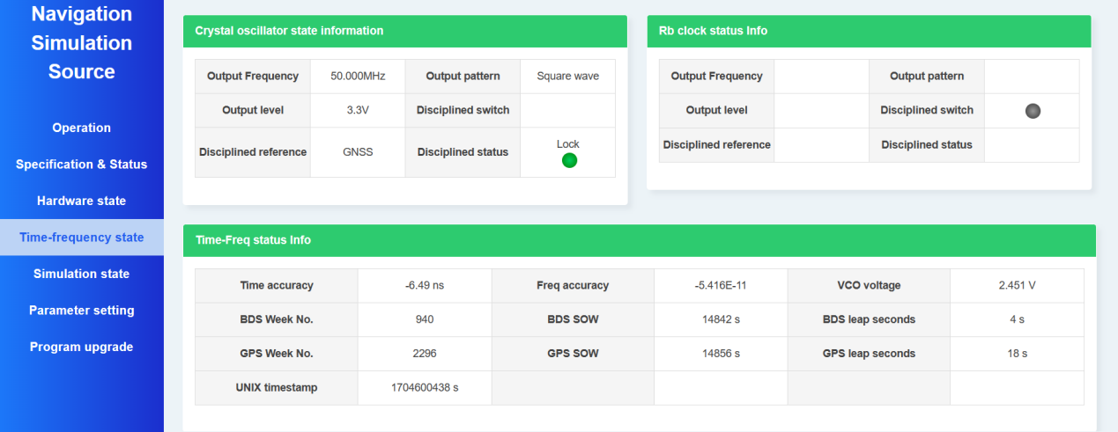
  - Crystal oscillator status information: The module contains a high-precision constant temperature crystal oscillator with a frequency of 50MHz, and the main parameters are as follows：
    - Discliplined reference: If the current receiver is locked, the reference is displayed as "GNSS". If the receiver is not locked and the external 1PPS is valid, the reference is displayed as "EXT 1PPS". By default, the factory board does not support external 1PPS taming, and customization is required to support this reference. When there is no reference, it is displayed as "no reference", indicating that the current clock is on time, and the accuracy depends on the holding performance of the constant temperature crystal oscillator itself. Generally, the locked clock continuously emits for 1 hour, and the time accuracy drift is less than 1us. Within 30 seconds after stopping the transmission, the accuracy can be tamed to within 50ns;
    - Taming state: When the time accuracy is less than 50ns, the taming state is locked, yellow when being tamed, and red when not being tamed.
  - Time frequency status information: including real-time information on clock tame, such as local time accuracy, crystal frequency accuracy, tame voltage, Beidou and GPS time, etc;
- Simulate State:
This page contains information on RF status, number of satellite simulations, supported simulation frequency points, ephemeris status, current simulation location, and more.
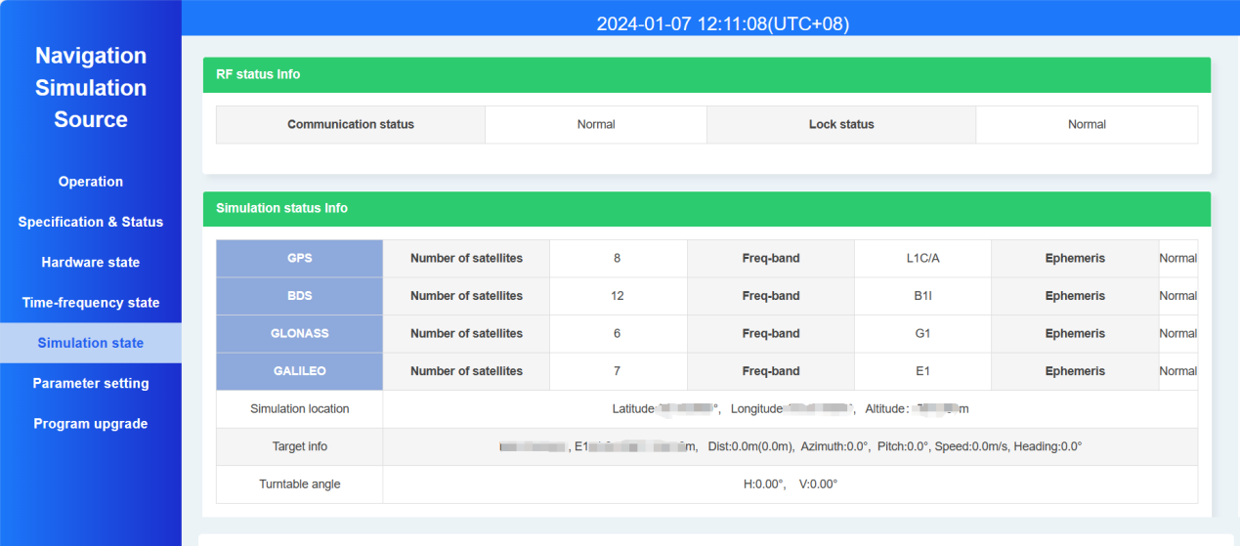
  - RF status: This includes the communication status and RF locking status of the RF chip. At all times, these two statuses should be displayed as "normal". Otherwise, there may be hardware failures. Please contact the manufacturer in a timely manner;
  - Simulation status: includes supported navigation systems and their simulated satellite numbers. The ephemeris status is considered valid for each frequency point when the number of satellites at a single frequency point exceeds 4 (as mentioned earlier, the ephemeris represents available satellite orbit data);
    - Simulation location: Real time false position simulated by the board;
    - Target information: If guided by 3D detection equipment such as radar and optoelectronics, and sent to the deception module through a protocol, the received target information will be displayed in a timely manner, and the azimuth, elevation, and other angle information relative to the device will be calculated. After power on, the module defaults to the current position as the target position;
    - Turntable angle: Only supports directional devices with turntables, displaying the angle of the turntable in real-time (0 degrees due north, increasing clockwise).
- Parameter setting:
This page includes functions such as time zone settings, IP settings, receiving antenna feeding settings, output timing jitter testing, and device restart.
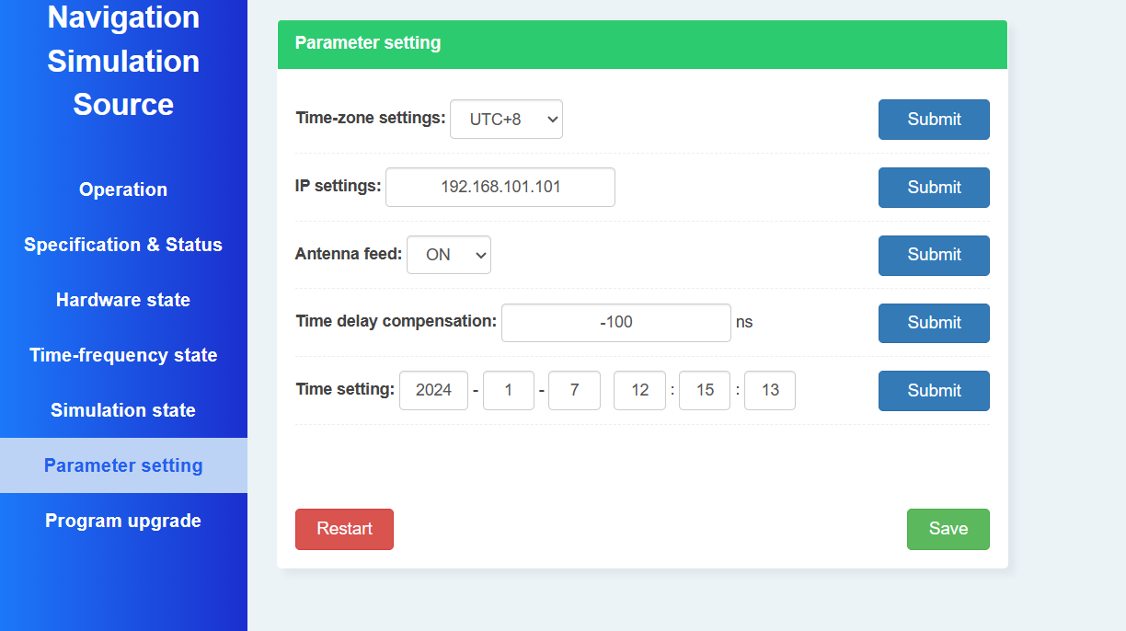
  - Time zone setting: Select different time zones based on the current region. After submission, the top of the webpage will display the time of the current region according to the selected time zone;
  - IP Settings: Change the IP address of the device, especially note that the parameter will not be saved after the IP is changed. You need to log in to the web page with the changed IP address in the browser, and then click the "Save Settings" button on the "Parameter Settings" page to ensure that the newly set parameters are executed after restartin;
  - Antenna feeding: used for setting the feeding switch of the module receiving port to the active antenna;
  - Delay compensation: The compensation value is the system delay, which is already configured at the factory and does not require user operation. If changed, it will affect the entry time of the drone;
  - Timing setting: Used during testing, the timing information of the module can be set when it is indoors (i.e. unable to locate);
  - Restart device: Clicking this button will trigger a soft reset of the module;
  - Save Settings: All settings parameters on this page will not be saved to the module FLASH after submission. To save them so that they remain valid even after power on, you need to click the "Save Settings" button. If you want to save after changing the IP address, please carefully read the "IP Settings" content in point 2).
- Programe upgrade:
This page is used to upgrade the device firmware program, and this feature is maintained by the manufacturer. It is not recommended for users to use this feature.

