Die-Cast Enclosure Integrated Drone Detector & Jammer System Specification

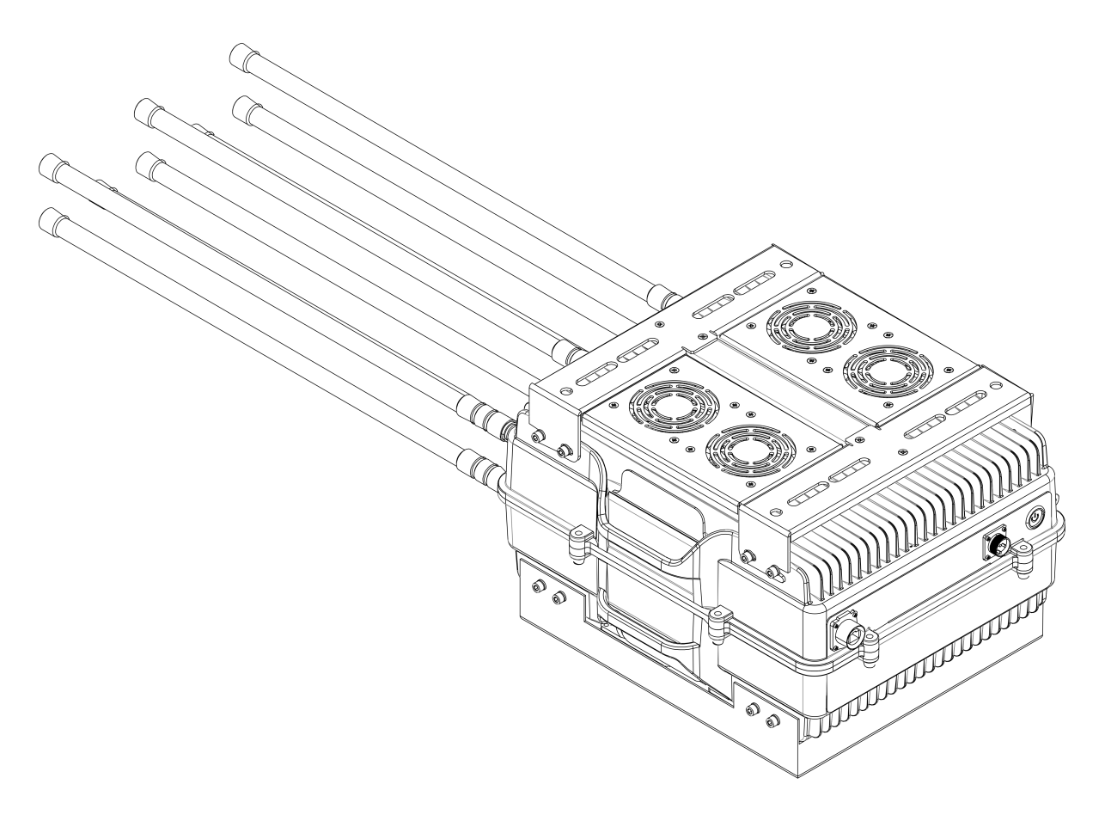

July 2025

Applications
This high-power outdoor fixed drone detection and jamming system is suitable for drone no-fly zones, luxury residences, scenic areas, gas stations and oil depots, power systems, security protection for key leaders and VIPs, individual operations, SWAT teams, EOD teams, counter-terrorism units, anti-drug units, explosion-proof teams, security checkpoints, administrative law enforcement, hostage negotiation, border control, military security forces, and other application scenarios.

Features
- High-power coverage to block most drone remote-control signals and drone video transmission signals; frequency bands can also be customized.
- All 6 channels can be switched on/off independently and support temperature, SWR, undervoltage, and overcurrent protection functions.
- The transmit power of each channel is not less than 30 W. Output power can be adjusted according to site requirements (optional, software adjustment).
- The standard antenna configuration uses omnidirectional antennas. Directional antennas can also be installed as required for better jamming performance.
- All sides of the enclosure adopt a double-layer structure with excellent waterproof performance, enabling direct outdoor installation.
- Precision manufacturing workmanship; the main enclosure is made of die-cast aluminum alloy and will not rust.
- Multiple high-performance cooling fans and extra-thick heat-dissipation fins ensure optimal operation even in high-temperature environments.
- With the fan mounting kit installed, the device can operate continuously for long periods with stable performance and a long service life.
- Product manufactured under the ISO 9001:2008 quality management system.

Packing List
Name | Image | Quantity | Remarks
Main Unit | 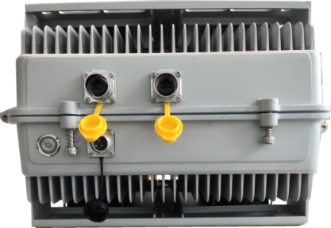 | 1 | 47 x 38 x 28 cm (excluding antennas)
Omnidirectional Antenna | 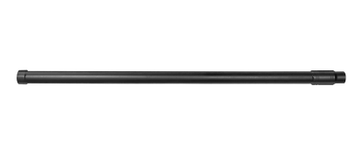 | 10 | Diameter 32 mm x Length 650 mm
GPS Receiving Antenna | 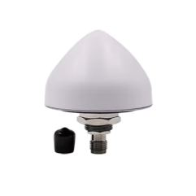 | 1
Power Cable | 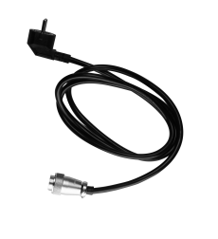 | 1
RJ45 Network Cable | 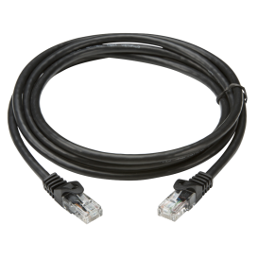 | 1

Detailed Technical Specifications
Frequency Band Parameters | Channel | Frequency | Signal Type | RF Power | Current
Frequency Band Parameters | 900M | 860-930MHz | Flight control / RC | 50W | 5A
Frequency Band Parameters | 1.6G | 1560-1620MHz | L1 navigation positioning | 50W | 5A
Frequency Band Parameters | 2.4G | 2400-2485MHz | Bluetooth / video link | 100W | 10A
Frequency Band Parameters | 5.2G | 5150-5350MHZ | Wi-Fi / video link | 50W | 5A
Frequency Band Parameters | 5.8G | 5725-5850MHz | Wi-Fi / video link | 50W | 4A
Frequency Band Parameters | 5.8G | 5725-5850MHz | Wi-Fi / video link | 80W | 7A
Main unit size (L x W x H) | 47 x 38 x 28 cm (excluding mounting bracket)
Antenna dimensions | Length 650 mm, diameter 32 mm (omnidirectional antenna)  Length 82.7 mm, diameter 66.5 mm (mushroom antenna)
Antenna type | High-gain omnidirectional antennas (10 pcs) and mushroom antenna (1 pc)
Power supply | AC 220V
Total power consumption | 400W
Weight | 26kg
Temperature / humidity | -20℃-+50℃/≤80%
System reliability | MTBF not less than 1,000 hours
System response time | No more than 30 seconds (from power-on to normal operation)
Enclosure design | Die-cast aluminum alloy
Drone detection specifications | Simultaneous drone detections >= 30
Minimum detection altitude | >= 0 m
Detection rate | ≥95%
Detection bands | 2.4G, 5.8G
Detection range | 5 km (open line-of-sight environment)  (Tested with DJI Mavic 2)
Jamming range | 3 km (open line-of-sight environment)  (Tested with DJI Mavic 2)

Installation

Pole-Mount Installation
The typical installation method for the main unit is pole mounting. Using the rear mounting bracket together with U-bolts or other accessories, the unit can be fixed directly to cylindrical objects such as utility poles, streetlight poles, or surveillance poles. The U-bolts or other accessories should be selected according to the actual pole diameter at the customer site.
During installation, the complete unit including the bracket can be directly connected and fixed with the U-bolt accessories. Alternatively, the bracket can be removed and first fixed to the pole with the U-bolt accessories, and then the main unit can be mounted onto the bracket.
An example of pole-mount installation is shown below. The antenna and enclosure in the figure are for installation reference only and are not the actual antenna or enclosure used with this device.
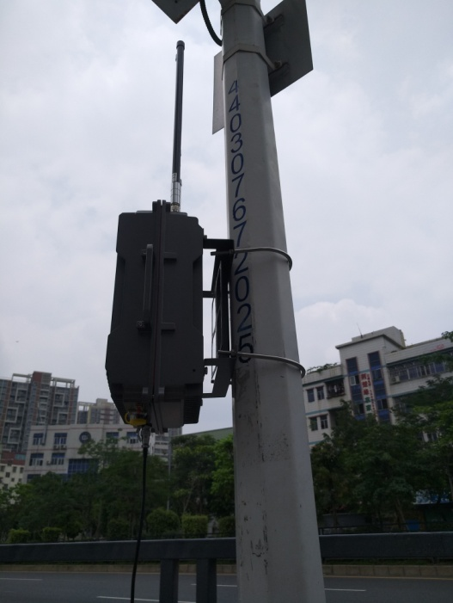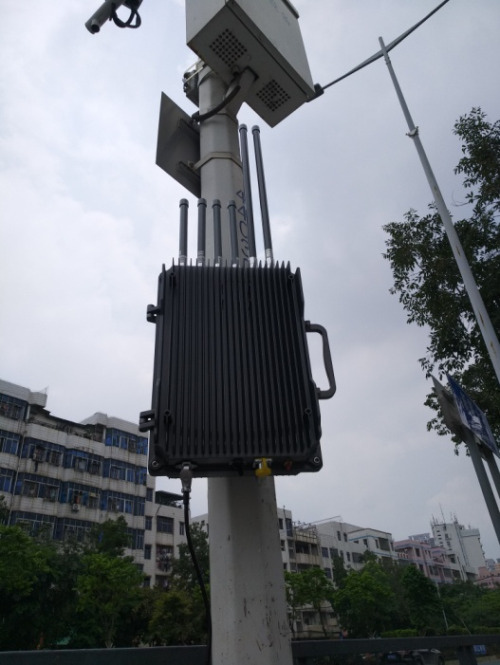

Wall-Mount Installation
The main unit can also be wall-mounted. For wall mounting, the rear bracket of the device is fixed directly to the wall using expansion bolts.
During installation, the complete unit including the bracket can be fixed directly to the wall with expansion bolts. Alternatively, the bracket can be removed and first fixed to the wall with expansion bolts, and then the main unit can be mounted onto the bracket.

Precautions

Antenna Installation Precautions
  - First screw each fiberglass antenna onto the corresponding marked port on the main unit. Ensure all connections are firm and secure.
  - After powering on the device, wait for approximately 1 minute and then check the antenna interfaces again. If abnormal temperature rise is found, it may be caused by poor contact between the feeder cable and the output connector. Immediately power off the device, unscrew the feeder connector, and reconnect it carefully.

Operation Precautions
  - When receiving the device, carefully unpack it and check the appearance and accessories. Do not open the device unless necessary.
  - Before powering on the device, ensure that all antennas have been properly connected and that the contacts are good. It is strictly forbidden to power on the device without antennas connected, otherwise the device may be damaged.

Safety Precautions
  - Do not open the enclosure in rainy weather to prevent rainwater from entering the enclosure and causing short-circuit damage.
  - After the device is powered on, do not touch any live components during switch operation to avoid electric shock.
  - After the device is powered on, the cooling fans start immediately and the blades rotate at high speed. Do not touch the rotating fan blades by hand when operating the device to avoid injury.
  - The device is supplied with the corresponding installation accessories. Installation must be performed by professional engineers. Non-professionals should not install the device without authorization.

User Operation

Local Network Settings

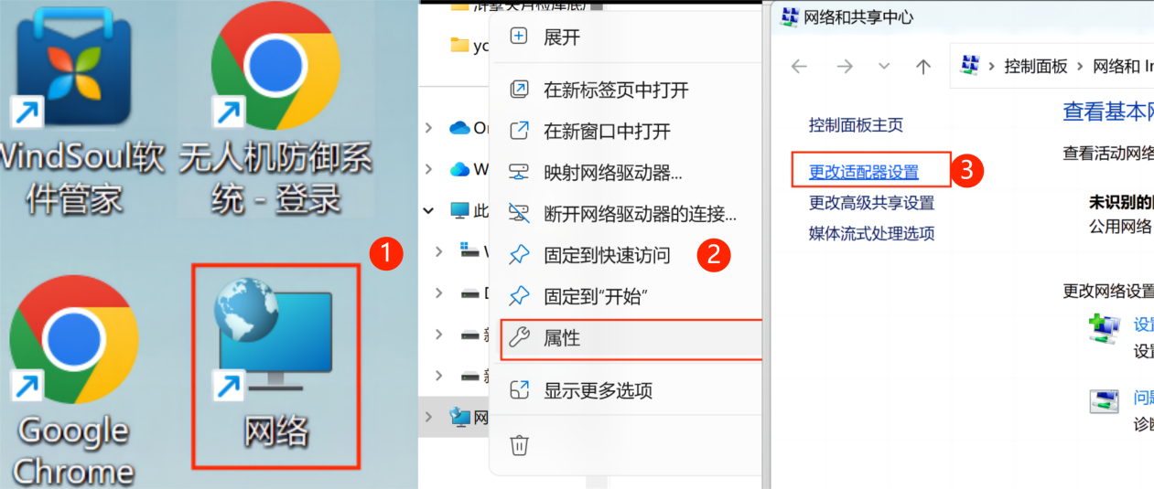
- Double-click “Network” to open the interface and locate “Network”.
- Right-click “Network”, locate “Properties”, and left-click it.
- Click “Change adapter settings” on the left side.
- Right-click “Ethernet”, locate “Properties”, and click it.
- Double-click “Internet Protocol Version 4 (TCP/IPv4)” and configure the network settings as shown in the figure.

Ethernet Settings
IP address: 192.168.3.X (X ≠ 164, X ≠ 80, X ≠ 81)
Subnet mask: 255.255.255.0
Default gateway: 192.168.3.1 (may vary depending on the device)

Software Introduction

Login Page
Prerequisite: Use Google Chrome and enter the product IP address 192.168.3.164 in the address bar to access the login page.
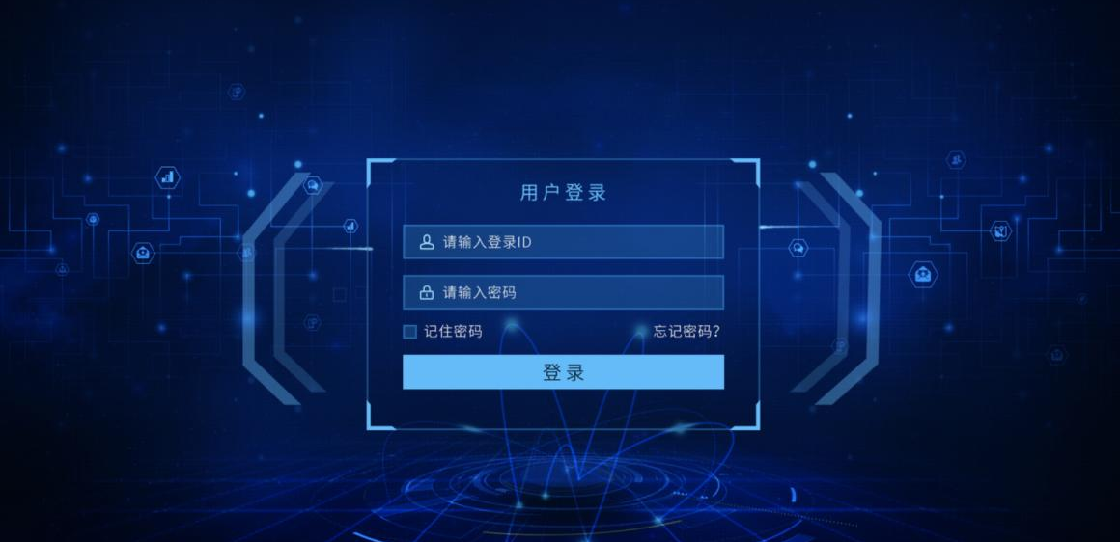
(1) Enter the username: admin
(2) Enter the password: 123456
(3) After confirming the username and password, click “Login” to enter the system.

Monitoring Interface Overview
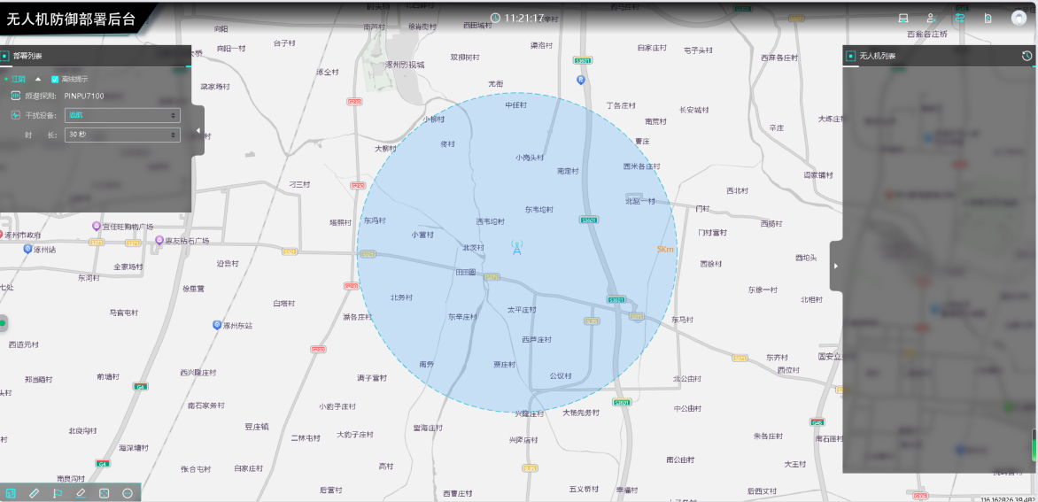
3
2
4
1
5
Label 1: Deployment List
Label 2: Function Bar
Label 3: Drone List
Label 4: Map Operation Bar
Label 5: Target Display

Deployment List
Users can view device status information and select countermeasure functions in this list.
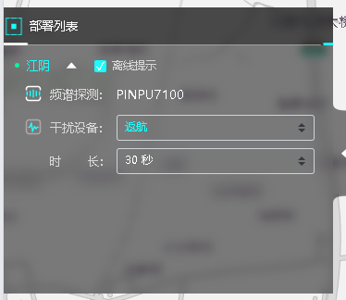
5
2
4
3
1
- Deployment point name. Click the deployment point name to automatically move the map to the current deployment point.
- Offline reminder: When selected, if any device at the current deployment point is offline or abnormal, a reminder will be displayed in the list.
- Spectrum detection: device name.
- Jamming device: function selection for the jamming device (return-to-home, forced landing, 2.4/5.8).
- Transmission duration of the jamming device.

Function List
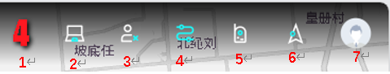
- Current number of detected targets.
- Open the backend management page.
- Unattended mode.
- Drone trajectory display.
- Drone remote controller display.
- Radar target display.
- User Management

User Management
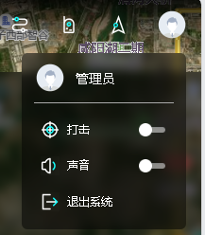
- Jamming: When an unauthorized drone is detected, the user can manually click the Jamming button to counter nearby unauthorized drones.
- Sound: When a nearby unauthorized drone is detected, the system issues an early warning and sounds an alarm to notify staff.
- Exit system: Click this function to return to the login page.

Drone List
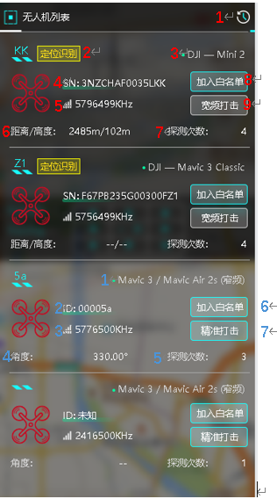
- History
- Currently identified drone
- Drone name
- Drone SN code (unique)
- Current communication frequency band used by the drone
- Distance between the drone and the device, and the current flight altitude of the drone
- Number of times this drone has been detected
- Add to whitelist. Drones on the whitelist will not trigger an alarm when detected.
- Broadband jamming. When displayed in gray, jamming is unavailable.

Description shown in the drone list when the drone has not been identified (see the blue text above).
  - The current drone may belong to these drone types.
  - Unique ID generated by the drone defense system.
  - Communication frequency band currently used by the drone.
  - Approximate direction of the current drone.
  - Number of times this drone has been detected.
  - Add to whitelist (same as “Add to whitelist” above).
  - Precise jamming: enable the jamming function.

Historical Data
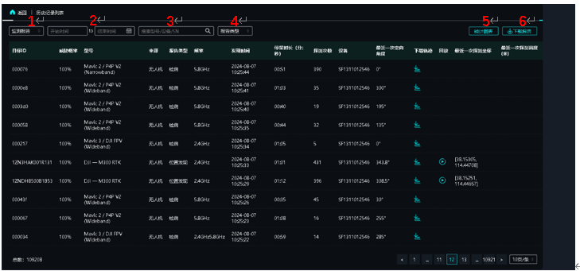
The record list can display information such as target ID, threat probability, drone model, signal source (drone or remote controller), report type, signal frequency, signal discovery time, duration of signal stay in the area, number of detections, detection device ID, latest signal angle, drone track download, playback, latest detected GPS position, and latest detected altitude.
- Switch report types (monitoring report/defense report) for filtering.
- Filter and query records by time.
- Filter by drone model, detection device ID, and SN code.
- Filter by discovery location, detection, and radar.
- Generate report charts.
- Download reports.
- Playback: Click the Playback button to enter the playback page. Video records are available only for drones identified with positioning. In playback, users can view information such as drone model, SN code, flight trajectory, position, and remote controller position.

Map Operation Bar
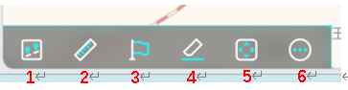
No. | Icon | Name | Function Description | Remarks
１ |  | Mode | Switch between online and offline maps | If the device network is LAN-only, offline maps must be downloaded for use.
２ |  | Dist. | Measure the distance between any two points on the map
３ |  | Mark | Temporarily mark a location on the map, such as the exact position of a drone
４ |  | Clear | Clear distance measurement and marker operations
５ |  | Full | Display the monitoring interface in full screen | Press F11 to control it.
６ |  | More | More functions include satellite map, road network map, compass, zoom, scale, overview map, and other view effects | See the instructions for details.

More
 | Plan | 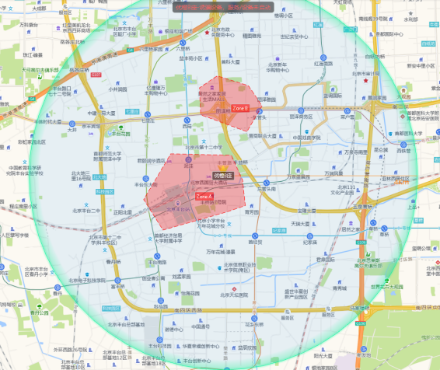
 | Satellite | 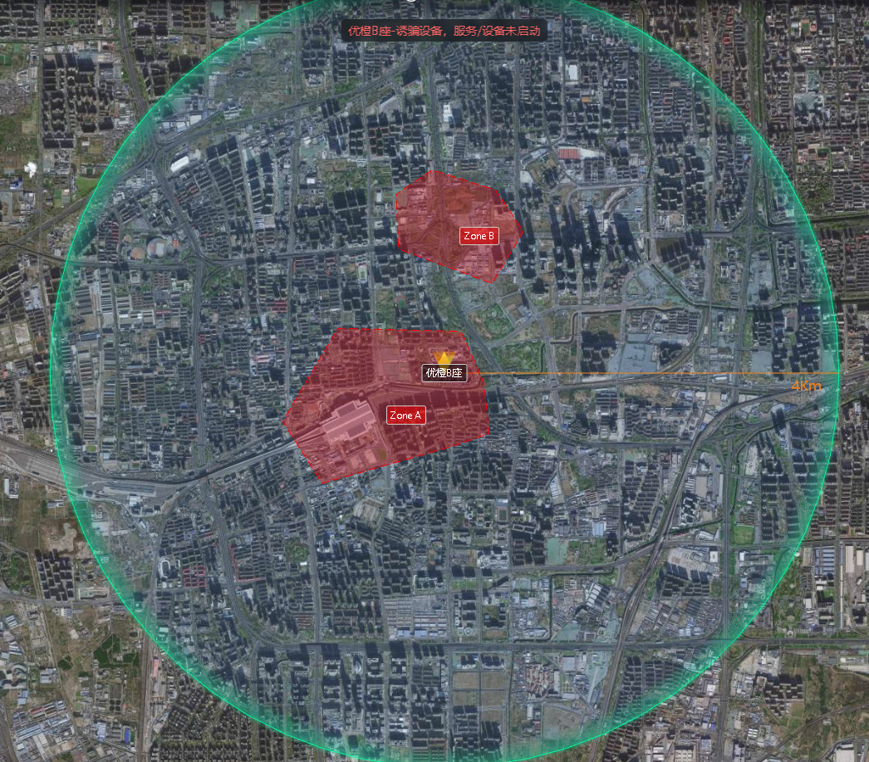
 | Road On
 | Road On | 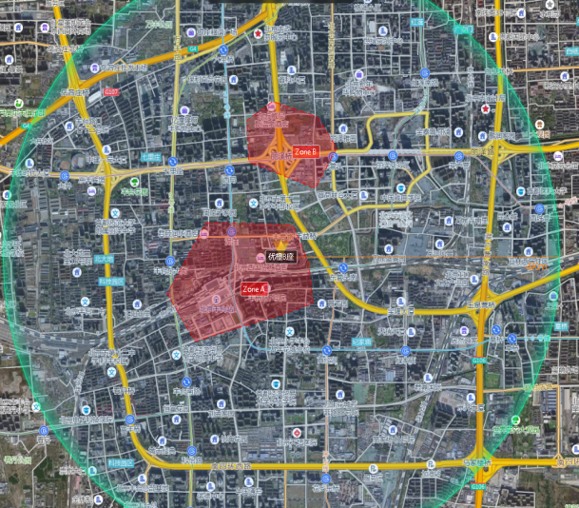
 | Off
 | On | 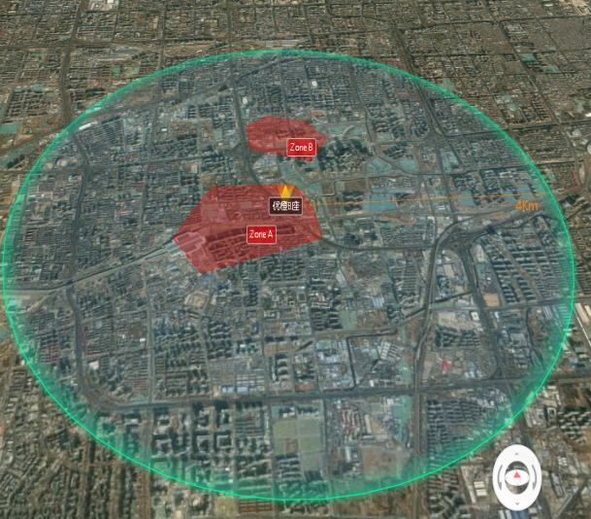 | Hold down the right mouse button and drag to switch to 3D view.  Click the compass in the red box on the left to restore the default map display.

